Powering K-C’s digital future
Respond to a Forward Auction Event (Suppliers)
Coupa Sourcing Optimization

For the best learning experience, please click the Editing button and select Open in Desktop to view this document in your desktop application of Microsoft Word. Viewing this document in SharePoint or in-browser may distort the placement of images and text.

Table of Contents

Purpose 2
Respond to a CSO Event 2
Change Version 8

Your screen in Coupa may differ slightly from this training, but the steps to complete the activity will be the same.

Purpose
This Quick Reference Card (QRC) explains how to Respond to Forward Auction Event (Suppliers). It is intended to support incumbent and prospective Kimberly-Clark Suppliers while performing the following tasks in CSO:
- Task 1: Access the Coupa Sourcing Optimization tool
- Task 2: Update your Account Information
- Task 3: Respond to a Sourcing Event
This QRC focuses on specfic call outs to complete to Respond to Forward Auction Event (Suppliers). Please reference the Respond to a CSO Event (Suppliers) QRC to follow the log in steps and how to update your account information to properly sign in.

Respond to a CSO Event
- After logging in successfully, review the list of Your Events.
  - Your Events contains a list of all open events that you have access to in the portal.
  - If this is your first time responding to a sourcing event with Kimberly-Clark in CSO, you will only have one event available.
- Click the appropriate Sourcing Event.
  - The most recent event will be displayed at the top.
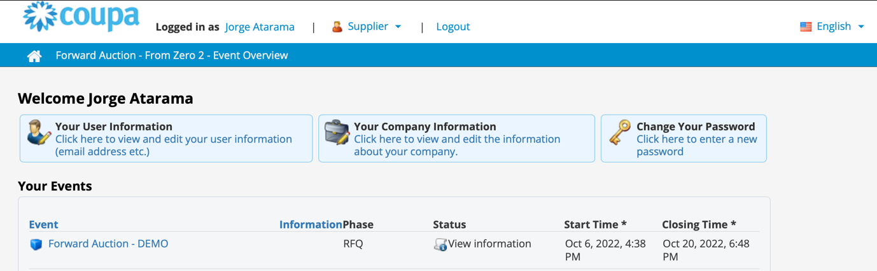

- If the event was created with any gating functionality, you may be required to complete an action item before being allowed into the event. An example of a gating step would be to download, review, and agree to event terms before participating.
  - Tip: If there are no gating requirements for the event, you will be directly routed to the Event Overview page.
- If applicable, download and review the Agreement Documents.
- If applicable, select the Confirmation checkbox if you have read and agree to all terms as stated in the Agreement Documents.

- If applicable, click Participate.
  - If you choose not to participate in the event, you will be required to submit a reason for declining.
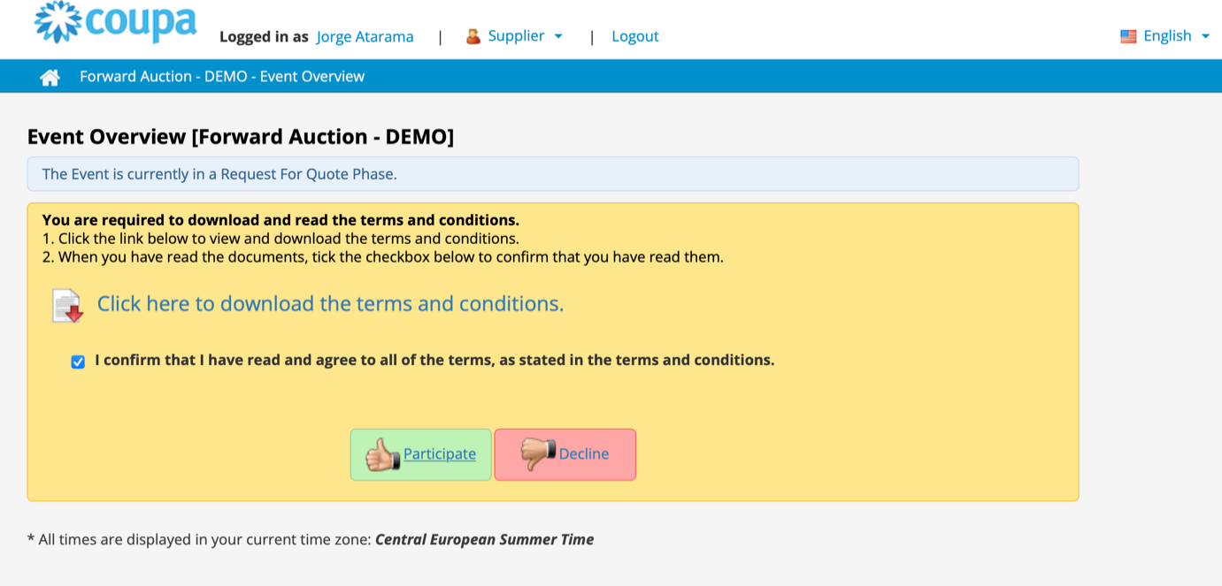

- Once the document has been downloaded, the Downloaded checkbox will be marked automatically.
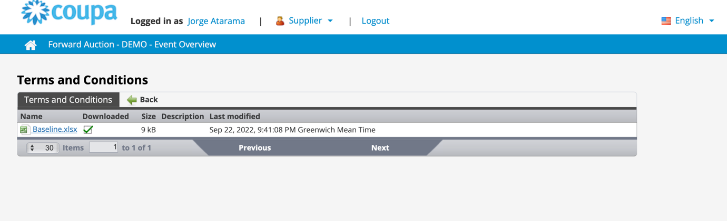

- Once you go back to the previous page, mark the check box and click the Participate button.
  - Note: Repeat the process with any additional documents you need to download.

- Once you reach the Event Overview page, review the current Event Phase.
  - The phase of the event will determine what you can see and do. In this example, the event is in a Request for Quote Phase so we will be able to submit a response. Once an event reaches the evaluation phase, you will no longer be able to submit a response of any kind.
- Review the Mandatory Actions message, including the submission deadline date.
  - Critical: Any new or updated responses will not be accepted after the date and time of the deadline.
- Review the Required Actions and Completion Status.

- Review the Options menu.
- If applicable, click Decline to Participate if you no longer wish to participate in the sourcing event. In this example, we will not decline to participate.
  - Reminder: You will be required to enter a reason or justification for declining to participate in an event.
- If desired, click View Documents.
  - View Documents provides quick access to all documents provided by the event to be downloaded as well as all the completed forms that you have submitted in the current phase.
- Once in the event, click on Place Bid.
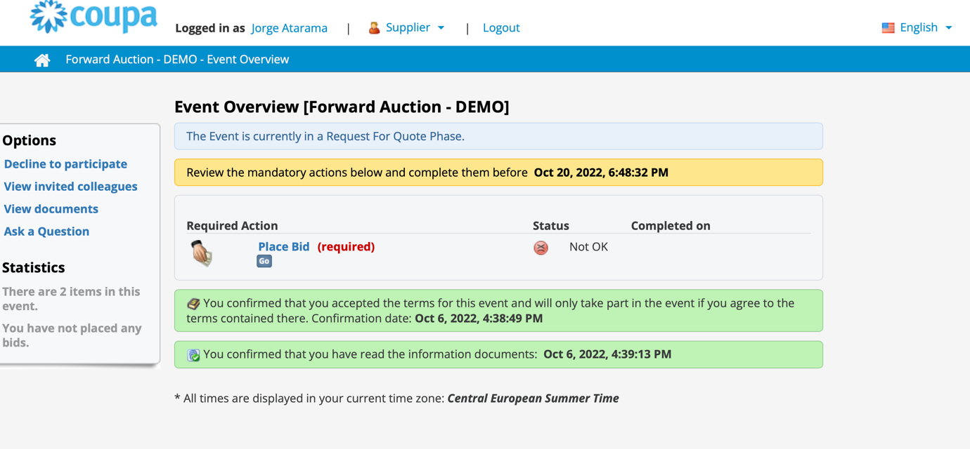

- On the Place Bid screen, select Go to Online Bidding.
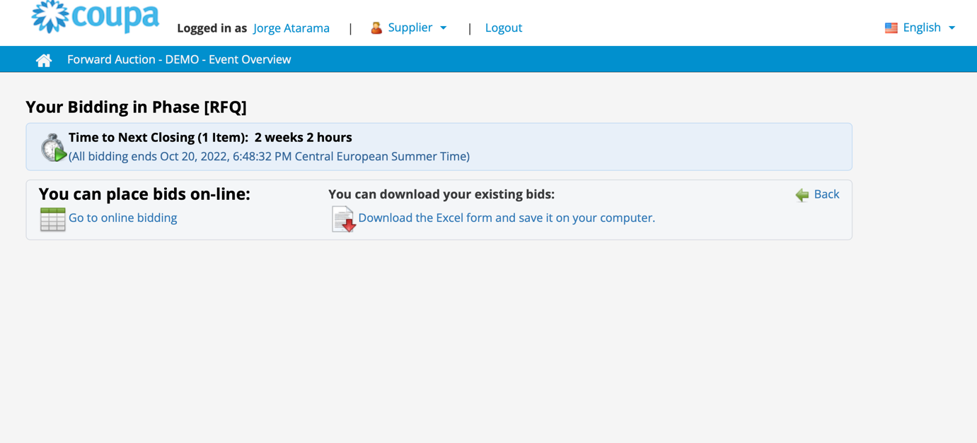

- The bid sheet will appear. Open item per item as you wish to bid.
  - Note: Once you bid, the rank and optional feedback fields will appear.
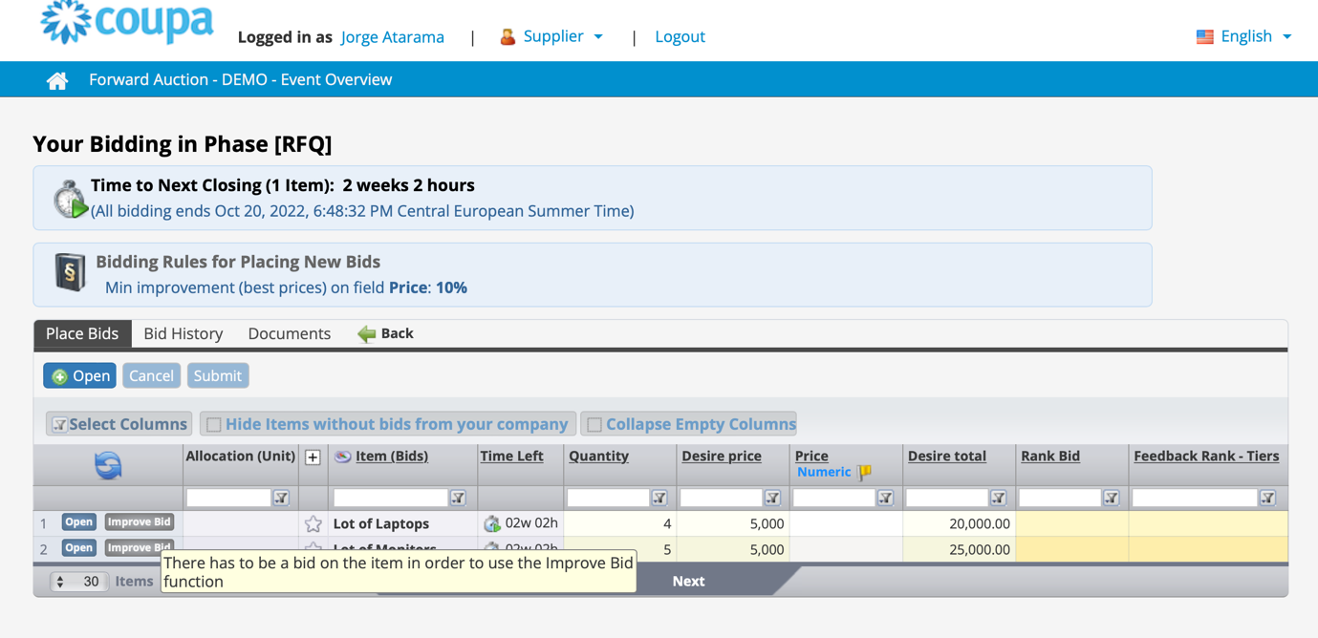

- If another supplier bids a better price, then you will see that in the column Rank Bid.
  - Note: The name of the column might change, but you will know which is your rank.
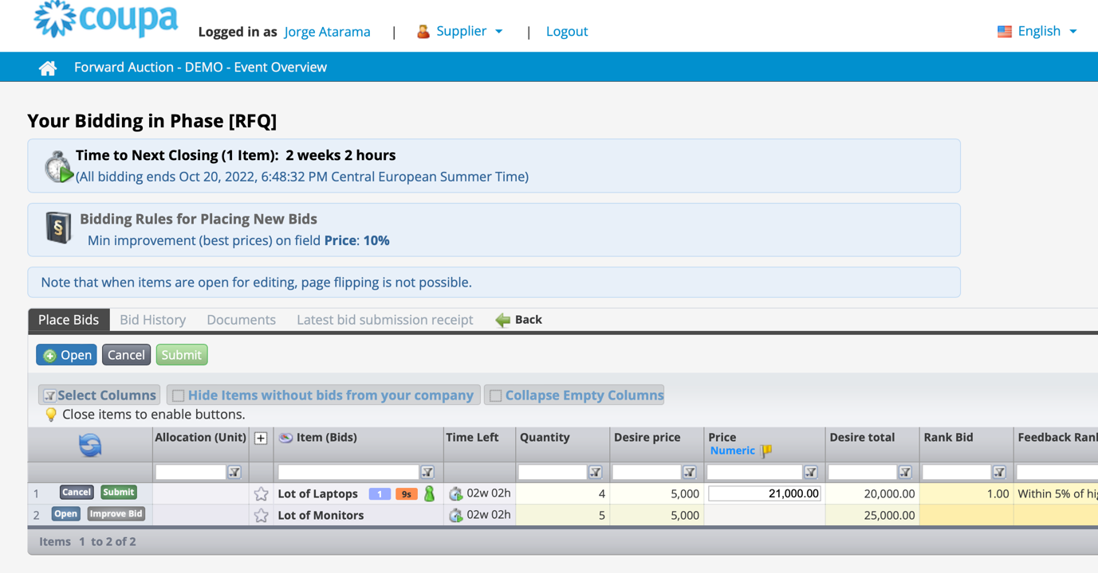

- Once you submitted at least 1 item per item, if another supplier bids a better price, then you will be allowed to click Improve Bid, which will apply the rules of the auction.
  - Example: If the minimum improvement is 10%, you will get the +10% automatically.
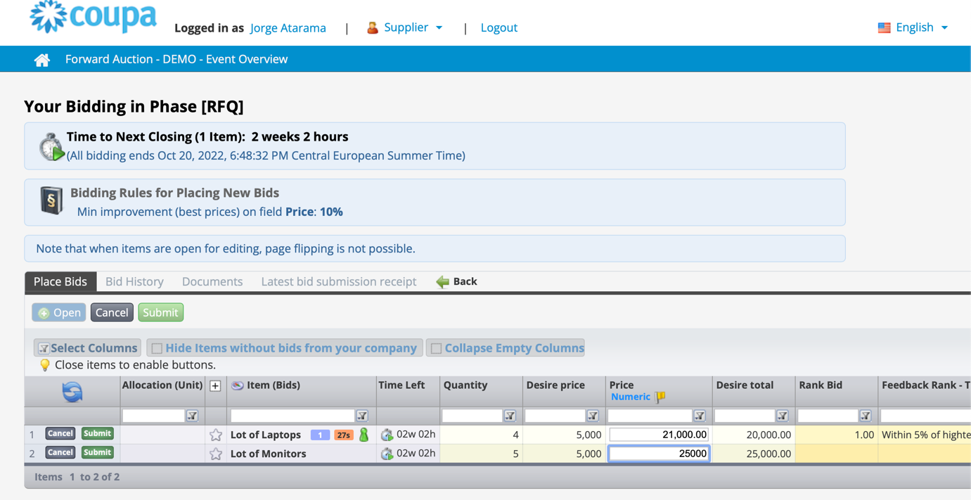
- Once the auction is closed, the ranking will be final.

Change Version
Version History
Version | Date | Change Description | Author
0.1 | 7-Oct, 2022 | Original | Park, Sarah (KPMG)
0.2
0.3
0.4

