Powering K-C’s digital future
Respond to a Sourcing Event (Suppliers)
Coupa

For the best learning experience, please click the Editing button and select Open in Desktop to view this document in your desktop application of Microsoft Word. Viewing this document in SharePoint or in-browser may distort the placement of images and text.

Table of Contents

Purpose 2
Respond to a Sourcing Event 2
Change Version 9

Your screen in Coupa may differ slightly from this training, but the steps to complete the activity will be the same.

Purpose
This Quick Reference Card (QRC) explains how to Respond to a Sourcing Event in Coupa. It is intended to support incumbent or prospective Kimberly-Clark Suppliers while performing the following tasks in Coupa:
- Task 1: Respond to a Sourcing Event
If you have any questions that cannot be answered by this document, please contact the Event Manager (Buyer) or the Supplier Enablement Team at Kimberly-Clark.

Respond to a Sourcing Event
Note: When a Sourcing Event has been scheduled at Kimberly-Clark and you have been identified as a Supplier that should respond, you will receive an email invitation with instructions on how to access the upcoming event.
- Navigate to your company email account, then search for and select the appropriate Inbox item.
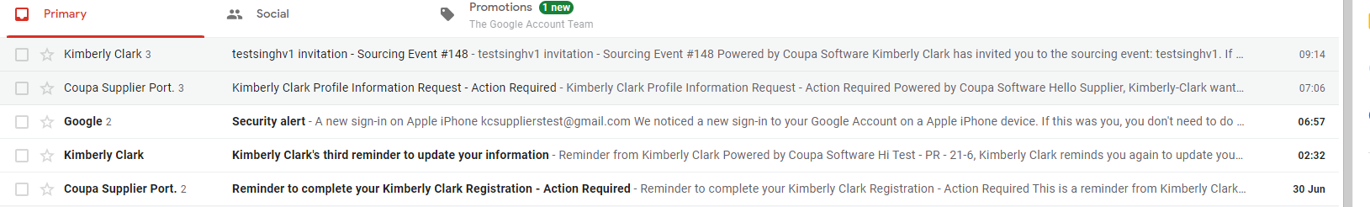

- Review the Event Invitation Message from Kimberly-Clark.
- Click the appropriate hyperlink to set up a new Password.
  - Critical: You must set up your password within 7 days of receiving the invitation.
  - If you do not have an existing account in Coupa (Kimberly-Clark’s Sourcing System), you will be required to create a new password in order to access the Supplier Portal and respond to the event.
  - Account creation is a one-time setup activity. All future event invitations will be linked to your account and will not require you to update a password.
- Review your assigned Username for the event.
- Review the Participation Instructions, then select the appropriate Participation option. In this example, we will select View Event.
  - The I intend to Participate button should be selected if you want to acknowledge the invitation and inform the Buyer that you intend to participate but will be submitting your response at a later date.
  - The View Event button should be selected if you want to view the event details and/or initiate your response at that moment.
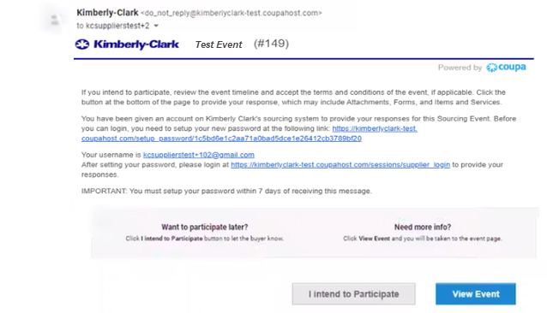

- A new tab will open on your preferred internet browser and will take you to the Kimberly-Clark Supplier Portal.
- Enter your login credentials to sign in to Coupa.
  - Reminder: Your username was provided in the event invitation email. Copy and paste the provided username into the Username field, then enter your password.
  - If this is your first time responding to an event through Coupa and you did not create a new password before attempting to log in, you will be prompted to create a new password.
- Click Sign In.
  - If you have trouble signing in, please contact the Event Manager (Buyer) or the Supplier Enablement Team at Kimberly-Clark.
  - If you forget your password, click the Forgot username or password? link, enter your username or email associated with the account, select the I’m not a robot checkbox, then click submit to request a new one-time ticket. The ticket is sent to your registered e-mail address and is valid for 24 hours. You will be requested to change the temporary password once you log in.

- After logging in successfully, you will be routed to the Sourcing Response Portal.
- Review the list of Sourcing Events.
  - If this is your first time responding to a sourcing event with Kimberly-Clark, you will only have one event available in the portal.
- Click the appropriate Sourcing Event.
  - The most recent event will be displayed at the top.
  - Tip: If desired, you can use the sort, filter, or search functionalities to find a specific event.
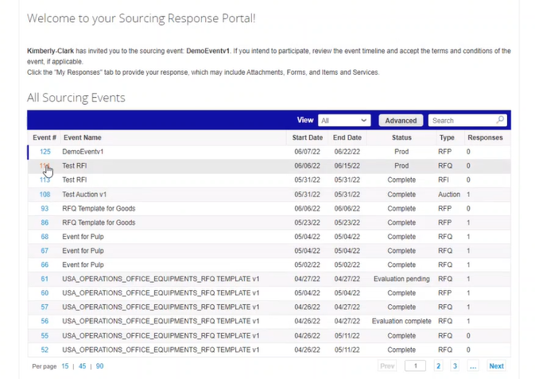

- Review the Event Info message and the Event Ends countdown.
  - Critical: Participating responses will not be accepted past the Event End Date.
- If you choose to participate, select the “I intend to participate in this event” checkbox.
- If applicable, review the Event Terms and Conditions. In this example, no terms or conditions were added to the event so nothing is available or required for review.
  - If any Terms and Conditions were available, you would need to use the radio button to accept or decline the provided Terms and Conditions.
- Review the Event Information and Bidding Rules.
- If applicable, review the Buyer Attachments. In this example, there are no attachments with additional requirements or instructions for the event.
- Review the Timeline for the event.
- Click Enter Response.
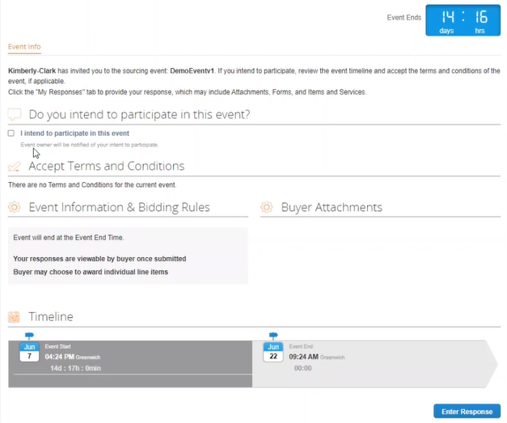

- Enter an appropriate response Name.
- If applicable, review or upload any appropriate Attachments as supporting documentation.
  - Attachments can be included to provide additional instruction or to gather additional information from you and your response.
  - If available, Attachments can be downloaded and reviewed.
- Review the Forms section to see if there are any additional Forms or Questionnaires that need to be completed for the event.
  - Forms can have many different response options.
  - If applicable, complete the Form or Questionnaire.
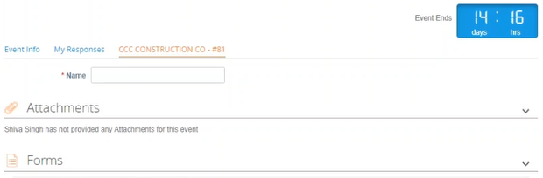

- Scroll down to the Items and Services section.
- Review all available Items, Lots, or Services that are included in the event. In this example, there is a single item included in the event.
- Enter your bid for all required fields, In this example, you are required to enter a Manufacturing Cost, Labor Cost, and Shipping Cost for the Hardwood Pulp item.
  - All required fields are notated by a red asterisk *.
- Review your response details for accuracy, then click Submit Response to Buyer.
  - If desired, you have additional options to provide the response using an excel sheet using the following steps:
    - Export to Excel: Export the response requirements of the event into a Microsoft Excel format.
    - Complete the exported Microsoft Excel worksheet with your response (bid).
    - Import from Excel: Load your response to the event in its Microsoft Excel format.
    - Save: Save your progress.
  - After submitting your bid, a Response submitted to Buyer message will appear on top of the screen as confirmation of your successful participation in the event.
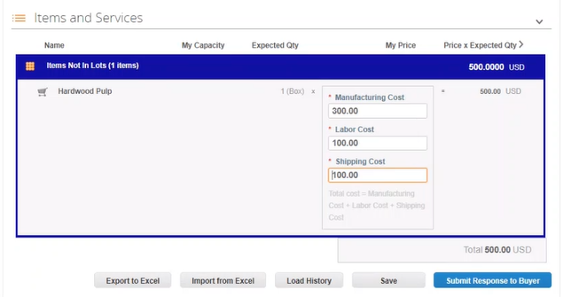

- If desired, you can log back into the Sourcing Response Portal at any time in order to view the status of the event.
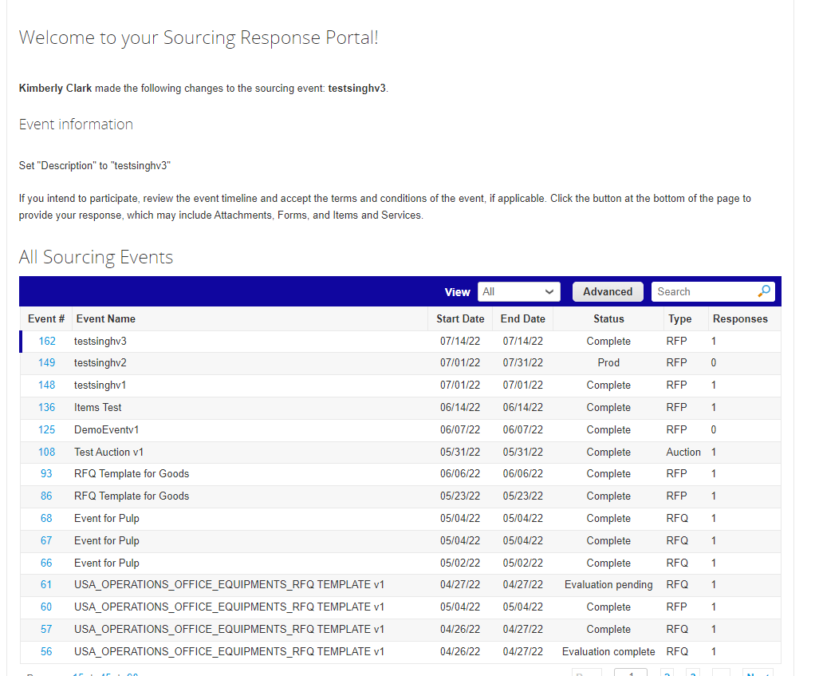

- If applicable, you can enter a new bid (response) as long as the event is still open and the event was set up to allow for response updates. In this example, we will not enter a new bid.
  - Reminder: Participating responses will not be accepted after the Event End Date has passed.
  - Please contact the Event Owner (Buyer at Kimberly-Clark) if you are having trouble making updates to a bid.
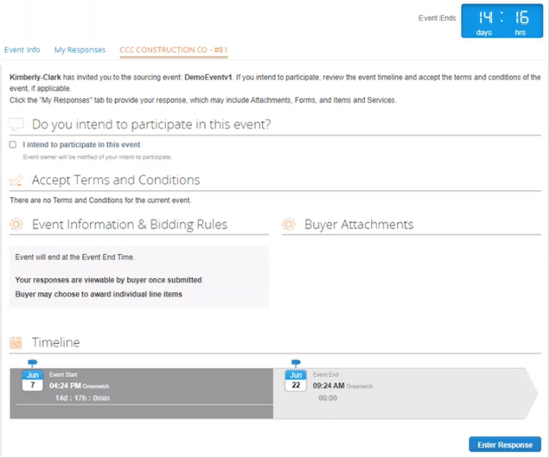

- When the event timeline is about to expire, you will receive a notification from Coupa at the email address that was registered for the event.
- If desired, review the message or navigate to the event in the Sourcing Response Portal to view the event. In this example, we will not take any further action.
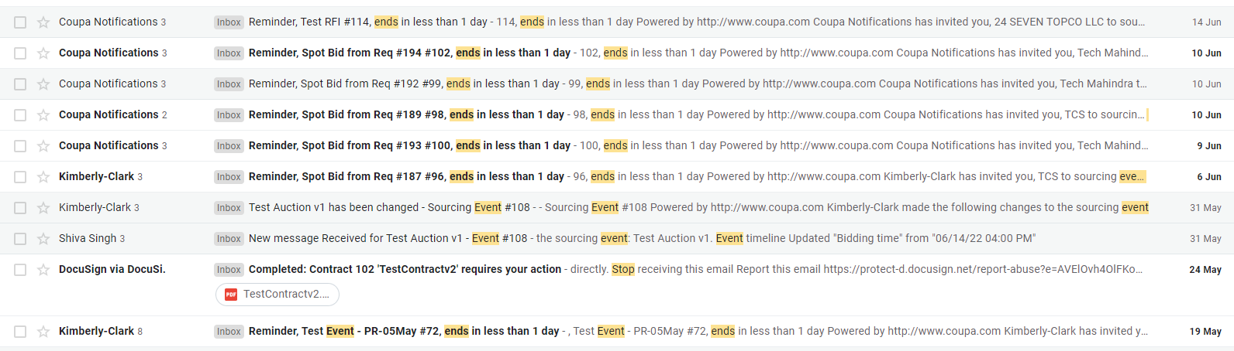

- If you were awarded any of the items, lots, or services of the event, the Event Manager will send a message to communicate the award.
- Click the appropriate Inbox item to view the award message.
  - The Subject of the Inbox Item will read, New Message Received for [Event Name] – Event #.
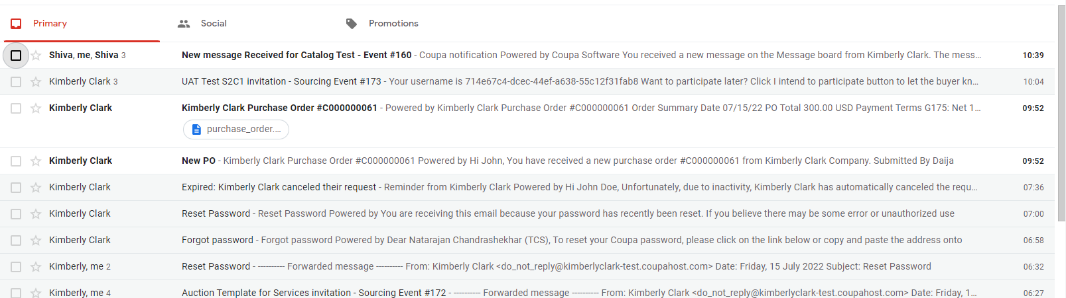

- Review the Award Message.
- If desired, click the View Online link to log in to the Sourcing Response Portal.
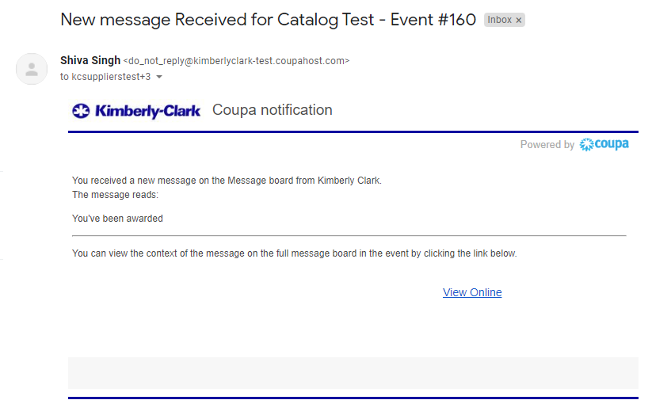

- Enter your log in credentials, then click Sign In.

- Click the appropriate Event.

- Click Messages.
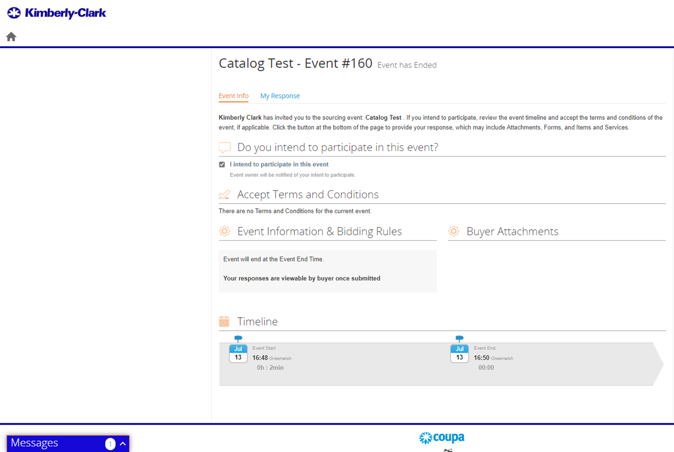

- Review the details of the Award Message and any instructions from the Event Manager (Buyer at Kimberly-Clark) regarding next steps.

Change Version
Version History
Version | Date | Change Description | Author
0.1 | 26-Jun, 2022 | Original | Park, Sarah (KPMG)
0.2 | 27-Jun, 2022 |  | Kallenberg, Danny (KPMG)
0.3 | 28-Jun, 2022 |  | Park, Sarah (KPMG)
0.4 | 13-July, 2022 | Incorporated GPL / SME feedback. | Kallenberg, Danny (KPMG)

