Powering K-C’s digital future
Respond to a CSO Event (Suppliers)
Coupa Sourcing Optimization

For the best learning experience, please click the Editing button and select Open in Desktop to view this document in your desktop application of Microsoft Word. Viewing this document in SharePoint or in-browser may distort the placement of images and text.

Table of Contents

Purpose 2
Log in to CSO 2
Update Your Account Information 4
Respond to a CSO Event 5
Change Version 14

Purpose
This Quick Reference Card (QRC) explains how to Respond to a Coupa Sourcing Optimization (CSO) Event. It is intended to support incumbent and prospective Kimberly-Clark Suppliers while performing the following tasks in CSO:
- Task 1: Access the Coupa Sourcing Optimization tool
- Task 2: Update your Account Information
- Task 3: Respond to a Sourcing Event
If you have any questions while participating in the event, please use the Ask a Question functionality (shown below) or contact the Event Manager (Buyer) using the contact information they provided in the event invitation. If preferreed, you may also contact the Supplier Enablement Team at Kimberly-Clark for additional support.

Log in to CSO
Note: When a CSO Event has been scheduled at Kimberly-Clark and you have been identified as a Supplier that should respond, you will receive an email invitation with instructions on how to access the upcoming event.
- Navigate to your company email account, then search for and select the appropriate Inbox item.
- Review the Event Invitation Message from Kimberly-Clark.
- Click the appropriate hyperlink in your invitation email to access CSO.
  - Critical: You must access the link and set up your password within 7 days of receiving the event invitation. After 7 days, this link will expire.
  - If this will be your first time using CSO or you do not remember your user credentials, select the Login with Ticket functionality. The One-Time ticket will expire after 7 days. Should this happen, you can log in by resetting your password or you can contact the event owner to send a new invitation.
  - If you do not have an existing account in CSO, you will be required to create a new password to access and respond to the event.
  - Account creation is a one-time setup activity. All future event invitations will be linked to your account and will not require you to update a password.
  - Critical: Logging in through the ticket can only be used once per event. If necessary, use the Forgot Password? functionality to retrieve a new temporary password.
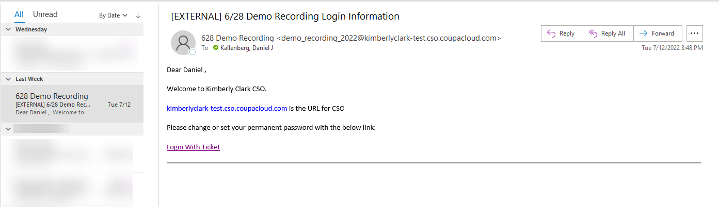

- A new tab will open on your preferred internet browser and will take you to the Log In page for Kimberly-Clark’s instance of Coupa Sourcing Optimization.
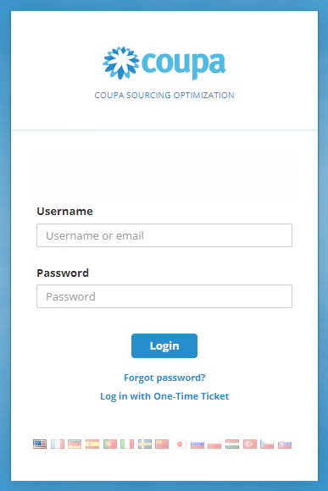

- Enter your login credentials.
  - If this is your first time responding to an event through CSO, you will be prompted to create a new password after your initial login.
  - Reminder: If this is your first time attempting to log in and you do not have any user credentials, select the Login with One-Time Ticket functionality. Logging in through a one-time ticket can only be used once per event.
- Verify or select the appropriate Flag to update your preferred language settings.
- Click Login.
  - If you have trouble signing in, please contact the Event Manager (Buyer/Category Manager) or the Supplier Enablement Team at Kimberly-Clark.
  - If you forget your password, click the Forgot password? link, enter your username or email associated with the account, select the I’m not a robot checkbox, then click submit to request a new one-time ticket. The ticket is sent to your registered e-mail address and is valid for 24 hours. You will be requested to change the temporary password once you log in.

Update Your Account Information
- After logging in successfully, you will be routed to the Supplier Portal for Coupa Sourcing Optimization.
- If this is your first time logging in to Supplier Portal, you will be asked to verify or update your User Information before participating in any events.
- It is critical that your name, email, and phone number information are correct in case the Event Management team needs to reach you.
- Click Your User Information to verify or update your account information, contact information, etc.
- If desired, click Your Company Information to add or update information about your Company.
- If desired, click Change Your Password. In this example, we will not update a Password.
- If desired, click the Flag icon in the top right corner of the Home screen in order to update your preferred language in the system.
- Updating your language will apply to all text / fields generated by CSO, but will not translate attachments that were originally created by the Event Management team.
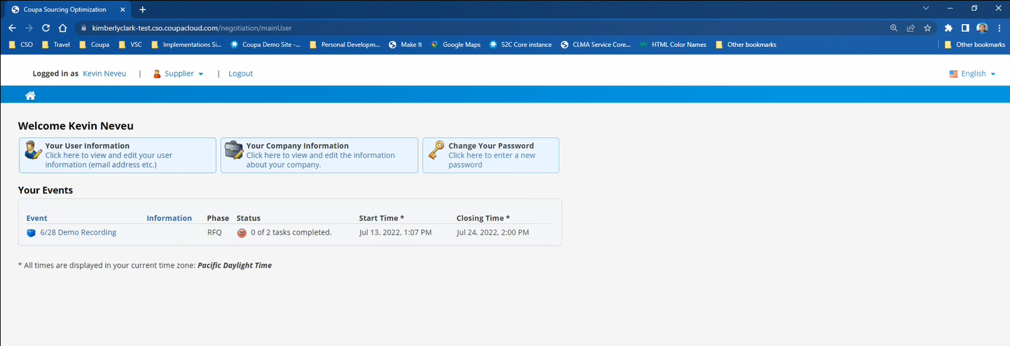

Respond to a CSO Event
- After logging in successfully, review the list of Your Events.
  - Your Events contains a list of all open events that you have access to in the portal.
  - If this is your first time responding to a sourcing event with Kimberly-Clark in CSO, you will only have one event available.
- Click the appropriate Sourcing Event.
  - The most recent event will be displayed at the top.

- If the event was created with any gating functionality, you may be required to complete an action item before being allowed into the event. An example of a gating step would be to download, review, and agree to event terms before participating.
  - Tip: If there are no gating requirements for the event, you will be directly routed to the Event Overview page.
- If applicable, download and review the Agreement Documents.
- If applicable, select the Confirmation checkbox if you have read and agree to all terms as stated in the Agreement Documents.
- If applicable, click Participate.
  - If you choose not to participate in the event, you will be required to submit a reason for declining.
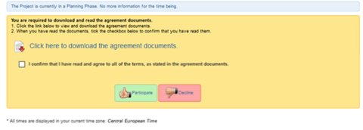

- Once you reach the Event Overview page, review the current Event Phase.
  - The phase of the event will determine what you can see and do. In this example, the event is in a Request for Quote Phase so we will be able to submit a response. Once an event reaches the evaluation phase, you will no longer be able to submit a response of any kind.
- Review the Mandatory Actions message, including the submission deadline date.
  - Critical: Any new or updated responses will not be accepted after the date and time of the deadline.
- Review the Required Actions and Completion Status.
- Review the Options menu.
- If applicable, click Decline to Participate if you no longer wish to participate in the sourcing event. In this example, we will not decline to participate.
  - Reminder: You will be required to enter a reason or justification for declining to participate in an event.
- If desired, click View Documents.
  - View Documents provides quick access to all documents provided by the event to be downloaded as well as all the completed forms that you have submitted in the current phase.
- Click Ask a Question.
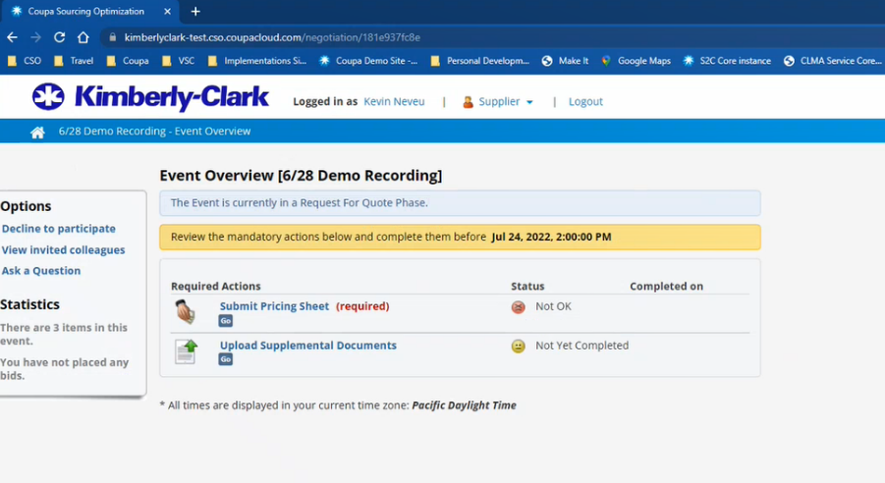

- If applicable, click Ask New Question or Download Questions for support during the event.
  - The Ask New Question functionality would send a personal question to the Event Management team. The Event Manager would then be able to reply to you privately, and, if the question was pertinent to all participating Suppliers, the Event Manager could add the question and their response to a list Frequently Asked Questions (FAQs) to be shared with the whole group of participating Suppliers.
  - The Download Questions functionality is offered as a repository of all questions and answers (FAQs) that would benefit all participating Suppliers.
- Click Back.
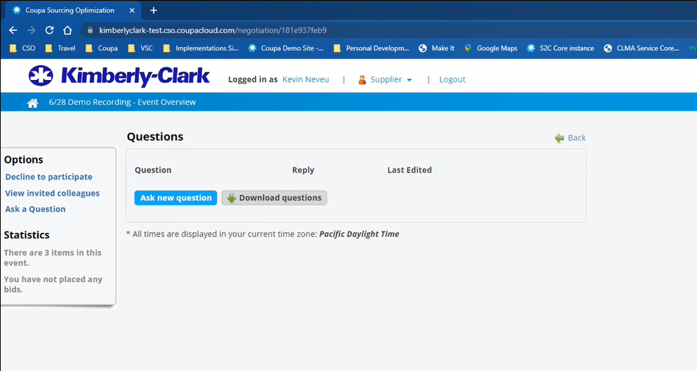

- Click the appropriate Required Action. In this example, we will select Submit Pricing Sheet.
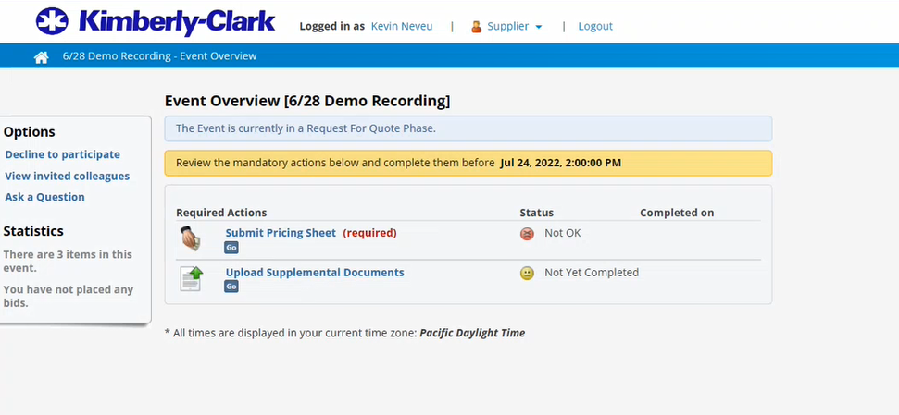

- Review the Time to Next Closing for the Bidding Phase.
  - Reminder: Any new or updated responses will not be accepted after the date and time of the deadline.
- Click the hyperlink to download the attached Excel Form. In this example, we are downloading our Pricing Sheet (Bid Form).
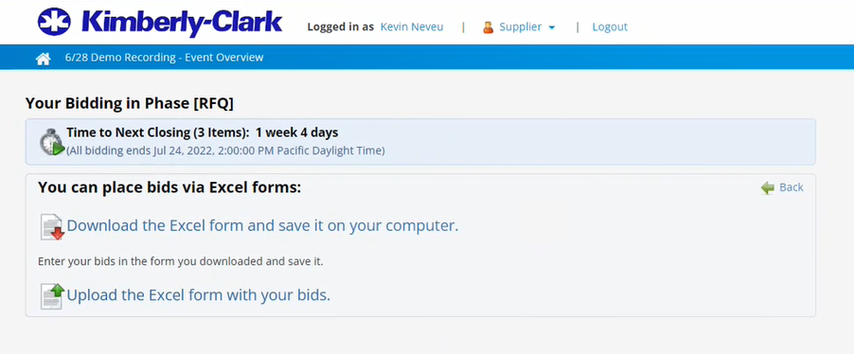

- Open the downloaded Excel Form for the event, then save it on your local computer with an appropriate naming convention.
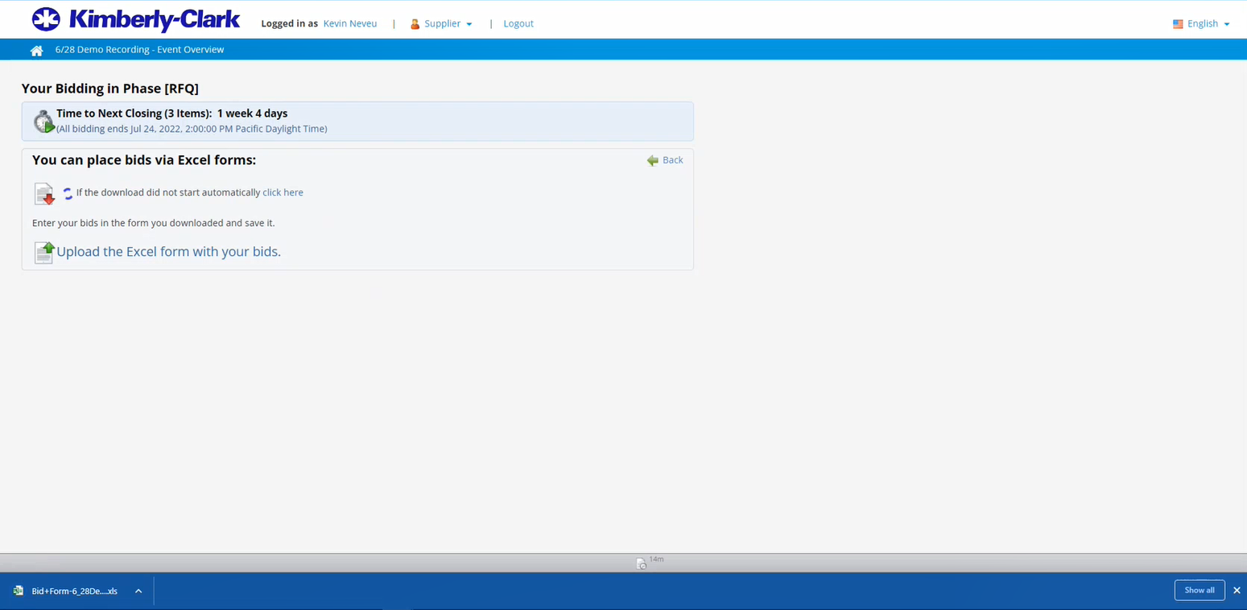

- Enter your bids for all appropriate items. In this example, we will only need to enter Unit Price, Capacity, and Server Condition for three items.
  - Note: Refrain from editing the excel bid sheet format to avoid errors when uploading the completed bid sheet.

- If applicable, click the additional worksheet tab(s) at the bottom of the file. In this example, we will click the RFP Questions tab.

- If applicable, answer all required RFx Questions with an appropriate response. In this example, we only need to provide one answer to address our Overall Capacity (how many units we can provide).
  - RFx is an inclusive acronym that refers to any RFI, RFQ, and RFP events / phases.
- Review all response details (both bids and answers) for accuracy, then save the updated copy of your Pricing Sheet (Bid Form).

- Return to the appropriate Required Action for the Event, then click the hyperlink to upload the completed Excel Form with your bids.

- Click Choose File.
- Search for and select the appropriate Pricing Sheet (Bid Form).
- Click Submit.
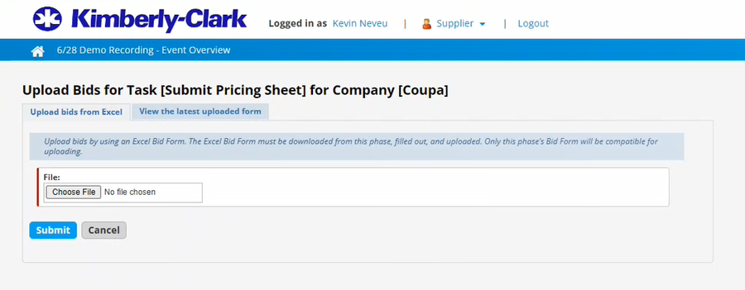

- Verify that your bid was successfully submitted.
  - If any mandatory information was omitted or entered in an incorrect format, you will get an error message in a red box that indicates which entries were invalid and why. In addition to the message, you would receive an additional sheet in the rejected form (Excel File) that lists the errors and cells that need to be corrected prior to resubmission.
- If desired, review your Submission details.
- If desired, click the Review submitted bid forms tab to download and review the details of your response.
- Click Ok.
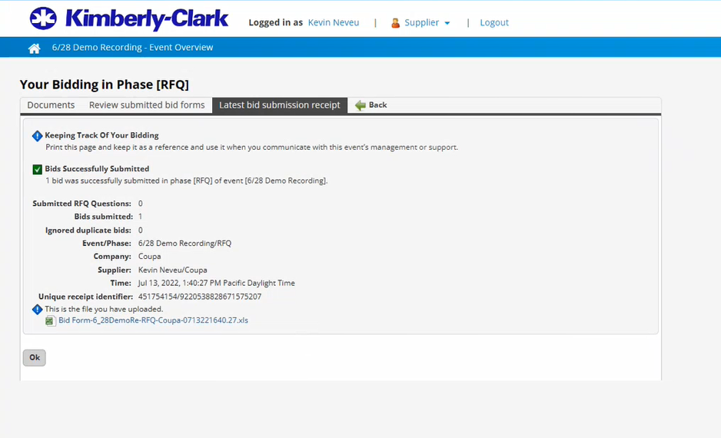

- Return to the appropriate Event Overview page.
- Review the updated Status and Completed On date for your Pricing Sheet Submission.
- If applicable, complete any additional Required Actions to finalize your response. In this example, the additional action item is not required so our bid for the event is complete.
- If desired, review the updated Statistics of the Event.
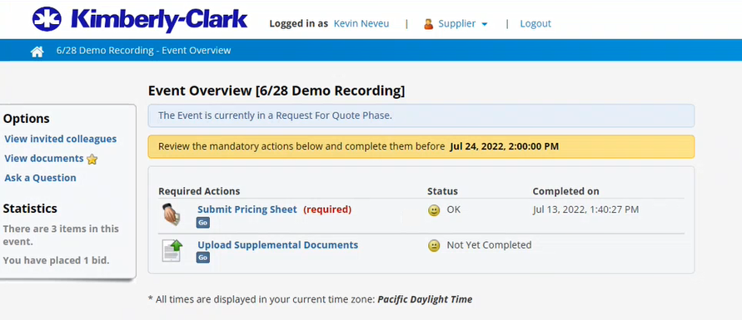

- After the Evaluation Phase is complete, you will be notified by the Event Management team if you were awarded any of the items, lots, or services included in the event.

Change Version
Version History
Version | Date | Change Description | Author
0.1 | 22-Jul, 2022 | Original | Park,Sarah (KPMG)
0.2
0.3
0.4

