Supplier Guide on Bank and Tax W-8 Requirements for Onboarding with K-C

1. Bank Details

Bank Details – What do we need to know?
To add your company to our system as a new supplier, we require you to provide us with banking details. Please provide the following on your financial institution’s letterhead:
- Wire Banking details (SWIFT and IBAN)
- Your company’s name and address
- Bank routing
- Bank account information
Please be aware, that the company’s name and address must match exactly your W8 declaration! Documents not matching will be rejected and send back for correction.
- Ensure all forms are submitted in English

2. What type of valid and recent W8 should I use?
- Most foreign suppliers use the W-8BEN-E form. See the Frequently Asked Questions below for other W-8 form options.
  - Check this with your tax department as we do not know the specifics of your company.

- To get the most updated version of W8 file please go to: Forms and Pubs Index Search | Internal Revenue Service (irs.gov).

- How to correctly fill the W8 form?

- The W-8 must be less than 3 years old
- Please ensure the following sections are filled out before submitting.

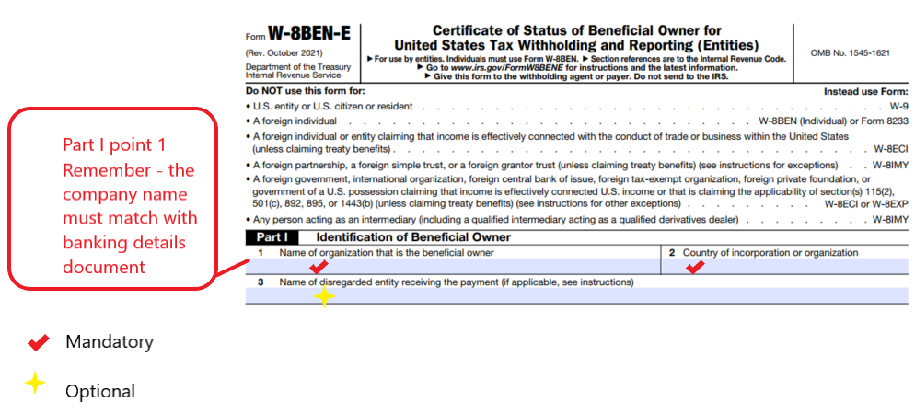
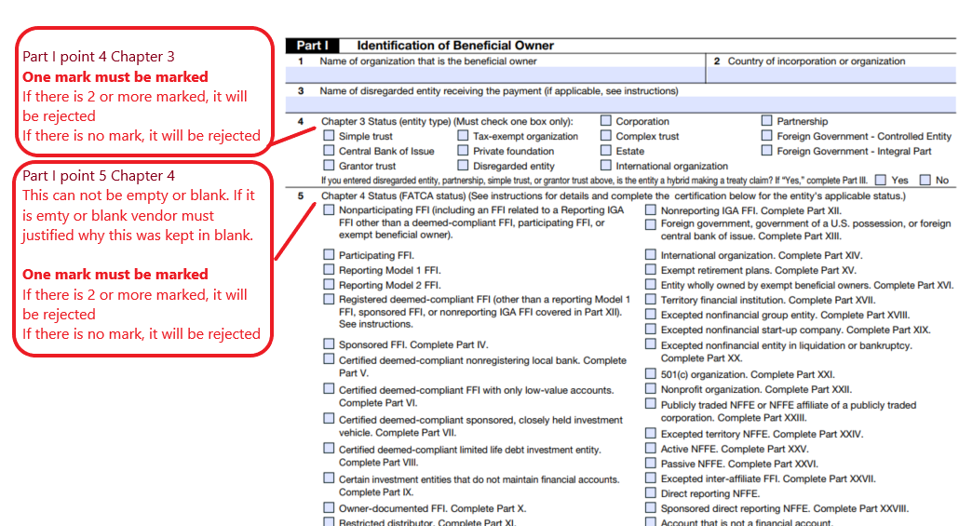

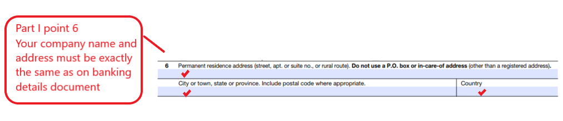

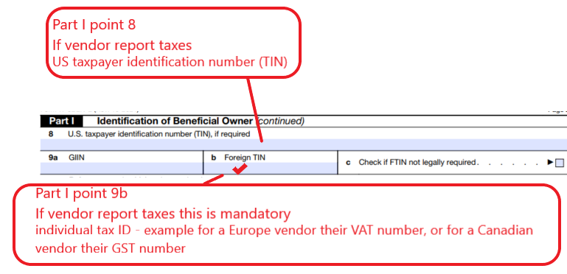
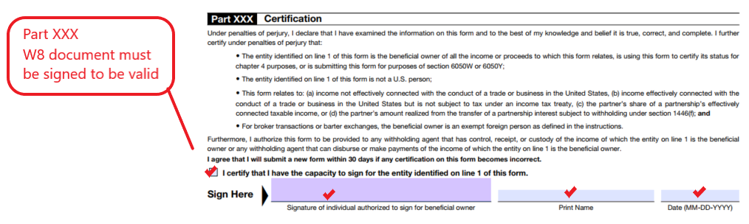

What if a mandatory field from the ones above in the W8 files is missing?
- If any of the above fields is missing, then W8 file is not acceptable. It must be rejected.
What if chapter 4 (FATCA Status) is not completed?
Please review the IRS Form Instructions for Form W-8BEN-E and either complete as applicable or confirm why this section is not required. Go to same previous link: https://www.irs.gov/forms-pubs-search?search=W8

What if the supplier does not complete Part III – Claim of Tax Treaty Benefits?
Unless this section is completed in full, a 30% withholding tax will be applied. In general, it is seen vendors complete sections 14 a&b and 15 claiming the Business Profits exemption under Article 7 of the applicable treaty. Please review the IRS Form Instructions for Form W-8BEN-E and complete as applicable consulting with your local tax advisor.

Frequently Asked Questions:

Where to start to get a Form W-8 completed?
All W-8 forms and corresponding form filling instructions can be found on the IRS website at this link. https://www.irs.gov/forms-pubs-search?search=w8
It is highly recommended that you consult your tax and finance person to choose the appropriate W-8 form and complete all the required questions of each form that are applicable to you. IRS publication 515 is also a great resource. This publication can be found on the IRS website or with the following link: http://www.irs.gov/pub/irs-pdf/p515.pdf

There are 6 different types of Form W-8’s; the below information is for your reference to help you start the process.
- Foreign entities shall use Form W-8BEN-E
- Foreign individuals shall use Form W-8BEN
- Foreign individuals or entities claiming that the income is effectively connected with the conduct of a trade or business in the United States (unless claiming treaty benefits) shall use Form W-8ECI
- Foreign governments, international organizations, foreign central banks of issue, foreign tax-exempt organizations, foreign private foundations, or governments of a U.S. possession claiming that income is effectively connected U.S. income or that is claiming the applicability of section(s) 115(2), 501(c), 892, 895, or 1443(b) (unless claiming treaty benefits) (see instructions) shall use Form W-8EXP or W-8ECI
- Foreign partnerships, foreign simple trusts, foreign grantor trusts (unless claiming treaty benefits) (see instructions for exceptions), or persons acting as an intermediary shall use Form W-8IMY
- Exemption From Withholding on Compensation for the Independent (and Certain Dependent) Personal Service of a Nonresident alien Individual shall use Form 8233.

What is a valid Form W-8?
A valid Form W-8 shall meet both of the below requirements:
- Use the correct Form W-8 that fits your business situation.
- Complete the form, sign it, ensure the box under the signature is checked. This confirms the signer has the proper authority to sign the form.

Using W-8BEN-E as an example, the form must include all of the following sections completed:
Part I:
Fill in basic information of the beneficial owner, the entity or individual who receives payment from KC, including:
- The beneficial owner’s name (line 1), country (line 2), address in details (lines 6 & 7), and any others that are applicable to the beneficial owner (lines 3, 8, 9, and 10)
- The beneficial owner’s “Chapter 3 status” (line 4), i.e., the beneficial owner’s entity type
- The beneficial owner’s “Chapter 4 status” (line 5), i.e., the beneficial owner’s FATCA status

Part II to Part XXVII:
- Fill in ONLY the parts applicable based on the beneficial owner’s Chapter 3 status and Chapter 4 status (see instructions for additional information).

Part XXVII:
- An individual with capacity to sign the form on behalf of the beneficial owner must sign it.
- This individual must check the box under the signature to confirm the signer has capacity to sign the form.

Part XXIX:
- This part must be completed ONLY IF the beneficial owner is a “Passive NFFE.”

What is “chapter 4 status”?
Chapter 4 Status is FATCA status that has to be provided and confirmed by beneficial owner. It includes 31 different statuses. Below are the full names of some general abbreviations. Go to www.irs.gov or search the 4 big accounting firms (Deloitte, EY, PWC and KPMG) for more detailed and accurate information.

FFI stands for Foreign Financial Institution.

NFFE stands for Non-Financial Foreign Entity.

Active NFFE is generally understood to be operating companies in which less than 50% of the NFFE’s gross income is passive income, and less than 50% of the NFFE’s assets are assets that produce or are held for the production of passive income.

Passive NFFE is defined as those NFFEs that do not meet the requirements of excepted NFFEs as set forth in the W-8 form.
International Organization has two main types: International nongovernmental organization (such as WTO, Red Cross, etc.) and International governmental organizations (such as United Nations)

