For the best learning experience, please click the Editing button and select Open in Desktop to view this document in your desktop application of Microsoft Word. Viewing this document in SharePoint or in-browser may distort the placement of images and text.

Contents
Purpose 2
Key Terms 2
How to Submit Vendor Acknowledgment of Purchase Orders in the CSP 2
Additional Resources 4
Change Version 4

Your screen in the Coupa Supplier Portal may differ slightly from this training, but the steps to complete the activity will be the same.
Powering K-C’s digital future
How to Provide Vendor Acknowledgement of Purchase Order
Coupa

Your screen in the Coupa Supply Portal may differ slightly from this training, but the steps to complete the activity will be the same.

This icon indicates there are further policy or business process details relating to a step. Click on the provided link(s) placed throughout the QRC for more information.

Purpose
This Quick Reference Card (QRC) explains the process for how Suppliers perform multiple tasks within the Coupa Supplier Portal such as configure Purchase Order (PO) transmission preferences, create online catalogs and electronic invoices and view Purchase Orders.

Key Terms
  - The Coupa Supplier Portal is a web portal to assist suppliers in managing business transactions with Kimberly-Clark (K-C).
  - The Advance Shipping Notice is an electronically communicated notification of shipment of goods from suppliers to their customers.
  - A Purchase Order (PO) is a commercial document issued by a buyer to a seller as a commitment to purchase goods or services in agreed upon types, quantities, and prices.
  - A Purchase Order (PO) Acknowledgement is a confirmation from a supplier to deliver specified quantities of products at specified prices within specified times.

How to Submit Vendor Acknowledgment of Purchase Orders in the CSP

Note: You can choose to let your customer know that you received their PO by selecting the Acknowledged checkbox on the PO.

- From your CSP Home screen, select the Orders tab.
- Click the Orders subtab.
- Click the corresponding PO Number to select the desired purchase order.

1

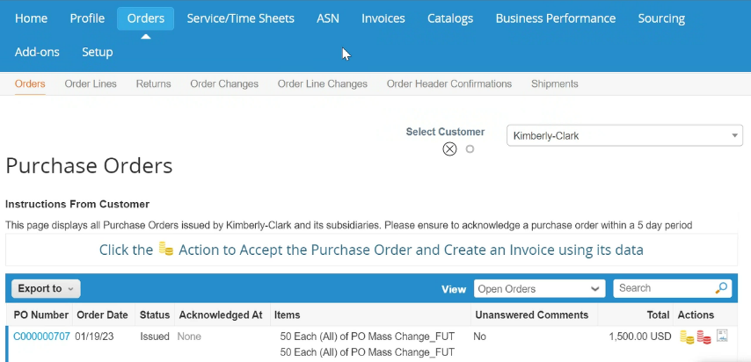

2

3

- Verify the following information on the PO as correct:
  - Company Code Plant
  - Ship-To Address
- Select the Acknowledged checkbox to acknowledge receiving the purchase order.
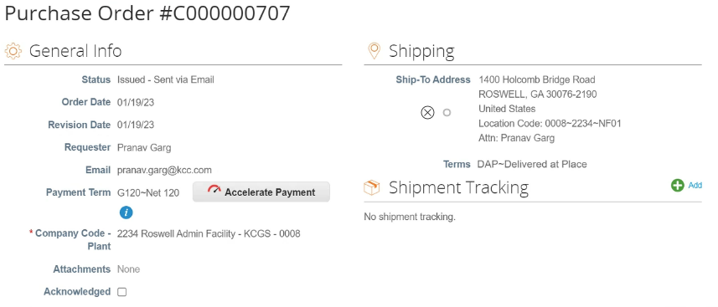

4b

4a

5

- Scroll to the end of the Lines section and click the Save button.
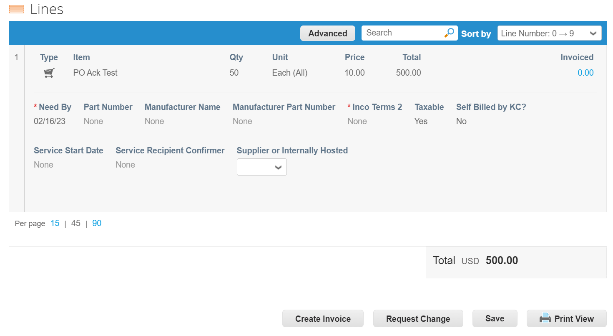

6

- You will receive an Order acknowledged notification.
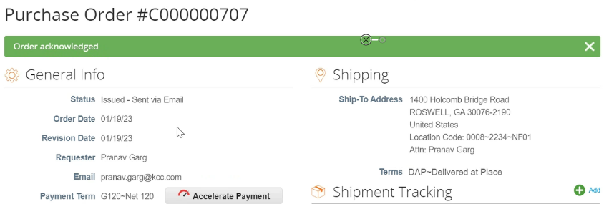

7

Additional Resources
  - How to Navigate Coupa Supplier Portal – (QRC)
  - How to Submit Vendor Acknowledgement of PO in CSP – (BSL)

