

Powering K-C’s digital future



How to Submit Help Tickets

STP Knowledge Center

Table of Contents

Key Terminology 1

Purpose 2

How to create a ticket with Procuree virtual assistant 2

How to get your issues resolved with STP Knowledge Center 4

Change Version 5

## Key Terminology

|  |  |
| --- | --- |
| **Term** | **Definition** |
| Coupa | Global procurement software that will enable K-C to submit requests for goods and services, source, contract, and manage our suppliers. |
| CSP | Coupa Supplier Portal |
| Procuree | Source to Pay virtual assistant name |
| STP | Source to Pay |
| STP Knowledge Center | Source to Pay team receiving and resolving queries raised in Procuree from supplier and K-C internal users |
| Ticket number | Technical name used to handle users request and queries. Each question creates a ticket number so that requests are not lost and can be processed with all related information. |

## Purpose

|  |
| --- |
| Are you experiencing an issue in our Source to Pay process? Do you need support with Coupa? In this Quick Reference Card (QRC) you will find the steps to raise questions to our Source to Pay virtual assistant via Coupa Supplier Portal and Taulia Supplier Portal.  Our virtual assistant, Procuree, offers guidance around-the-clock, immediately responding to your inquiries with relevant guidelines, references, or data from our systems when applicable.  If further support is needed, Procuree can raise a ticket on your behalf with the STP Knowledge Center to assist with your inquiries  In an effort to reinforce Coupa Supplier Portal and self-service, we strongly recommend you to take advantage of the wealth of Coupa training materials and resources available to you. If you cannot find the solution to your issue, raise a ticket with Procuree to the STP Knowledge Center.  We recommend following the below tasks to learn how to solve your inquiries:   * How to create a ticket with Procuree virtual assistant * Get your issue resolved with STP Knowledge Center |

## How to create a ticket with Procuree virtual assistant

1. There are three ways to find and create a ticket with Procuree – a) Coupa Supplier Portal, b) Taulia Supplier Portal or c) Supplier Link
   1. Go to Coupa Supplier Portal, you will find the link for Procuree in the Announcements log to list out and find link to Procuree.

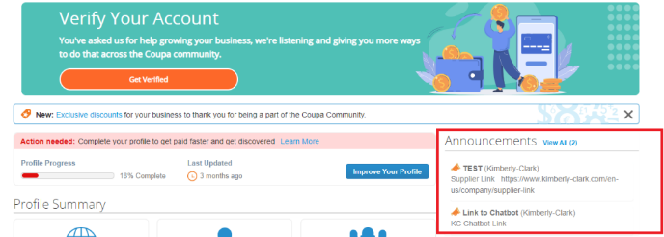

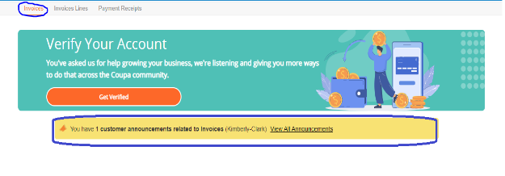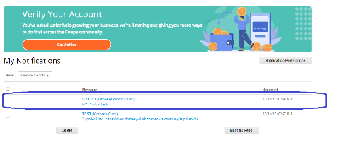

Coupa Supplier Portal: Find Procuree

* 1. Go to Taulia Supplier Portal, press Home tab and click on Customer Announcements to list out and find link to Procuree.

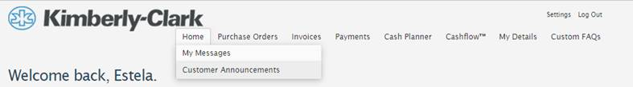

Taulia Supplier Portal: Find Procuree

* 1. Go to Supplier Link and find at the botton the icon for Procuree.

1. All three ways will lead you to [Supplier Link](https://www.kimberly-clark.com/en-us/company/supplier-link/procure-to-pay) webpage where you will find Procuree’s icon to start a conversation.

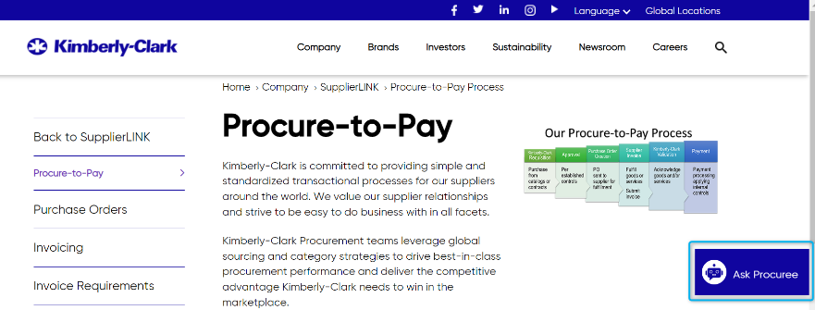

1. After clicking on the Procuree link, you will be welcomed and asked to enter the following details for authentication:
   * E-mail address field: Insert your company e-mail address
   * Name: Insert your full name
   * Click on the “Submit” button to proceed.

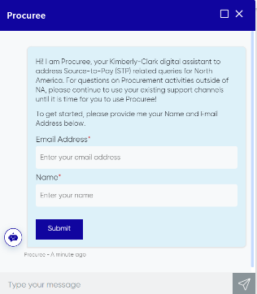

1. Next, you can ask your question to Procuree
   * Type your message and click on the **Send** icon (or press the enter key to send)

**OR**

* Select a default option that best matches your issue
* Wait for a few seconds to get a reply from the virtual support agent.

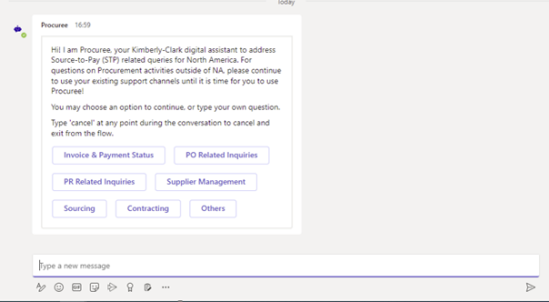

|  |  |
| --- | --- |
|  | During a support chat, at any time, you can leave the chat by typing “Cancel” in the chat box or type “Menu” to go back to Main Menu. |

1. If you are facing any challenges or need further assistance, you can click on **Others** and select **Create a Ticket**

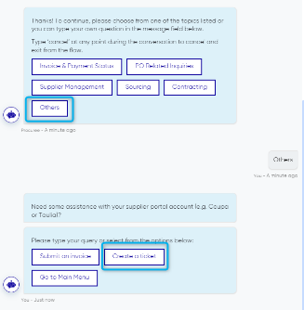

1. Procuree will ask you to provide more details in the Create Ticket screen

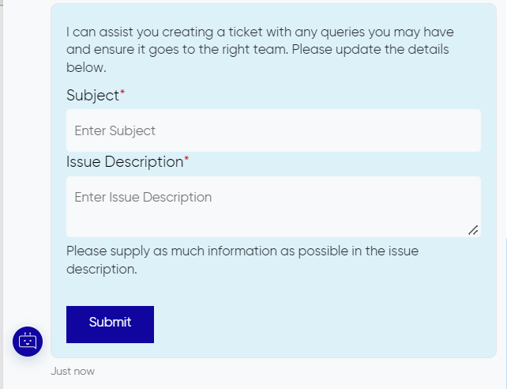

1. Add details and then press send to submit the ticket to STP Knowledge Center
2. Your case number will be shared in the chat window to confirm creation of your ticket.

|  |  |
| --- | --- |
|  | **Note:** After submitting the ticket, please expect to receive immediate notification with the Case Number and details. A STP agent will get in touch with you when needed and provide complete case resolution confirmation via e-mail. |

## How to get your issues resolved with STP Knowledge Center

Procuree hands your case number off to our STP Knowledge Center team, which assigns the ticket to a live agent to resolve your query in the next **48 working hours from the moment the ticket number was created in Procuree.**

* STP agent reviews your profile, nature of your request, category, and STP workstream related. STP agent reviews if your request is business critical. If so, your ticket priority is adjusted to a shorter resolution time.
* When additional information is needed from you, the STP agent will contact you via e-mail. Please provide information via e-mail keeping subject and content as it comes.

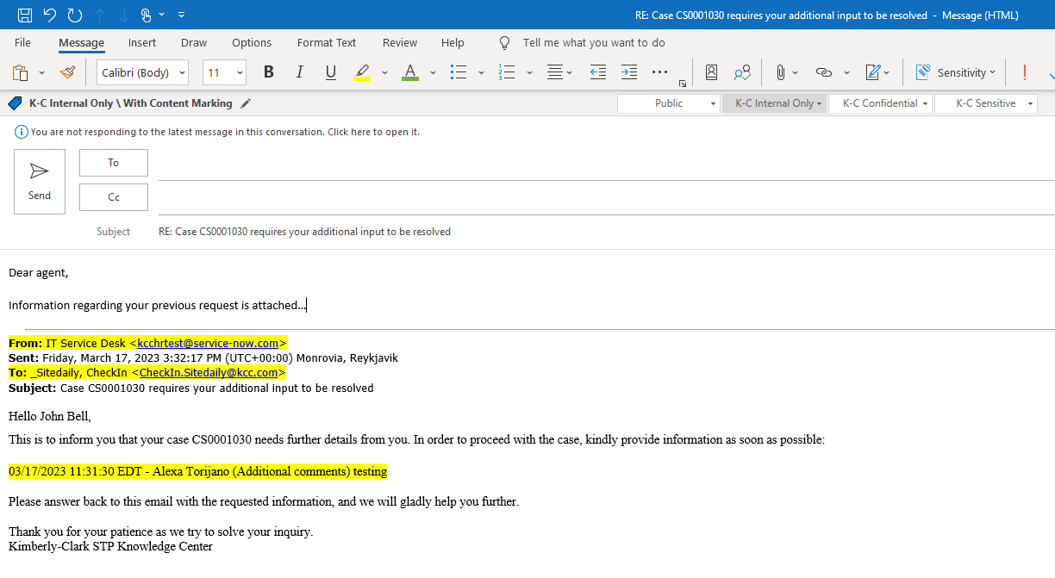

* The proposed solution to your ticket is provided via email. If you feel comfortable with the proposal you can accept or reject from e-mail and the agent will get in touch to improve the service response.

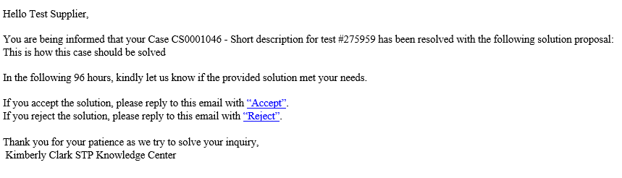

|  |  |
| --- | --- |
|  | **Note:** To address new issues, it is necessary to create new ticket number via Procuree, otherwise your request will be rejected. Please expect a satisfaction survey from the STP Knowledge Center team. Your feedback is very important to K-C. |

## Change Version

|  |  |  |  |
| --- | --- | --- | --- |
| Version History | | | |
| **Version** | **Date** | **Change Description** | **Author** |
| 0.1 | March 9th 2023 |  | Alexa Torijano |
| 0.2 | April 26th, 2023 |  | Alexa Torijano |
|  |  |  |  |