Powering K-C’s digital future
How to Sign
a Legal Agreement
Coupa

Table of Contents

Purpose 2
Key Terms 2
How to Sign a Legal Agreement 3
Change Version 7

For the best learning experience, please click the Editing button and select Open in Desktop to view this document in your desktop application of Microsoft Word. Viewing this document in SharePoint or in-browser may distort the placement of images and text.

Your screen in Coupa may differ slightly from this training, but the steps to complete the activity will be the same.
This icon indicates there are further policy or business process details relating to a step. Click on the provided link(s) placed throughout the QRC for more information.

Purpose
This Quick Reference Card (QRC) explains How to Sign a Legal Agreement. It is intended to support Legal and Legal Agreement Signatory in executing the following activities:
- Task 1: How to Sign a Legal Agreement

Key Terms
  - The Approval Chain is a series of stakeholders who must approve the contract record and linked legal agreement before it can be signed or published.
  - Contract Approver is a person who provides approval for some aspect on a Contract Record, which can include Spend Approval, Payment Term Exceptions, and other approvals as required.
  - The Contract Record Owner is a person who will receive notifications about contract record renewals and expirations.
  - The Contract Record Reviewer are people / teams that are added as ad hoc content reviewers for visibility or notes
  - The Counterparty is the supplier or other party on the legal agreement that K-C is negotiating the contract record with.
  - The Legal Team is a team that oversees review of legal agreement
  - The Signatories are people who sign the legal agreement based on its dollar amount or its equivalent in local currency, and other variables in DocuSign.
  - The Status tracks the progression of the contract record stages, which include the following: draft, approvals, and active status.
  - The Contract Record is used to store and maintain the contract record metadata and item details. The contract record is required to capture approvals in Coupa, and to also tie to transactional objects downstream (such as a PO).
  - The Legal Agreement is a legal document drafted and reviewed with the supplier. A legal agreement is not required to enable a contract record in Coupa for transactions.

How to Sign a Legal Agreement
- On the Coupa home screen, click the Contracts tab to view the Approved Contract Record.
  - Note: All legal agreement signatories will in succession receive an email from DocuSign with the request to provide a signature for the legal agreement.
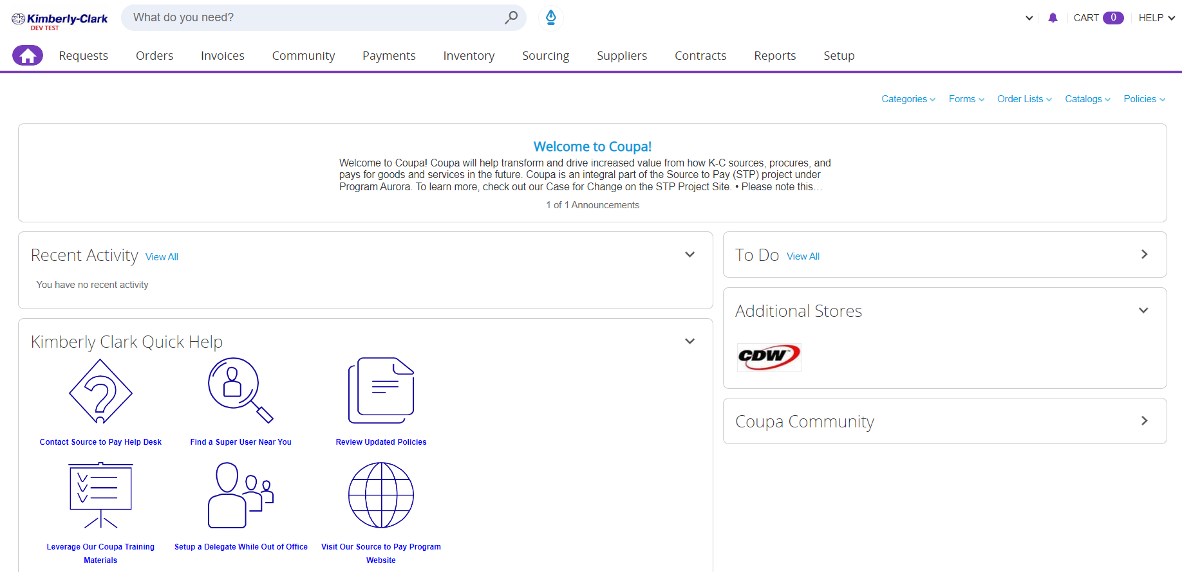

- Click on the link to view the Approved Contract Record. See the Status column to confirm which contract records are Approved.
  - Note: Please view the QRC on How to Approve or Reject Contract Records.
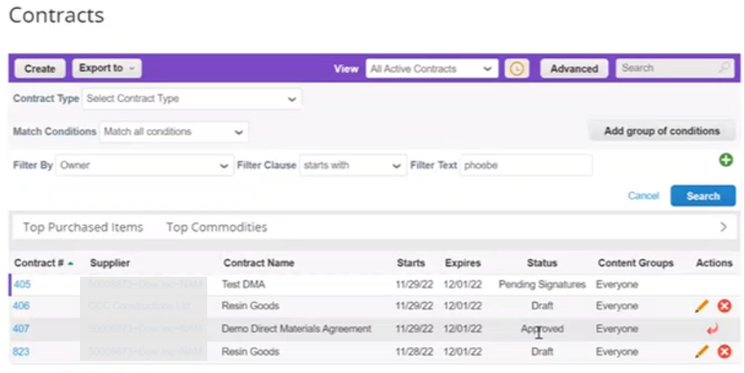

- After clicking on the Approved Contract Record link, click Review Signatures button, which will trigger the DocuSign for signatures.
Please view the K-C Policy on DOA
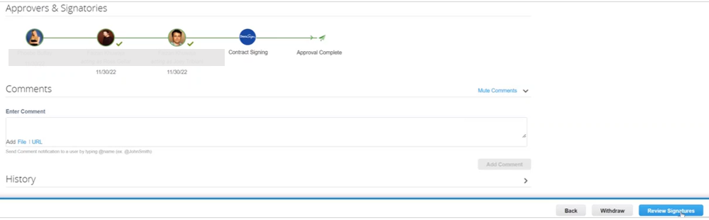

- A Review Signatures message pop-up screen will appear. Read the message and click Continue.
  - Note: All legal agreement signatories will have received an email from DocuSign with the direct DocuSign to start the signature process.
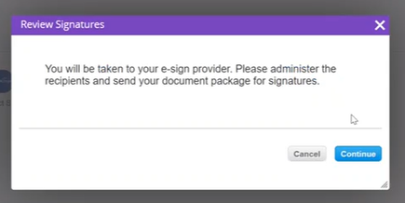

- Once you select Continue, a separate DocuSign window will appear. Click the Set signing order checkbox.
  - Note: For additional guidance on DocuSign please view the DocuSign QRC.
- To add additional recipients, click the Add Recipient drop-down menu.
- Add the recipient’s name(s) and email address(s) and select Needs to Sign.
  - Note: Please include all the legal agreement signatories information from both the Counterparty and K-C.
- Click Next.
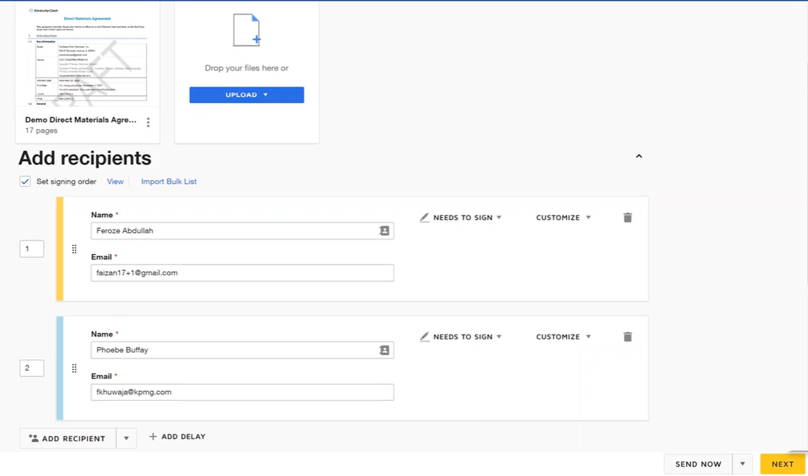

- After clicking Next, verify the details in the agreement. Add in signature, date, initial, or title boxes as needed on to the DocuSign agreement.
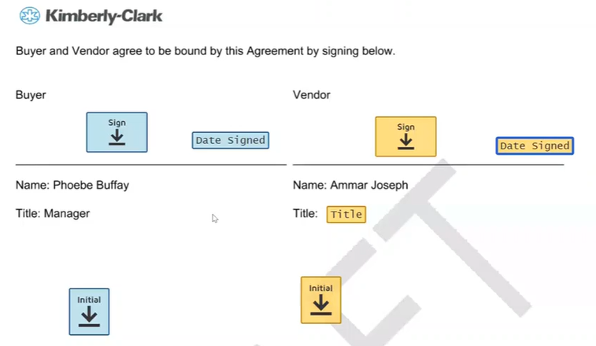

- Click Send once completed.
  - Note: Once the legal agreement is signed by all legal agreement signatories, DocuSign will send a signed copy of the legal agreement to all signatories via email.
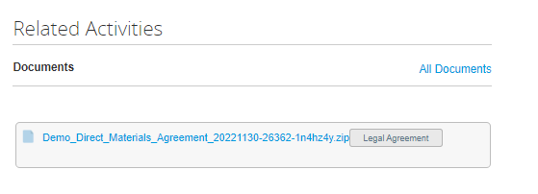
  - Note: Once the legal agreement is signed by all legal agreement signatories, the signed legal agreement can also be found under the Related Activities tab in the contract record.

Change Version
Version History
Version | Date | Change Description | Author
0.5 | 1/12/2023 | Original | Frederik Terheggen (KPMG)
1.0 | 1/17/2023 | Functional Feedback | Faizan Khuwaja (KPMG)
1.0 | 1/18/2023 | Functional Feedback Incorporated | Frederik Terheggen (KPMG)
2.0 | 1/27/2023 | Round 1 K-C Feedback Incorporated | Frederik Terheggen (KPMG)
3.0 | 2/1/2023 | Round 2 K-C Feedback Incorporated | Frederik Terheggen (KPMG)
4.0 | 2/22/2023 | Round 3 K-C Feedback Incorporated | Erin O’Rourke  (KPMG)

