Powering Kimberly-Clark’s digital future
How to Review and
Redline Legal Agreements for Suppliers
Coupa

Table of Contents

Purpose 2
Key Terms 2
How to Review and Redline Legal Agreements (Suppliers) 3
Change Version 5

For the best learning experience, please click the Editing button and select Open in Desktop to view this document in your desktop application of Microsoft Word. Viewing this document in SharePoint or in-browser may distort the placement of images and text.

Purpose
This Quick Reference Card (QRC) explains How to Review and Redline Legal Agreements for Suppliers. It is intended to support Suppliers in executing the following activities:
- Task 1: How to Review and Redline Legal Agreements

Key Terms
  - The Contract Reviewer are people / teams that are added as ad hoc content reviewers for visibility or notes
  - The Contract Owner is a person who creates the contract record, drafts the legal agreement, and drives the contracting process. Also, will receive notifications about contract record renewals and expirations. The Contract Owner can be changed during or after the contracting process
  - The Legal Agreement is a legal document drafted and reviewed with the supplier. A legal agreement is not required to enable a contract record in Coupa for transactions.

How to Review and Redline Legal Agreements for Suppliers
- After internal Kimberly-Clark Review, the Legal Agreement will be sent to the supplier.
- The supplier will receive an email with the link to start the review of the legal agreement. Click on Open Contract to start the review of the legal agreement.
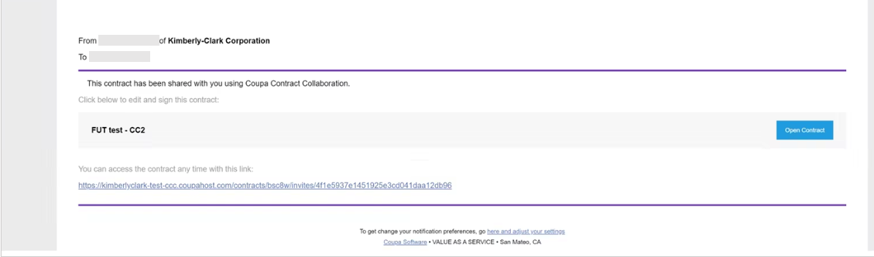

- On the Agreement screen, click the Edit Document drop-down menu and select Edit Document.
  - Note: When selecting the Edit Document button, click the Download for Edit option to download the file onto your local computer in a Word Document to make edits.
  - Note: During review, the Word file name should not be changed.
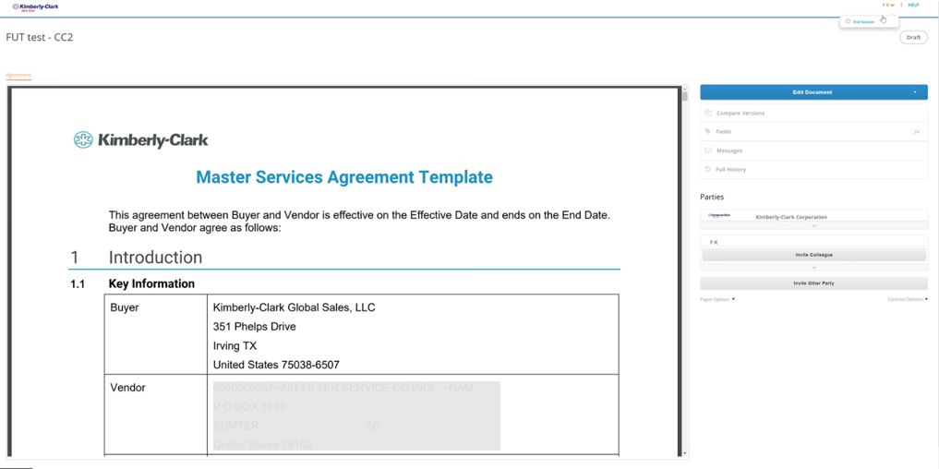

- Open the downloaded Legal Agreement Word document and make edits as needed in Microsoft Word.
  - When you have completed the redlines and review, save the Legal Agreement on your local computer. Ensure that tracked changes is and remains enabled in the Word document when reviewing and redlining.
  - Note: During review, the Word file name should not be changed.
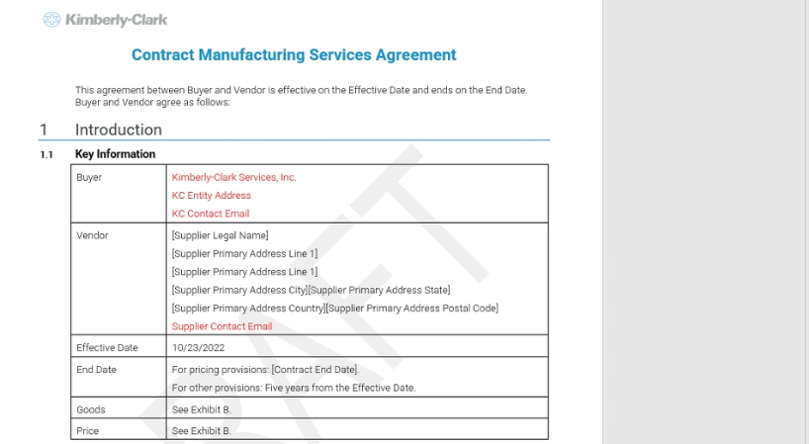
- Return to the Legal Agreement screen, click the Upload button to upload your revised agreement.
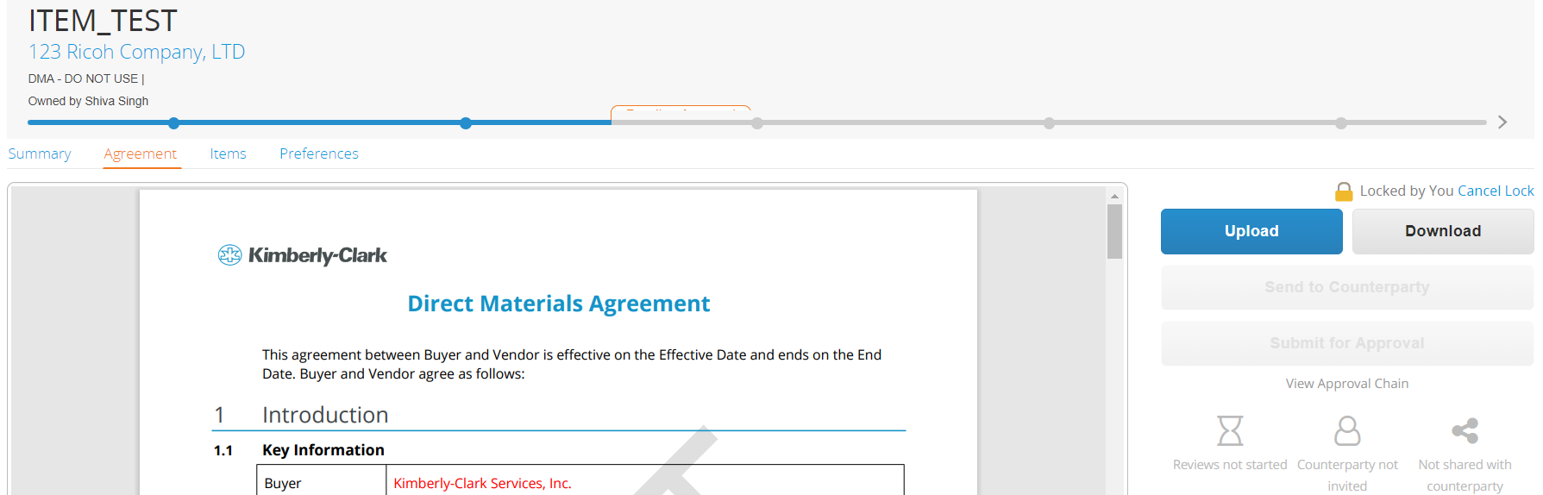

- A Document Upload pop-up screen will appear, click the Upload my changes to upload the revised Legal Agreement.
  - Note: The new version of the agreement will be available and previous version can be seen in Coupa.
- Click Send to Counterparty button to submit.
- After the new version of the legal agreement is uploaded, it will remain with the Contract Owner until another review is triggered.

Change Version
Version History
Version | Date | Change Description | Author
0.5 | 1/30/2023 | Original | Frederik Terheggen (KPMG)
0.5 | 2/6/2023 | Functional Feedback Incorporated | Faizan Khuwaja  (KPMG)
1.0 | 3/3/2023 | Round 1 K-C Feedback Incorporated | Frederik Terheggen (KPMG)
2.0 | 3/9/2023 | Round 2 K-C Feedback Incorporated | Frederik Terheggen (KPMG)
3.0 | 3/16/2023 | Round 3 K-C Feedback Incorporated | Frederik Terheggen (KPMG)

