Powering K-C’s digital future
How to Respond to Risk Action Plans for Suppliers

For the best learning experience, please click the Editing button and select Open in Desktop to view this document in your desktop application of Microsoft Word. Viewing this document in SharePoint or in-browser may distort the placement of images and text.

Table of Contents

Purpose 1
Key Terms 2
Responding to an Action Plan 3
Additional Resources 6
Change Version 6

Your screen in the Coupa System may differ slightly from this training, but the steps to complete the activity will be the same.

This icon indicates there are further policy or business process details relating to a step. Click on the provided link(s) placed throughout the QRC for more information.

Purpose
This Quick Reference Card (QRC) explains the processes for how to create, respond to, and track risk action plans in Coupa Risk Assess.
- Task 1: Respond to an Action Plan

Key Terms
  - The Approver is the individual who will approve the action plan.
  - The Action Item is specific item being tracked within the action plan.
  - The Action Item Description provides more detailed information regarding the action item.
  - Action Required/Request is the action which the recipient of the action plan needs to take.
  - Action Taken/Response is the field completed by the supplier or internal Kimberly-Clark user based on the action plan’s outcome.
  - Coupa Risk Assess (CRA) is a system that connects all parties involved in third-party risk management to collaborate on reducing the cost of compliance, minimizing risk and maximizing the value of their relationships.
  - Action plans are created in CRA to communicate and document issues that require remediation by an internal Kimberly-Clark user or a supplier within a given timeframe.
  - A Risk Action Plan informs which risk domain the action plan is regarding, the Supplier’s name, and their relationship name.
  - Risk Domains are categories or focus areas that help to guide third-party risk management. Risk domains are used to scope or frame types of controls that should be evaluated during a vendor risk assessment.
  - Risk Management is the continuing process of identifying, analyzing, mitigating and monitoring risk to avoid supply disruptions and financial loss to both Kimberly-Clark and our Supply Chain.

Responding to an Action Plan
When an Action Plan is assigned, the supplier will receive an email with the subject line, Action Plan Item Submitted for (Supplier name). The email will contain a link to respond to the Action Plan.
- Click on the link in the email.
  - Suppliers can also access additional training resources if additional assistance is needed to complete the task.

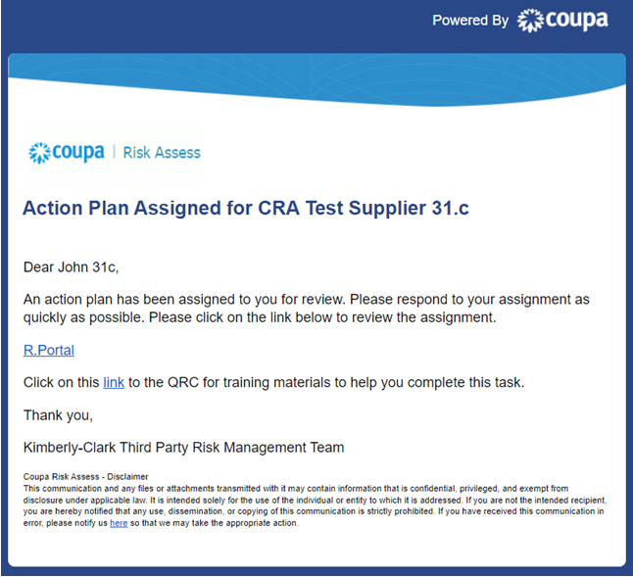

1
1a

- Login to Coupa.
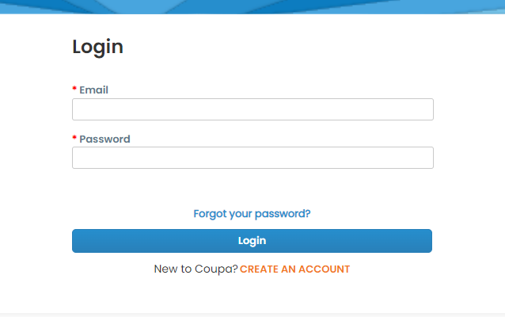
2

The Coupa Risk Assess Dashboard appears.
- Locate the Action Plans tile and click the Show Me All link.
  - If there are multiple action plans, locate the specific plan that needs addressing via the Status column – In Process.
- From the displayed list of Action Plans, find the name of the desired pending plan and click the View button next to it.
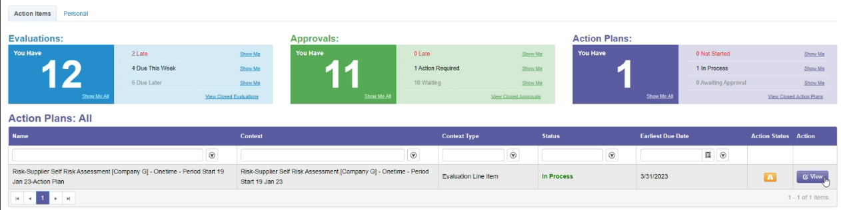
3

4
3a

- Review the Action Plan for the following relevant information:
  - Action Item Description
  - Action Required/Request (this indicates the action to be taken/responded to by the Supplier)
  - Priority
  - Due Date
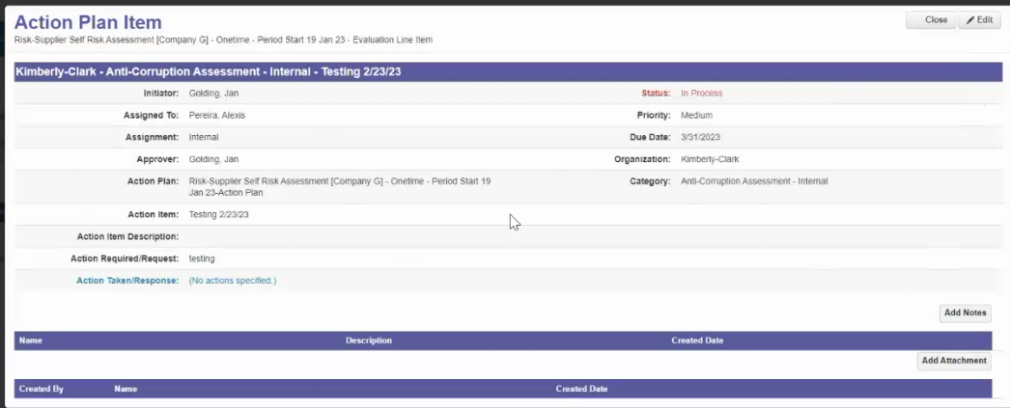
5

Note: If the Action Plan needs to be completed by another individual in the organization, the plan can be delegated to that individual.

*IMPORTANT: Delegating an Action Plan can only be done if the related due diligence questionnaire (e.g., Anti-Corruption Assessment, Cybersecurity Assessment, etc.) has been previously delegated to that desired individual.

To delegate the Action Plan, perform the following:
  - Click the Edit button.
5a

  - Locate the Assigned To field and change the existing individual to the desired individual.
  - Click the Save button.
5c
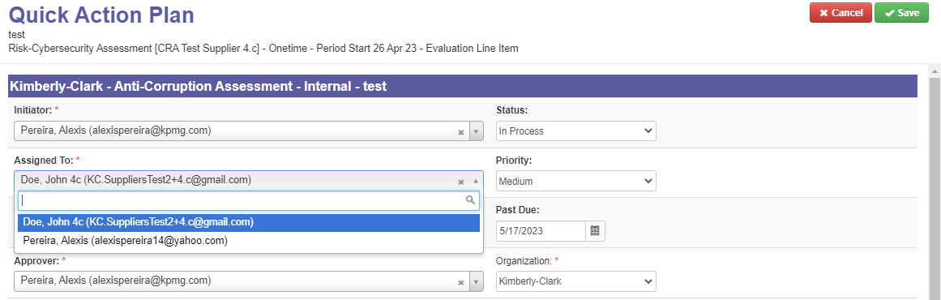

5b

Note: The action plan will be routed via CRA to the selected individual for their completion.

Whether delegation is needed or not, continue with the following steps to respond to the Action Plan.
- Click the Add Attachment button to upload any requested and/or supporting documentation to the plan.

3a

7

- Click the Add Notes button to record the actions taken.
- Click the Save button when finished.
- After recording the actions, the Action Plan is ready to be sent to the approver. Click the Edit button to access the Quick Action Plan menu.

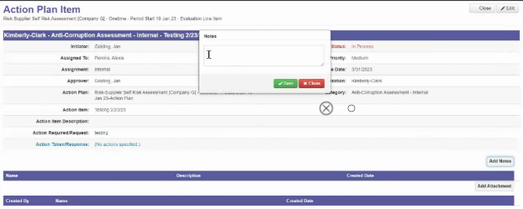
9

8

7

- Click on the Status dropdown menu and select Completed.
- Click Save when finished.
11
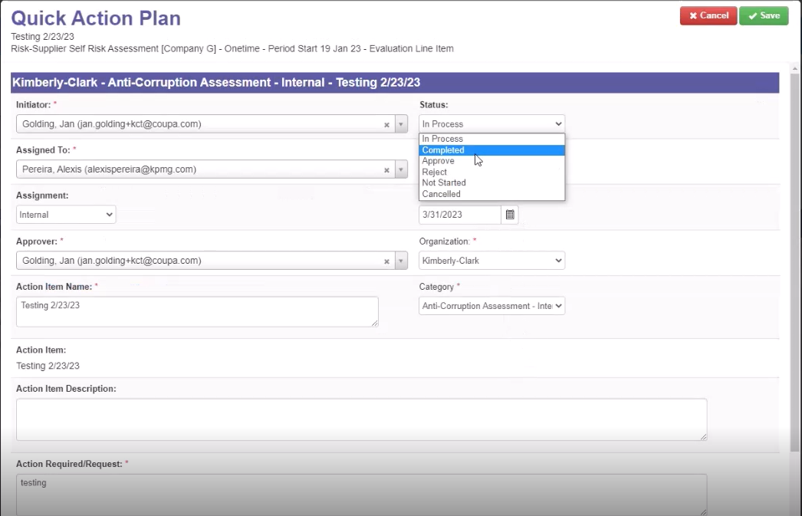

10

The view returns to the Action Plan Item screen.
- Click the Close button.
13

Note: The Action Plan will route to a Kimberly-Clark approver via CRA. The supplier receives an email notification when their action plan regarding the status of their plan (e.g., approved or rejected [for more information]).

If more information is required, the supplier will be redirected to the Action Plan via link embedded in the email to address and resubmit their Action Plan.

Additional Resources
N/A

