

Powering K-C’s digital future



How to Onboard as a Supplier in Coupa (for Suppliers)

*For the best learning experience, please click the* ***Editing*** *button and select* ***Open in Desktop*** *to view this document in your desktop application of Microsoft Word. Viewing this document in SharePoint or in-browser may distort the placement of images and text.*

Purpose 1

Key Terms 2

Supplier Onboarding 3

Setting Up a New Supplier Profile to Kimberly-Clark on Coupa 3

Updating an Existing Supplier Profile via Kimberly-Clark Information Forms 10

Completing a Financial and Legal Assessment 16

Delegating a Financial and Legal Assessment 18

Updating Supplier Profile for General Information 21

Additional Resources 25

|  |  |
| --- | --- |
| Warning outline | **Your screen in the Coupa Supply Portal (CSP) may differ slightly from this training, but the steps to complete the activity will be the same.** |

|  |  |
| --- | --- |
|  | **This icon indicates there are further policy or business process details relating to a step. Click on the provided link(s) placed throughout the QRC for more information.** |

## Purpose

This Quick Reference Card (QRC) explains the processes for suppliers to onboard to Kimberly-Clark Coupa.

|  |  |
| --- | --- |
|  | **Note:** SomeKimberly-Clark suppliers are already set up in the Coupa Supplier Portal to transact with their other customers. These suppliers should complete the **Setting Up as an Existing Supplier Profile** (e.g., Task 2) portion of the set-up process.  For those suppliers who do not currently transact with their customers via the Coupa Supplier Portal, they should follow the **Setting Up a New Supplier Profile** (e.g., Task 1) set-up process first, then continue to Task 2 to complete their setup via Kimberly-Clark Information forms. |

* **Task 1:** Setting Up a New Supplier Profile in Coupa Supplier Portal to Kimberly-Clark Coupa
* **Task 2:** Setting Up as an Existing Supplier in Coupa Supplier Portal to Kimberly-Clark Coupa via Kimberly-Clark Information Forms
* **Task 3:** Completing a Financial and Legal Assessment
* **Task 4:** Updating a Supplier Profile for General Information

## Key Terms

* + **New Supplier Request Form** is a form that initiates the supplier onboarding process and is submitted by a Requester. The submission of the New Supplier Request Form will initiate the Supplier External Update Form.
  + **Supplier External Update Form** is a form submitted by the supplier to either update their existing information in the Coupa Supplier Portal or to provide their information for the first time as part of the supplier onboarding process.
  1. In addition to this form, some suppliers may be required to complete a Financial and Legal Assessment questionnaire. This questionnaire may be a part of the onboarding process for some suppliers and must be completed, and any applicable issues addressed, in order for the Supplier External Update Form to be approved.
  2. Once this form has been approved, the supplier record information will integrate to other systems for set up. After that set up is complete, transactions can be conducted between Kimberly-Clark and the supplier.
  + **Coupa Supplier Portal (CSP)** is a web portal to assist suppliers in managing their transactions with Kimberly-Clark.
  + **External Financial and Legal Assessment** is an external questionnaire that is part of the onboarding process designed to determine a suppliers’ financial and legal health. This questionnaire is triggered for select suppliers that meet criteria.

## Supplier Onboarding

### Setting Up a New Supplier Profile to Kimberly-Clark on Coupa

|  |  |
| --- | --- |
|  | **Note:** Kimberly-Clark onboards suppliers through the Coupa system. Suppliers will receive an invitation with specific instructions on how to access the Coupa Supplier Portal and open an account. |

Please perform the following steps to begin the New Supplier Onboarding process.

1. Suppliers will be sent an email invitation from the **Coupa Supplier Portal** (**do_not_reply@supplier.coupahost.com)** with the subject line, **You are Connected to Kimberly-Clark on Coupa.**
2. Click the **Login to Coupa** button from the invitation email.

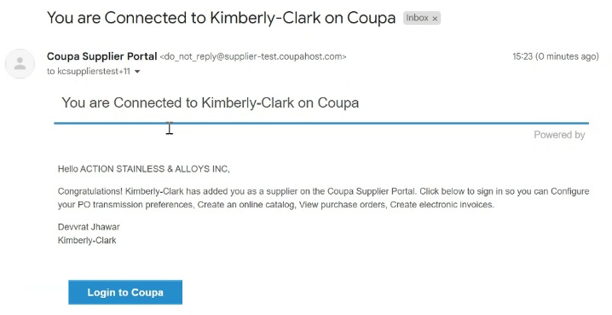

**1**

**2**

**2**

1. Enter the following information for the following fields (required fields are indicated by a red asterisk *):
   * **Business Name**
   * **Email address**
   * **First Name**
   * **Last Name**
   * **Password** (alphanumeric, minimum 8 characters)
2. Select the **Privacy Policy and the Terms of Use** checkbox (this is a requirement).
3. Click the **Create an Account** button when complete.

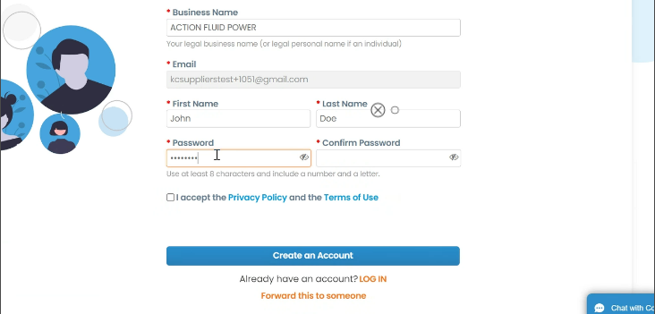

**3**

**4**

**5**

|  |  |
| --- | --- |
|  | **Note:** The legal terms of use list the terms and conditions for using e-invoicing through Coupa and the CSP. As a supplier, especially if responsible for managing legal tax invoices; please read, assess, and agree to these terms of use as an acknowledgement of any responsibilities towards the content and handling of these invoices. |

1. The **Tell us about your business screen** appears.
2. Enter the following information about your business for the following fields (required fields are indicated by a red asterisk *):
   * **Company Name**
   * **Country/Region**
   * **Address**
   * **City**
   * **State**
   * **Postal code**
3. Select the **Invoice-from location** checkbox to set the address as the invoice address.

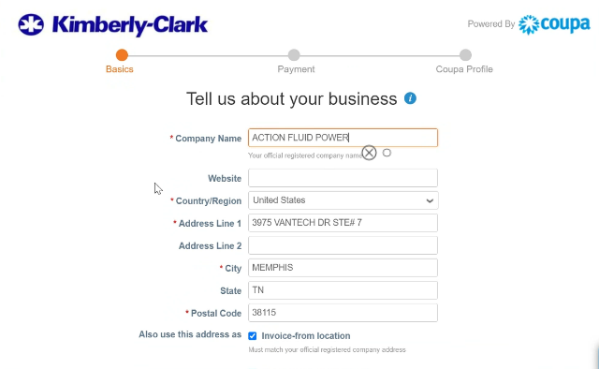

**8**

**7**

**6**

1. Deselect the **Pay to location (Remit-To)** checkbox to not receive payment for invoices at the address on this screen.
2. Deselect the **Ship from location** checkbox if the ship-from address is different from the invoice-from address or if there is more than one location.
3. Select the **We support integration for invoicing** checkbox if using cXML or SFTP transactions to send and receive between the supplier’s system and Kimberly-Clark Coupa.
4. Select the tax country/region from the **Tax Country/Region** drop-down list.
   * Enter your **Tax ID** information (Select the **I don’t have a Tax ID Number** checkbox if not applicable).
5. Click the **Next** button.

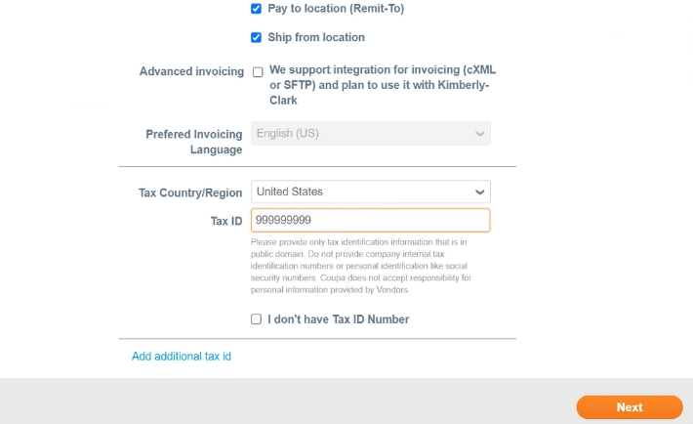

**9**

**10**

**11**

**12**

**13**

1. The **Payment Discount Preferences** screen appears. **Do not** select nor provide any information on this screen.

|  |  |
| --- | --- |
|  | **Note:** Payment terms and preferences are outlined in accordance with the contractual agreements between the supplier and Kimberly-Clark. Payment term values entered here are nonbinding and will not be applicable to transactions with Kimberly-Clark. |

1. Click the **Next** button.

**14**

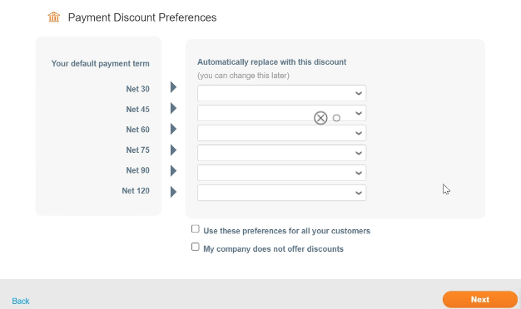

**15**

1. The **Enhance your Coupa profile** screen appears. At this time, **do not provide any enhancements to your Coupa profile.**

* After onboarding is complete, if desired, suppliers can return to the CSP and enhance their profile.

1. Click the **Do it later** button.

|  |  |
| --- | --- |
|  | **Note:** Enhancing a supplier Coupa profile is optional and is not germane to the Kimberly-Clark registration process. |

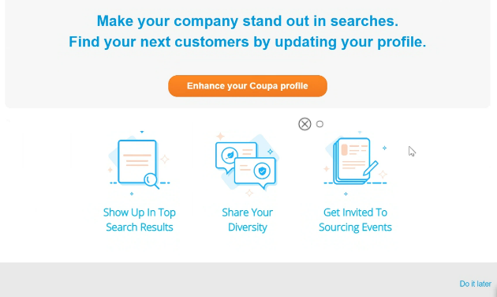

**16**

**17**

1. The **CSP Home** screen will appear.

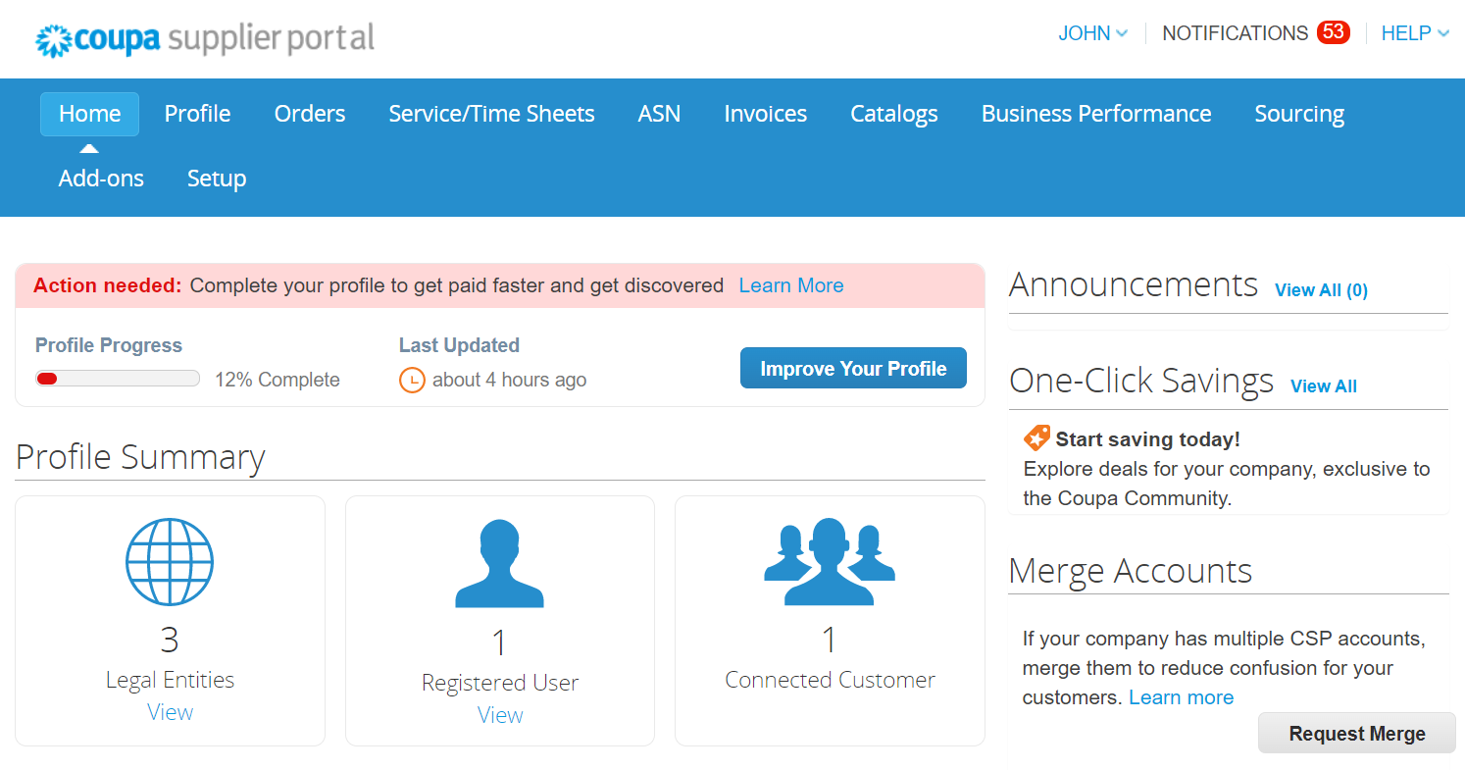

**18**

|  |  |
| --- | --- |
|  | **Note:** The CSP account is based on a specific email address. Using a different email address from the one that Kimberly-Clark has on file will impact the ability to connect with Kimberly-Clark. Please ensure that the email addresses match accordingly. |

Congratulations!

The profile in the Coupa Supplier Portal is setup.

Next, continue to the next section: **Updating an Existing Supplier Profile via Kimberly-Clark Information Forms** to complete the onboarding process.

### Updating an Existing Supplier Profile via Kimberly-Clark Information Forms

Suppliers who already transact with other customers via Coupa Supplier Portal will need to setup their existing CSP profile with Kimberly-Clark via the Supplier External Update form.

Please perform the following steps to setup transacting with Kimberly-Clark.

|  |  |
| --- | --- |
|  | **Note:** It is important that suppliers complete the form to be setup and transact with Kimberly-Clark.  Coupa is the system for Kimberly-Clark to manage supplier information for all suppliers, even in the case for suppliers receiving purchase orders from a different system (e.g., Taulia). |

1. Suppliers will be sent an email invitation from the **Coupa Supplier Portal** (**do_not_reply@supplier.coupahost.com)** with the subject line, **Kimberly-Clark Profile Information Request – Action Required.**
2. Click the **Join and Respond** button from the invitation email.

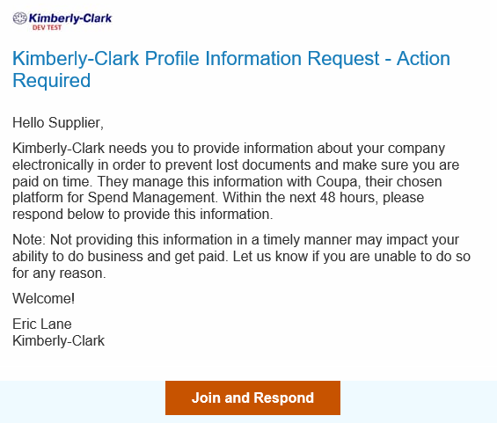

**1**

**2**

1. The **Coupa Supplier Portal login** screen appears, enter the login credentials for CSP.

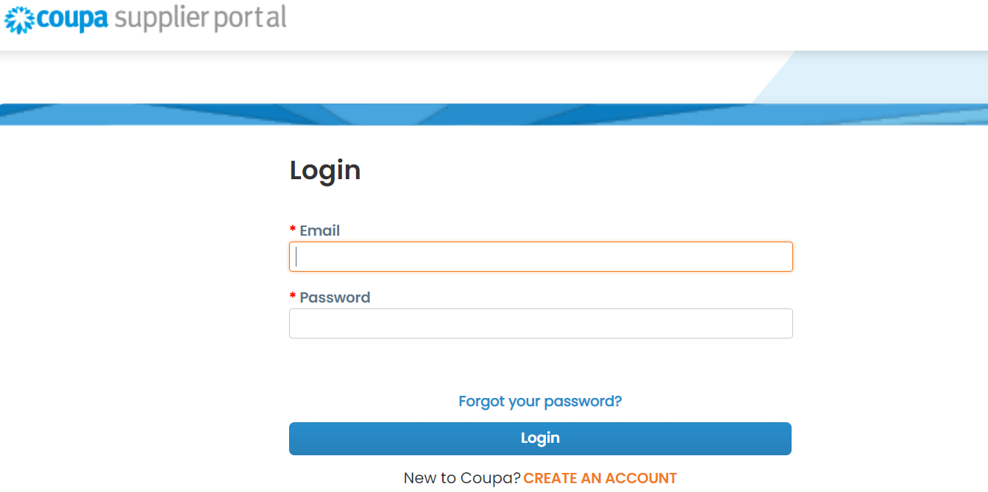

**3**

1. From the **Coupa Supplier Portal home** screen, click the **Profile** tab.

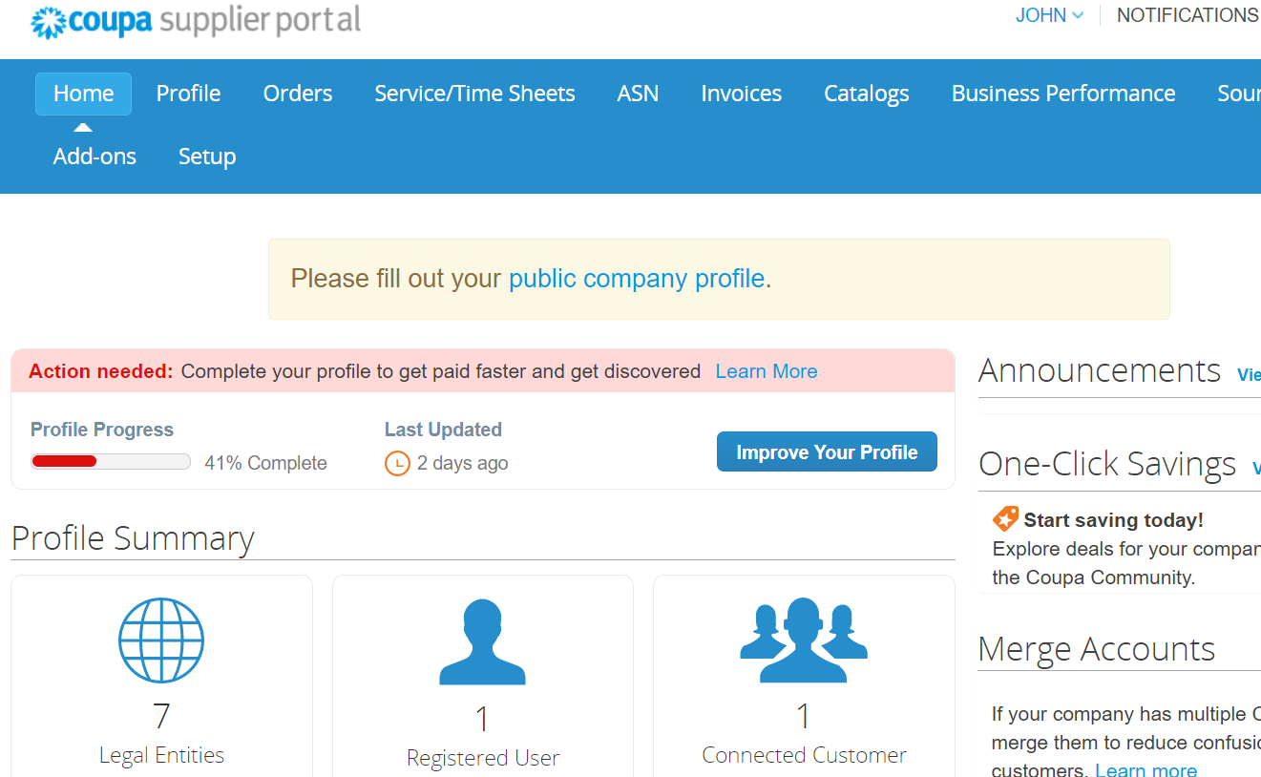

**4**

1. Click the **Information Requests** subtab.

The **Supplier External Update** form will load.

* + Some fields will auto-fill from prior information from the public profile. Please update any information that may have changed in the *required fields.

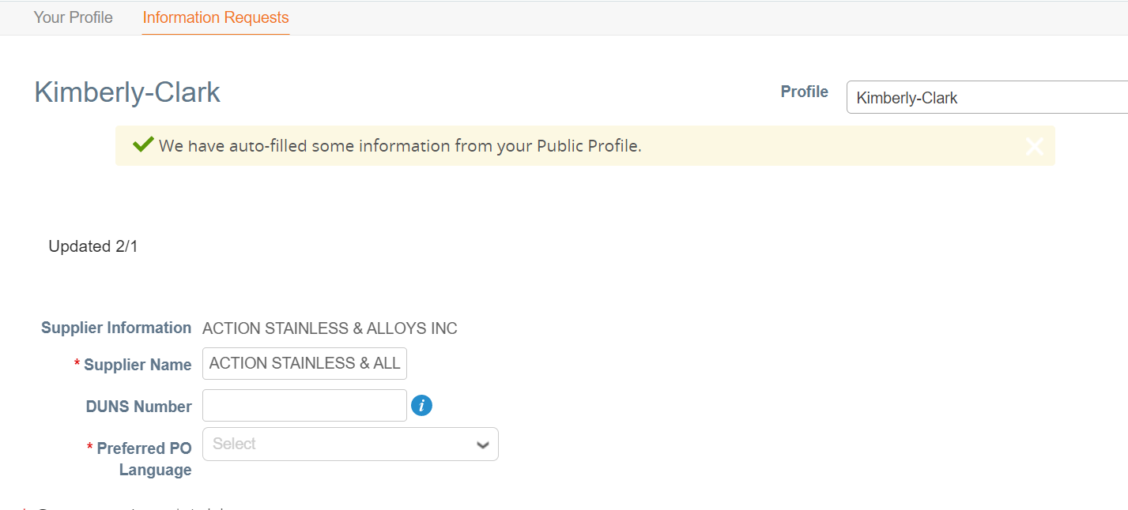

**5**

Review the following sections to ensure the accuracy of auto-filled information or fields that require information to be entered:

* + **Tax Registrations**
  + **Remit-To /Bank Details**
  + **Documentation**
  + **Additional Supplier Contacts**

1. Click the **Add Tax Registration** button to enter **Tax Registration** information (as applicable).
2. Select the radio button option **Yes or No** for the **Do you need to add a Remit To/Bank Details?** question to add or update banking information.

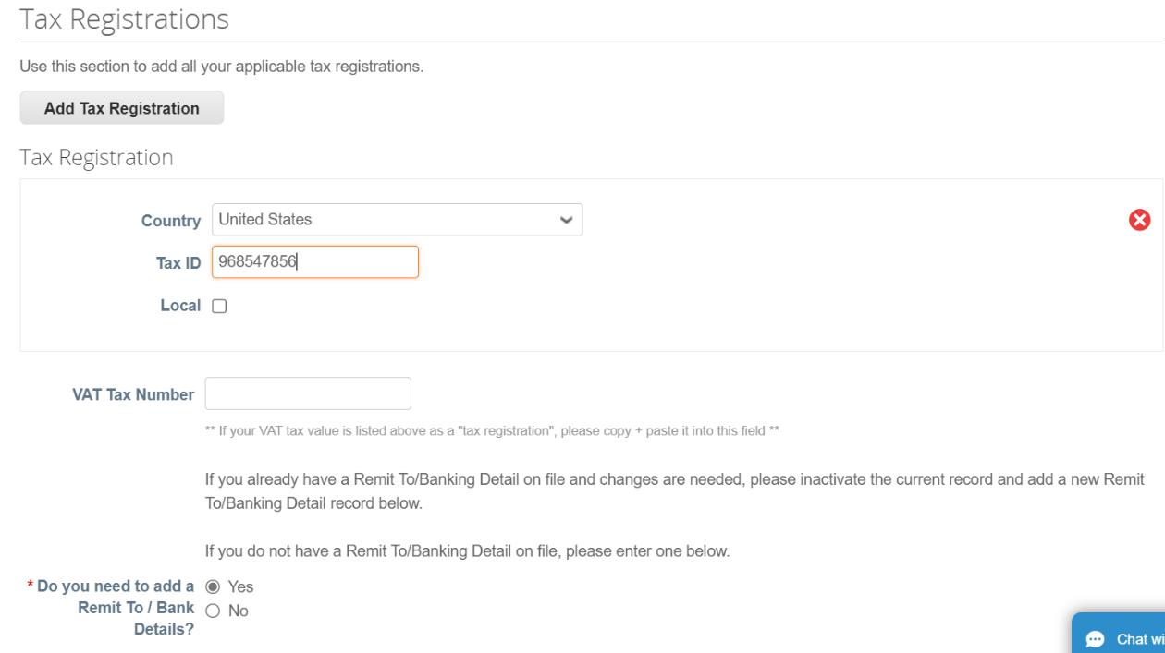

**6**

**7**

1. Click the **Add Remit To** button to add or update banking information.

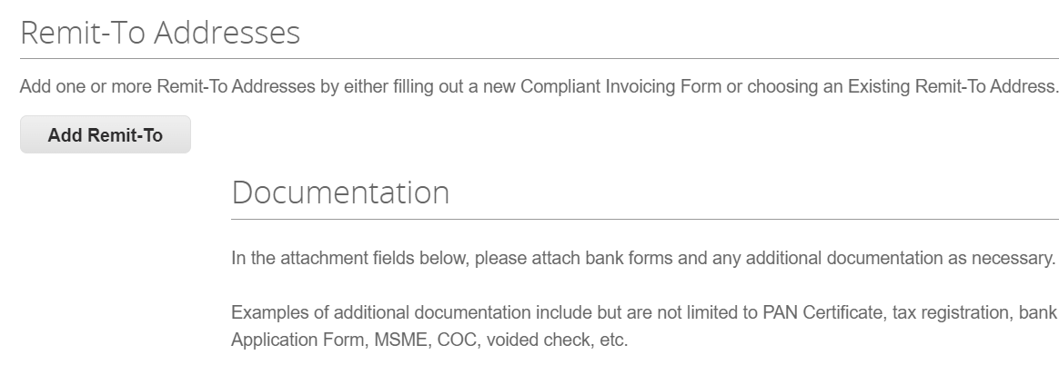

**8**

The **Choose Remit-To Address** screen appears.

1. Click the **Choose** button to add existing banking information.
2. Click the **Create New Remit-To Address** button to add new banking information.

|  |  |
| --- | --- |
|  | **Note:**  Kimberly-Clark requires suppliers to choose a Remit-To Address that includes payment information. |

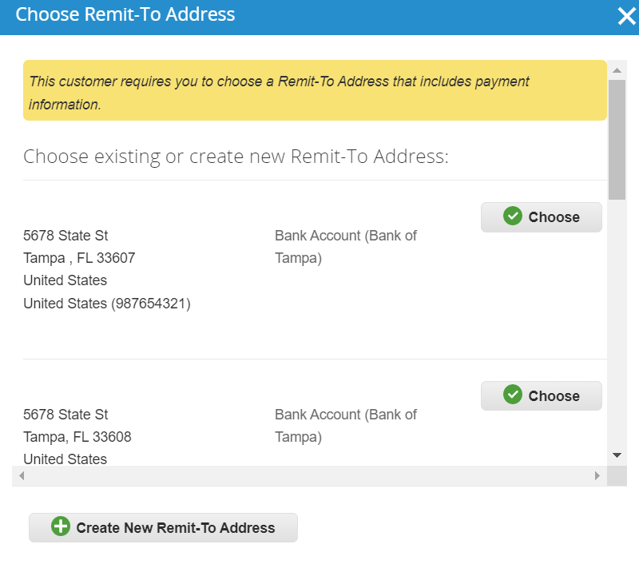

**9**

**10aa**

1. In the **Documentation** section, upload any relevant banking and tax documents using the **Attachments Add File** link.

* Banking attachments (e.g., bank forms, voided checks, etc.)
* Tax information attachments (e.g., Permanent Account Number (PAN) Certificates, tax registration, W8/W9 tax forms, etc.)
* Other supporting attachment information (e.g., Ministry of Micro, Small & Medium Enterprises (MSME) certification, Certificate of Conformance (COC), or vendor application form).

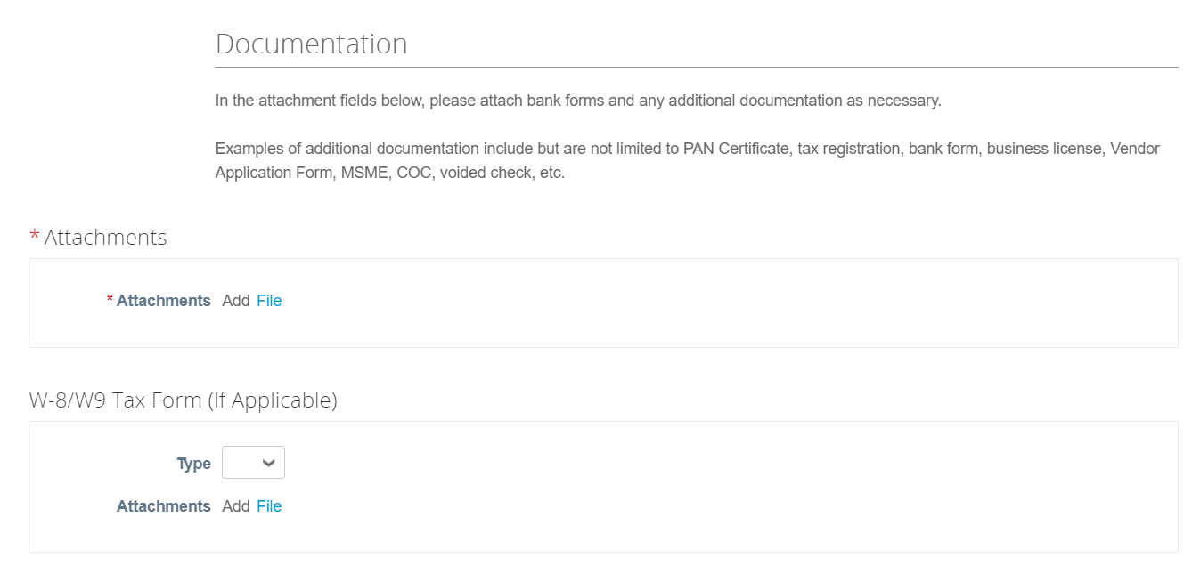

**11**

1. In the **Additional Supplier Contacts** section, provide a **Product Safety and Mfg. Quality** point of contact.
2. Verify the **PO Email address** entered is correct.

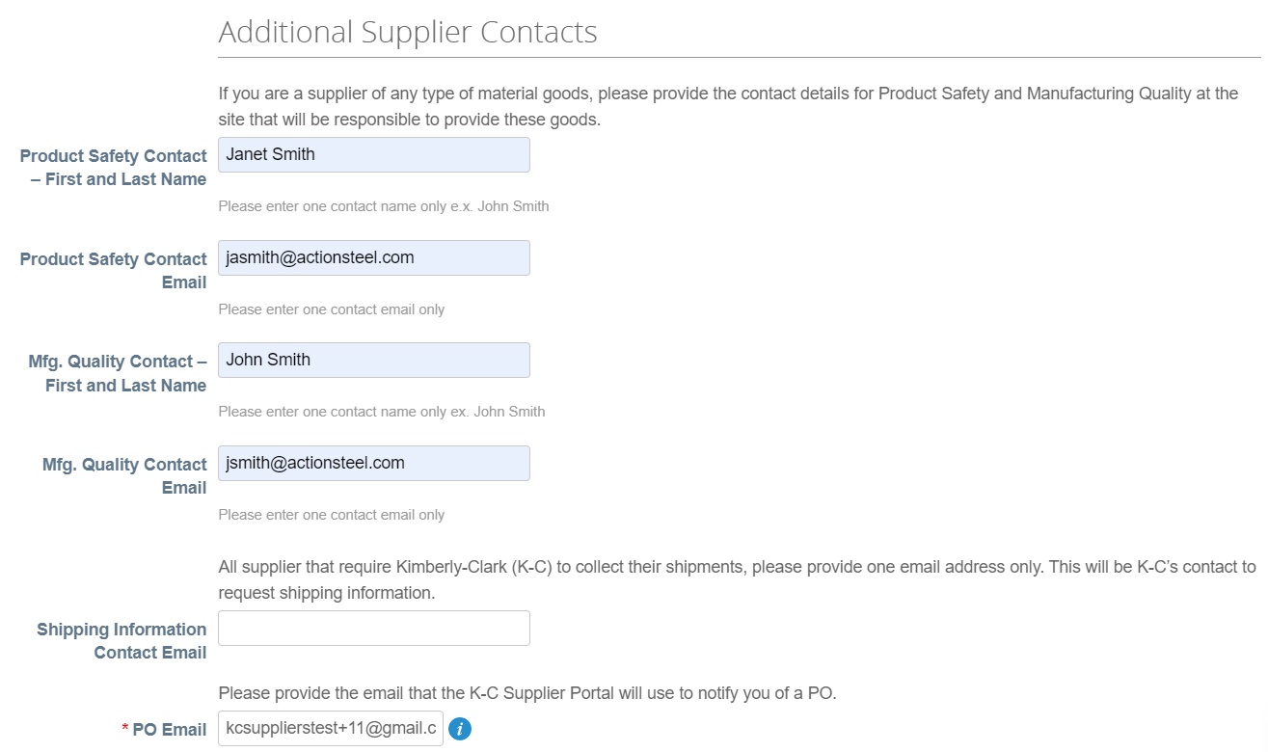

**12**

**13**

The Coupa Supplier Portal allows suppliers to share their Environmental, Social, Governance and Diversity details with their customers. After clicking the Add Diversity button select from the diversity categories.

1. Click the **Add Diversity** button (optional).
   * Select from the Diversity Category field (optional).

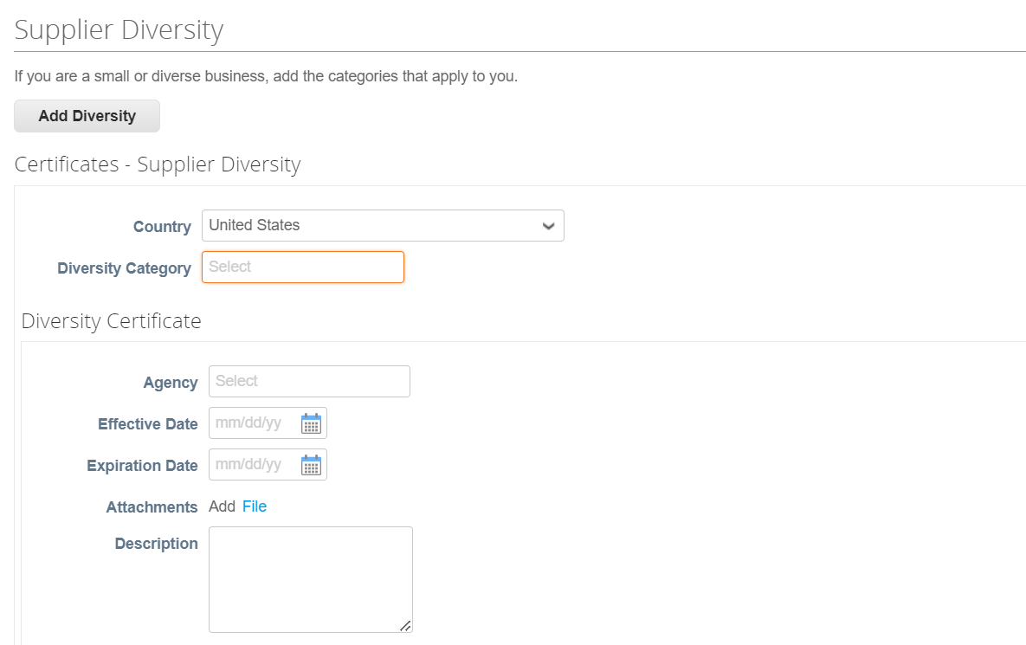

**14a**

1. Click the **Save** button to save the information entered.
2. Click the **Submit for Approval** button to submit the form to Kimberly-Clark for approval.

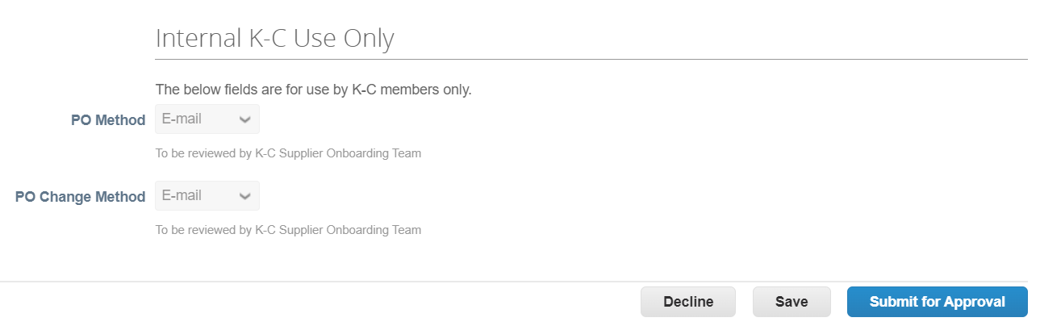

**16**

**15**

|  |  |
| --- | --- |
|  | **Note:** After submitting for approval suppliers will receive an email notification of either: approval or rejection with comment.  Contact Kimberly-Clark to resolve any errors or provide required documentation and resubmit. |

### Completing a Financial and Legal Assessment

In some cases, Kimberly-Clark may ask suppliers to complete a Financial and Legal Assessment as part of their Onboarding process. This is an external questionnaire that is designed to determine a supplier’s financial and legal health risk.

|  |  |
| --- | --- |
|  | **Note:** In addition to the Financial and Legal Assessment DDQ, some suppliers may be required to complete and submit other questionnaires in accordance with Kimberly-Clark’s risk management processes shared throughout the onboarding process.  There are various risk programs that will trigger the involvement for different suppliers and the order is differentiated between all the DDQ types. |

If a supplier meets the criteria to complete a Financial and Legal Assessment, the same point-of-contact who received the invitation to connect with Kimberly-Clark will also receive the assessment in their email.

|  |  |
| --- | --- |
|  | **Note:** If a Financial and Legal Assessment is required, it must be completed and submitted before being onboarded as a Kimberly-Clark supplier. |

1. Suppliers will be sent an email invitation from Kimberly-Clark with the subject line, **Financial and Legal Assessment for <<insert company name>> is ready to complete** fromKimberly-Clark.
2. Click the **Link** in the invitation email to access the assessment.
   1. Click the **link to ChatbotLink** to communicate with Kimberly-Clark if additional assistance is needed.
   2. Click the **link to the QRC** for additional training materials to help complete this task.

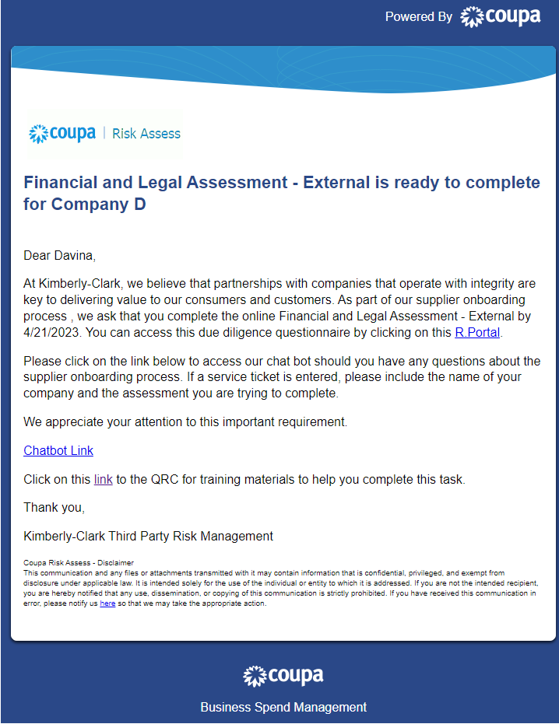

**1**

**2**

**2a**

**2b**

The form will populate and open.

1. Click the **Instructions** button to expand the instructions for form completion.

|  |  |
| --- | --- |
|  | **Note:** Please answer all questions. Failure to complete required fields may have an impact on being able to service Kimberly-Clark.  If a Financial and Legal Assessment needs to be reassigned for completion to another individual in the organization, skip to the **Delegating a Financial and Legal Assessment** section of this document. |

1. In the **Financial Risk** section, provide the information to complete all applicable field. Please remember to complete all required (*) fields.

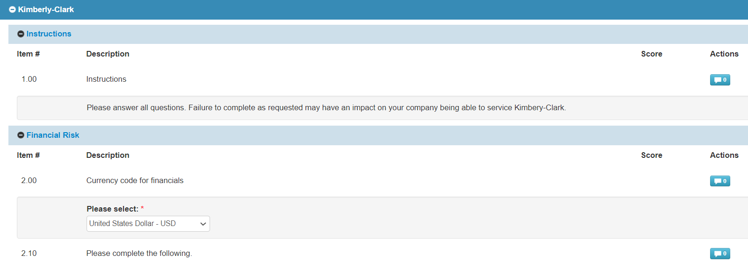

**3**

**4**

1. In the **Legal** section, use the drop-down list options to answer the questions and complete all applicable fields. Please remember to complete all required (*) fields.
   1. Note, selecting **Yes** to some questions will prompt additional required fields to provide a more detailed explanation for the answer choice.
2. Click the **Submit** button when complete.

**5**

1. 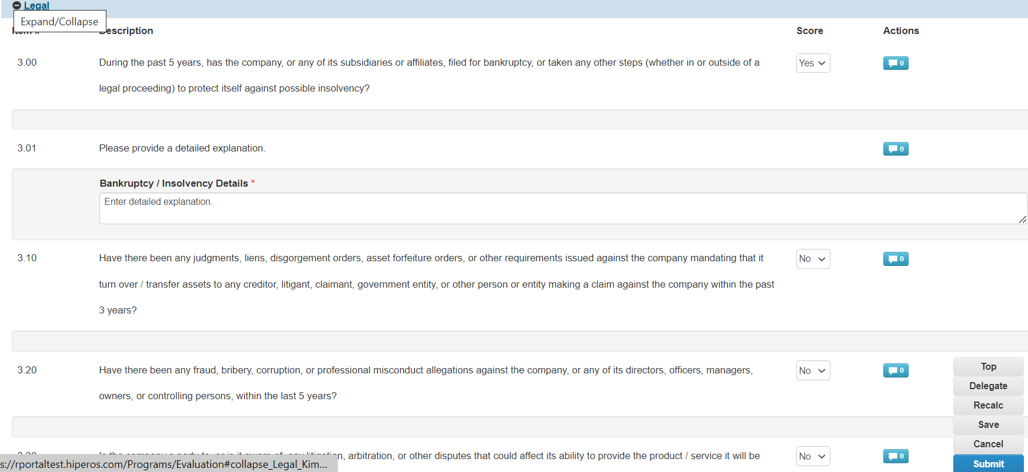

**5a**

**6**

|  |  |
| --- | --- |
|  | **Note:** The form will route to Kimberly-Clark for review and Approval. |

### Delegating a Financial and Legal Assessment

If a Financial and Legal Assessment needs to be reassigned for completion by another individual in the organization, follow these steps.

1. Click the **Delegate** button to assign the completion of the assessment to a designee.



**1**

The **Confirm Action** popup window appears.

1. Click the **Confirm** button.

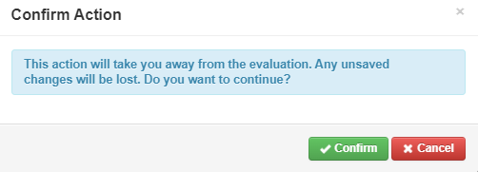

**2**

|  |  |
| --- | --- |
|  | **Note:** Confirming this action continues the process of reassigning your ability to submit responses to the questionnaire. |

1. In the **Delegate to User/Group** section select from either of the following radio button options:
   * **Delegate User** (assigns and delegates approval authority of this action to an individual)
2. Enter the **Name of the individual** in the field.
   1. If the individual’s name does not populate, click the green **(+)** icon to add the individual as user.

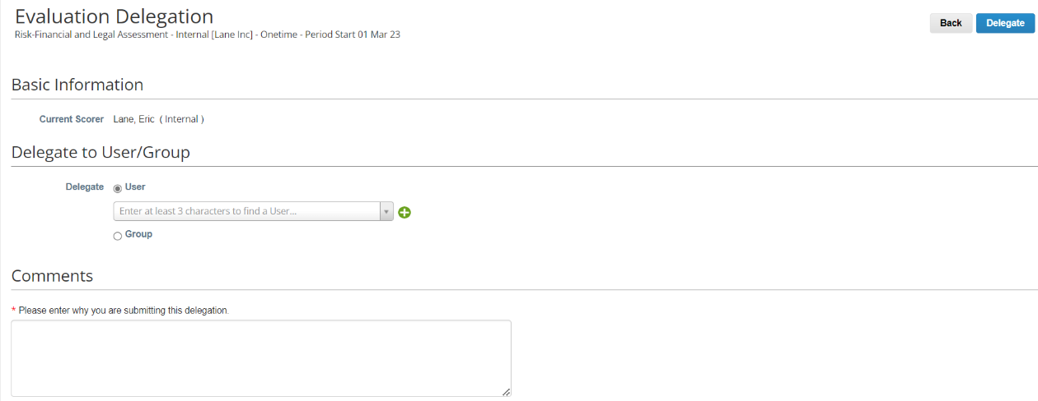

**3**

**4a**

* 1. Complete the following fields to add a user:
     + **Email Address**
     + **First Name**
     + **Last Name**

1. Click the **Create User** button when complete.

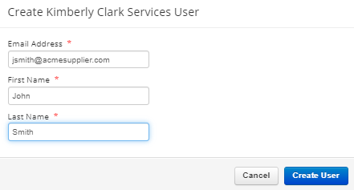

**4b**

**4c**

1. Enter an **Explanation** for submitting the delegation in the comments field (*required).
2. Click the **Delegate** button when complete.

**6**



**5**

|  |  |
| --- | --- |
|  | **Note:** The delegated individual receives an email notification of their newly assigned action. |

### Updating Supplier Profile for General Information

The supplier public profile is created at CSP account creation. It contains general company information, for example: company name, logo, website, industry, year of establishment, top commodities, currencies, diversity, and corporate

social responsibility rating.

To make any updates/edits to a public profile, perform the following steps.

1. From the **CSP Home** screen, click the **Profile** tab.

**1**

1. Select which area of the profile requires editing from the menu listing.

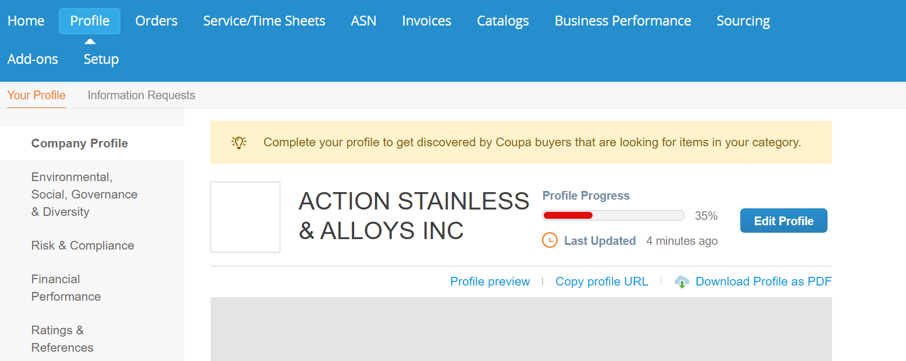

**2**

1. Click the **Edit Section** button.

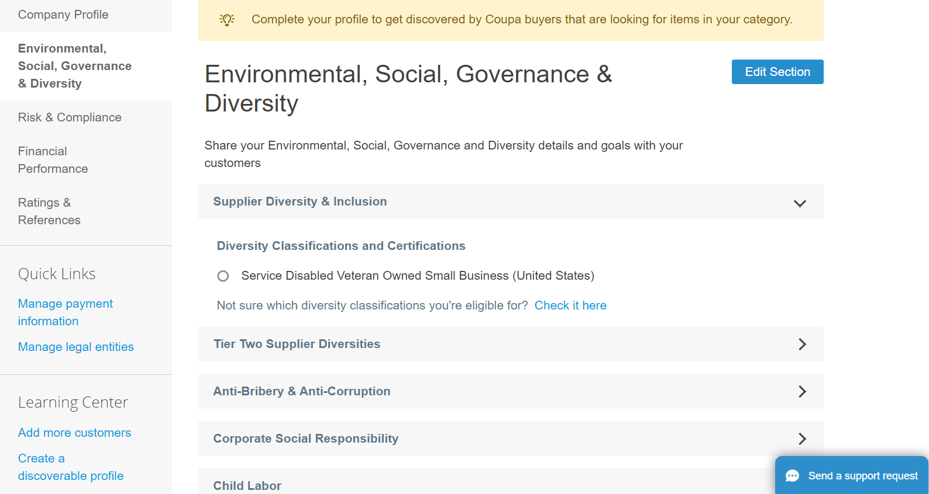

**3**

1. Click any of the **right-facing arrow** buttons to expand/collapse content within a particular section and provide any edits and/or updates for the desired section(s).

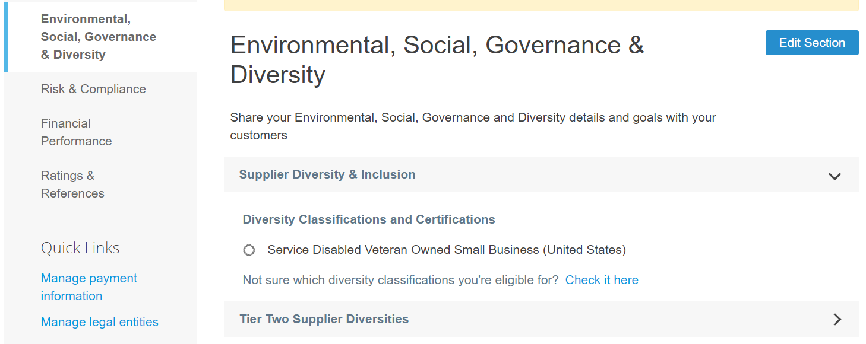

**4**

1. Scroll to the bottom of the page and select from the following:
   1. **Save & Go to Next** (saves information entered and advances to the next sequential section in the menu listing)
   2. **Save changes** (saves information entered and returns to the Profile screen)

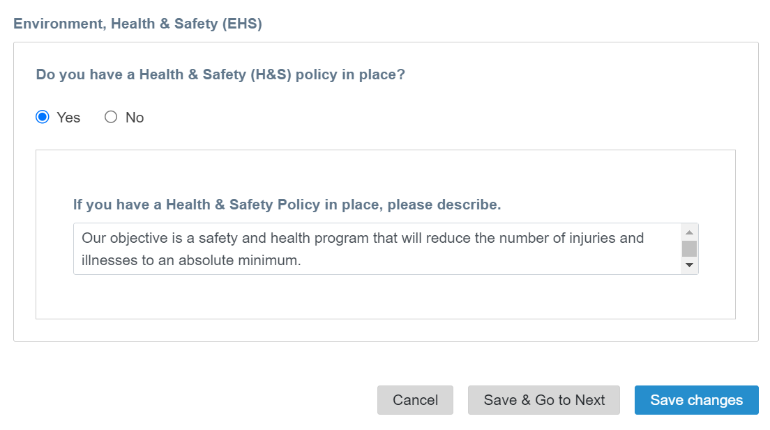

**5b**

**5a**

## Additional Resources

* [How to Navigate and Use the Coupa Supplier Portal – Quick Reference Card](../../../:w:/r/sites/i797/Learning%20Document%20Library/STP_S4_QRC_How%20to%20Navigate%20and%20Use%20Coupa%20Supplier%20Portal_NA_EN.docx?d=w857c929c292a4c3dad98a2a233225bd8&csf=1&web=1&e=tk0fvG)
* [How to Respond to Risk Action Plans for Suppliers – Quick Reference Card](https://kimberlyclark.sharepoint.com/:w:/r/sites/i797/Learning%20Document%20Library/STP_S4_QRC_How%20to%20Respond%20to%20Risk%20Action%20Plans%20for%20Suppliers_NAM_EN.docx?d=w964da6088aaf47c1bc7e318cfee92336&csf=1&web=1&e=RJKVVE)
* [Kimberly-Clark Supplier Link](https://www.kimberly-clark.com/en-us/company/supplier-link)