

Powering K-C’s digital future



How to Navigate and Use the Coupa Supplier Portal (CSP)

Coupa

*For the best learning experience, please click the* ***Editing*** *button and select* ***Open in Desktop*** *to view this document in your desktop application of Microsoft Word. Viewing this document in SharePoint or in-browser may distort the placement of images and text.*

Contents

Purpose 2

Key Terms 2

Getting Started with the Coupa Supplier Portal (CSP) 3

How to Register for the CSP 3

Administering in the CSP 10

How to Setup Legal Entity in the CSP 10

How to Manage Legal Entity in the CSP 18

How to Invite Users to the CSP 24

How to Manage Notification Preferences in the CSP 28

Working within the CSP 29

How to View and Search Purchase Orders in the CSP 29

How to View and Search Invoices in the CSP 32

How to Submit Vendor Acknowledgment of Purchase Orders in the CSP 34

How to Request a Change Order for a Purchase Order in the CSP 36

How to Create an Advance Shipping Notice (ASN) in the CSP 39

How to Create Invoices in the CSP (Flipping a PO) 41

How to Track Invoices in the CSP 47

How to Create a Credit Note in the CSP 49

How to View Payment Confirmation Details in the CSP 53

Additional Resources 55

Change Version 55

|  |  |
| --- | --- |
|  | **This icon indicates there are further policy or business process details relating to a step. Click on the provided link(s) placed throughout the QRC for more information.** |

|  |  |
| --- | --- |
| Warning outline | **Your screen in the Coupa Supply Portal may differ slightly from this training, but the steps to complete the activity will be the same.** |

## Purpose

This Quick Reference Card (QRC) explains the process for how Suppliers perform multiple tasks within the Coupa Supplier Portal such as configure Purchase Order (PO) transmission preferences, create online catalogs and electronic invoices and view Purchase Orders.

## Key Terms

* + The **Coupa Supplier Portal** is a web portal designed to assist suppliers in managing their business transactions with Kimberly-Clark (K-C).
  + The **Advance Shipping Notice** is an electronically communicated notification of shipment of goods from suppliers to their customers.
  + An **Invoice** is a billing document issued from suppliers to Kimberly-Clark stating the financial obligations owed for goods received or services performed.
  + A **Disputed Invoice** is a billing document rejected by Kimberly-Clark to a supplier for readmittance of a new invoice.
  + A **Credit Note** is an invoice submitted from a supplier to Kimberly-Clark with a negative value as an offer of credit or to resolve a disputed invoice.
  + A **Purchase Order** **(PO)** is a commercial document issued by a buyer to a seller as a commitment to purchase goods or services in agreed upon types, quantities, and prices.

**Return to Table of Contents**

## Getting Started with the Coupa Supplier Portal (CSP)

Description: You get a custom invitation with specific instructions and a proactive message from K-C. When you accept the invitation and create your account, you are automatically connected/linked to K-C. This is the preferred and only process K-C accepts for suppliers to register with them through the CSP.

### How to Register for the CSP

1. You will be sent an email invitation from K-C with the subject line, **You are Connected to Kimberly-Clark on Coupa.**
2. Click the **Login to Coupa** button from the invitation email.

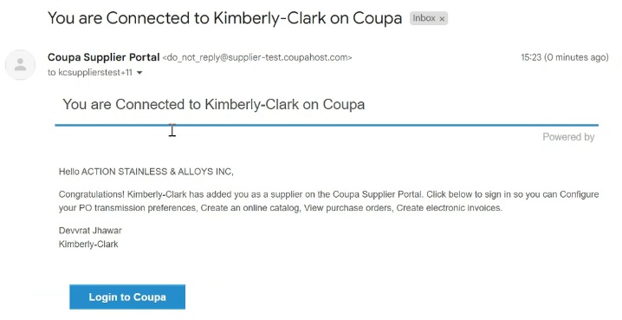

**2**

**1**

1. Enter the following information for the following fields (required fields are indicated by a red asterisk *):
   * **Business Name**
   * **Email address**
   * **First Name**
   * **Last Name**
   * **Password** (alphanumeric, minimum 8 characters)
2. Select the **Privacy Policy and the Terms of Use** checkbox (this is a requirement).
3. Click the **Create an Account** button when complete.
   1. Click the **LOG IN** link (if you have an existing CSP account).

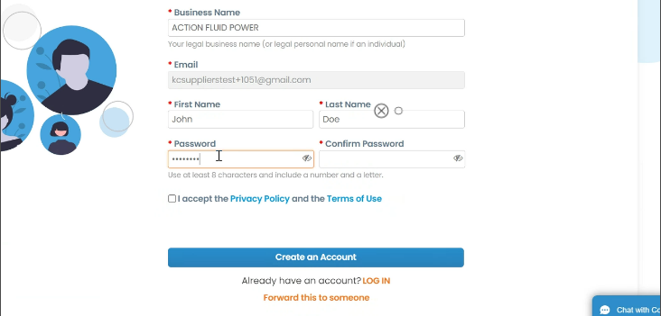

**3**

**4**

**5**

**5a**

|  |  |
| --- | --- |
|  | **Note:** The legal terms of use list the terms and conditions for using e-invoicing through Coupa and the CSP. You as a supplier, especially if you are responsible for managing legal tax invoices, are required to have read, assessed and agreed to these terms of use and to be aware of your responsibilities towards the content and handling of these invoices. |

1. The **Tell us about your business screen** appears.
2. Enter the following information about your business for the following fields (required fields are indicated by a red asterisk *):
   * **Company Name**
   * **Country/Region**
   * **Address**
   * **City**
   * **State**
   * **Postal code**
3. Select the **Invoice-from location** checkbox to set the address as your invoice address.

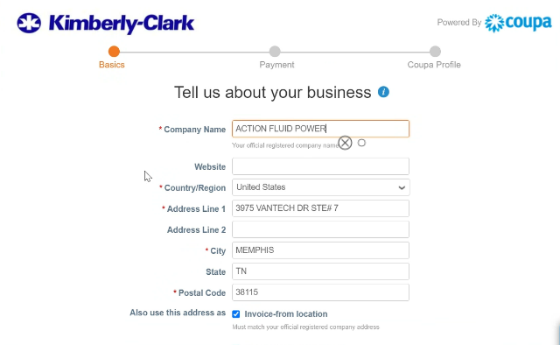

**6**

**7**

**8**

1. Deselect the **Pay to location (Remit-To)** checkbox if you do not want to receive payment for your invoices at the address on this screen.
2. Deselect the **Ship from location** checkbox if your ship-from address is different from your invoice-from address or you have more than one location.
3. Select the **We support integration for invoicing** checkbox if you plan to use cXML or SFTP transactions to send and receive between your system and K-C Coupa.
4. Select your tax country/region from the **Tax Country/Region** drop-down list.
   * Enter your **Tax ID** information (If you do not have a Tax ID, select the **I don’t have a Tax ID Number** checkbox).
5. Click the **Next** button.

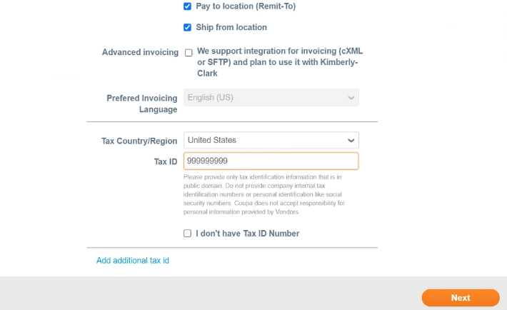

**9**

**10**

**11**

**12**

**13**

1. The **Payment Discount Preferences** screen appears. **Do NOT select nor provide any information on this screen.**

|  |  |
| --- | --- |
|  | **Note:** Payment terms and preferences are outlined in accordance with the contractual agreements between your business and K-C. |

1. Click the **Next** button.

**14**

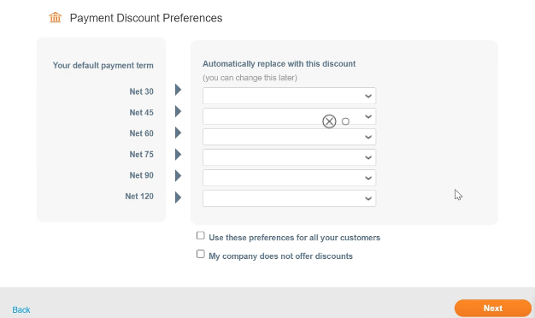

**15**

1. The **Enhance your Coupa profile** screen appears. **Do NOT provide any enhancements to your Coupa profile at this time.**

* Later, if desired, click the **Enhance your Coupa profile** button to provide profile information.

1. Click the **Do it later** button.

|  |  |
| --- | --- |
|  | **Note:** Enhancing your Coupa profile is for personalization purposes and not germane to the registration process for K-C; providing more than the required profile information is optional. |

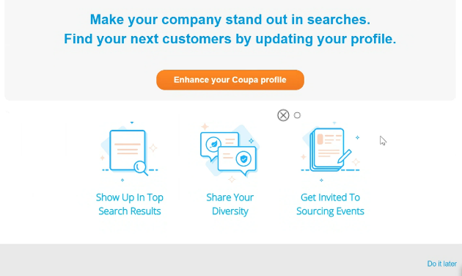

**16**

**17**

1. 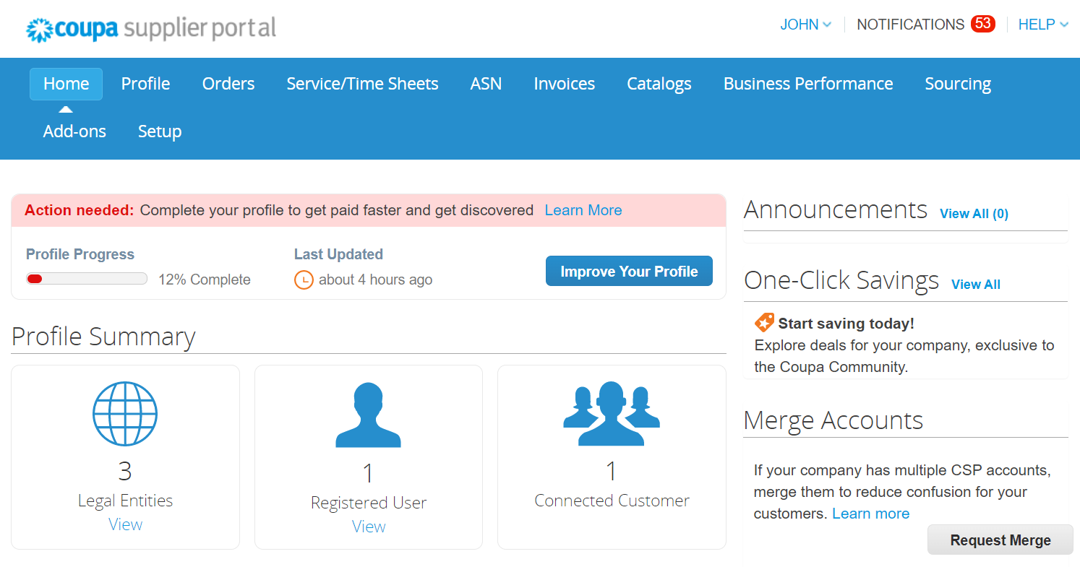Your **CSP Home** screen appears.

**18**

|  |  |
| --- | --- |
|  | **Note:** Your CSP account is based on a specific email address. If you use an email address different from the one that K-C has on file for you, you cannot connect with them until you give them the email address or create a CSP account with that email address. |

**Return to Table of Contents**

## Administering in the CSP

### How to Setup Legal Entity in the CSP

Description: Setting up your legal entity and linking it to K-C enables electronic invoicing via the CSP or via your actionable e-mail address provided during registration.

1. From your **CSP Home** screen, click the **Setup** tab.
2. Click the **Admin** subtab.

|  |  |
| --- | --- |
|  | **Note:** K-C requires that Suppliers with multiple legal entities set up their additional entities within the Coupa Supplier Portal. Suppliers with only one (1) legal entity can bypass this process. |

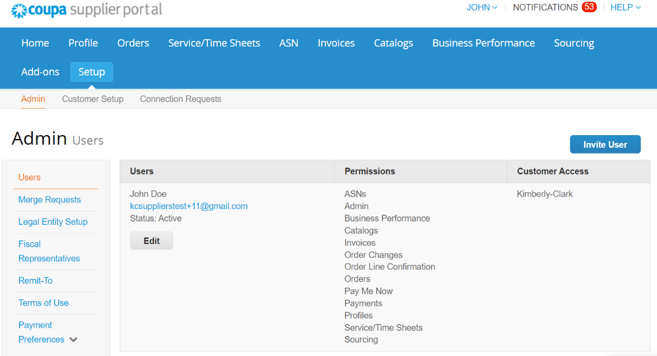

**1**

**2**

1. Select the **Legal Entity Setup** link.

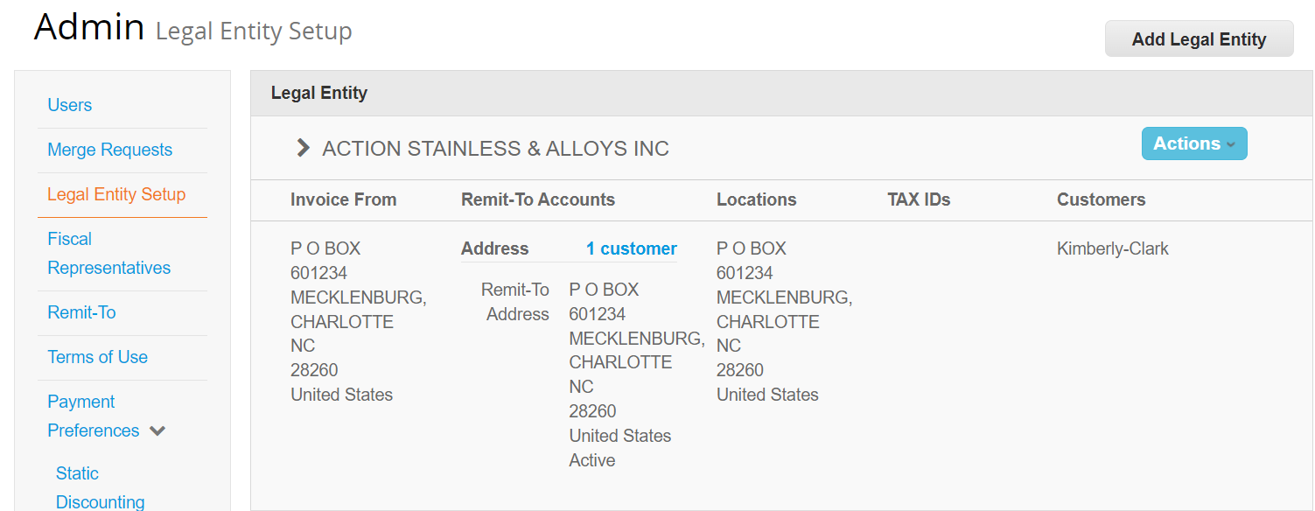

**3**

1. Click the **Add Legal Entity** button.



**4**

|  |  |
| --- | --- |
|  | **Note:** Proceeding with the following steps ensures that if you participate in electronic invoicing, you are submitting a tax compliant invoice. |

1. The **Where’s your business located** screen appears.
2. Enter the official name and country of your business as registered with the local government (required fields are indicated by a red asterisk *).
3. Click the **Continue** button.

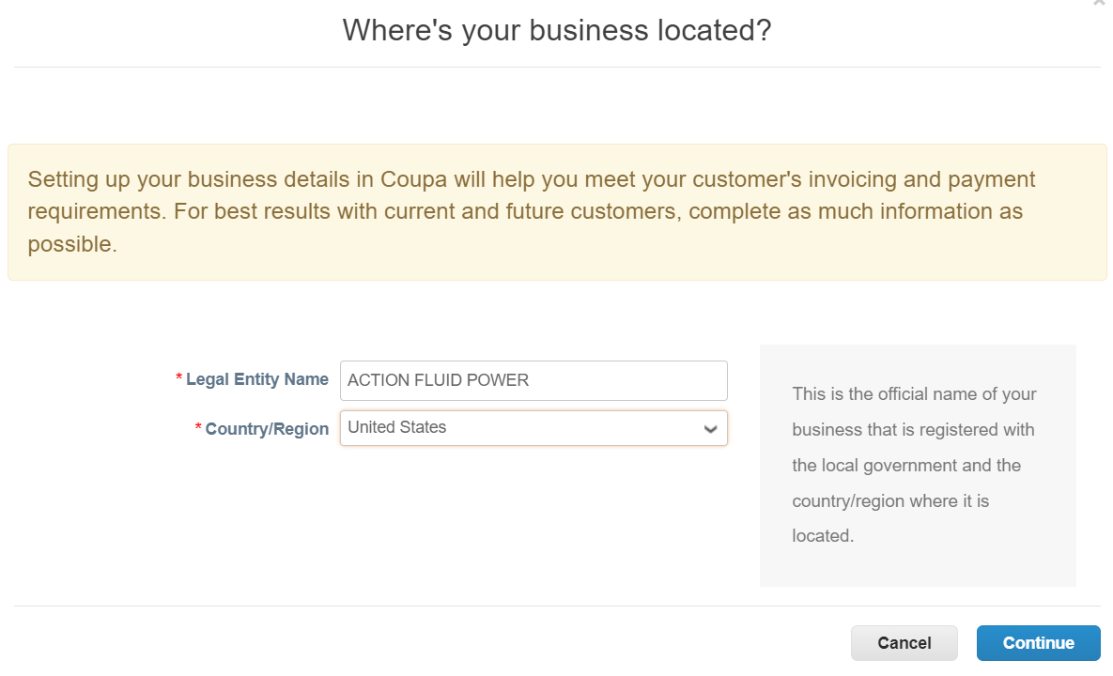

**5**

**7**

**6**

1. The **Tell your customers about your organization** screen appears.
2. Select Kimberly-Clark from **Customers** checkbox.
3. Enter the registered address and tax identification information for your business (required fields are indicated by a red asterisk *).
   1. Deselect the **Use this address for Remit-To** checkbox if you receive payment for invoices at a different address.
   2. Deselect the **Use this for Ship From** address checkbox if you ship from a different address.

**8**

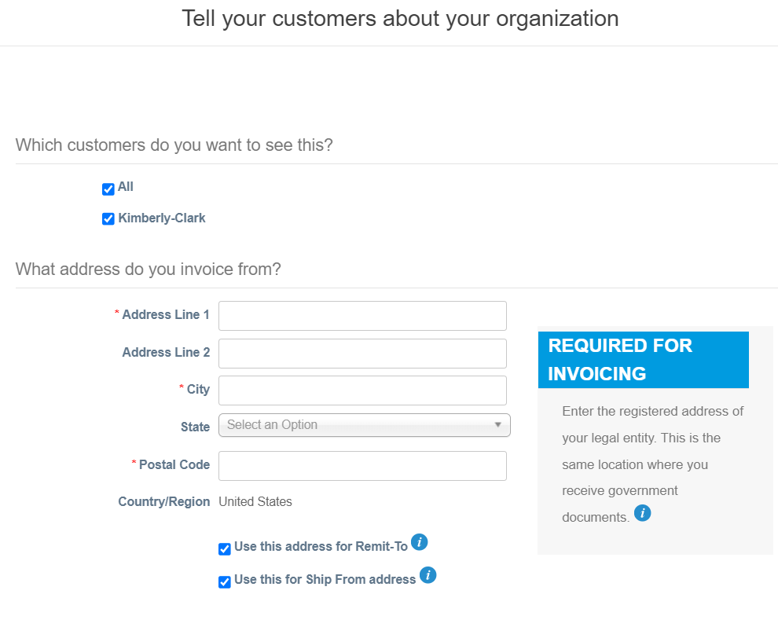

**9**

**10**

**10a**

**10b**

|  |  |
| --- | --- |
|  | **Note:**   * Remit-To is the address where you want to receive payment (you can change this address should the need arise). * K-C requires Suppliers to receive payment **only** via electronic form. * Ship From address is the address where you ship goods from (e.g., warehouse location) |

1. Click the **down arrow** to scroll to the next section, **What is your Tax ID**.
2. Select your country/region from the **Country/Region** drop-down list.
3. Enter your tax ID in the Tax ID field.
   1. Select the **I don’t have a Tax ID Number** checkbox if you do not have a tax ID.
4. If applicable, enter an appropriate value in the **Invoice From Code** field to connect your CSP invoice-from address (registered address) with the corresponding address in your ERP.
5. Click the **Save & Continue** button when complete.

**11**

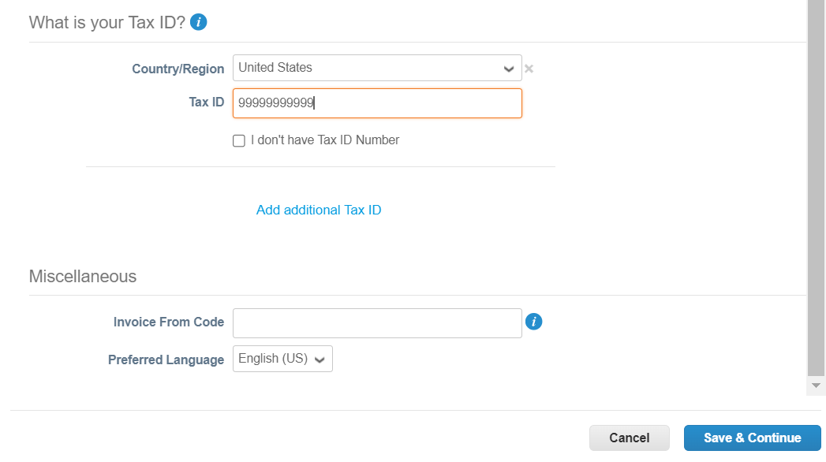

**12**

**13**

**13a**

**14**

**15**

1. Select **Bank Account** from the **Payment Type** drop-down list.
2. Complete all applicable **Bank Account Details** fields.

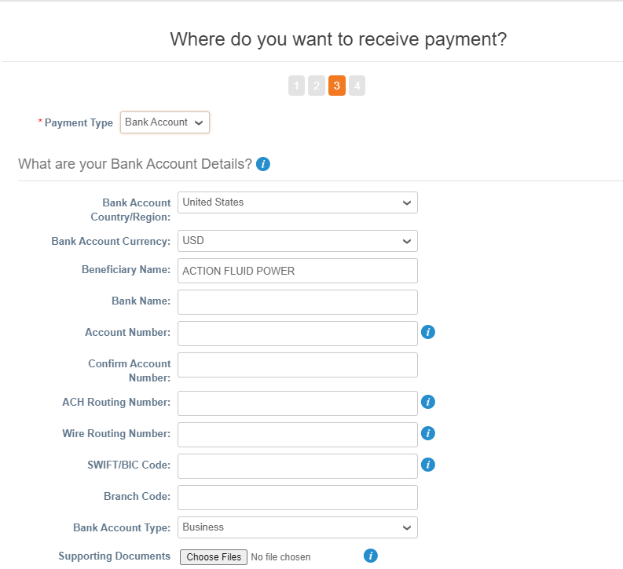

**16**

**17**

1. Upload bank details **Supporting Documentation** (* Required).
   1. Acceptable file type is .pdf only
2. Enter the **Bank Address** information.
3. Click the **Save & Continue** button.

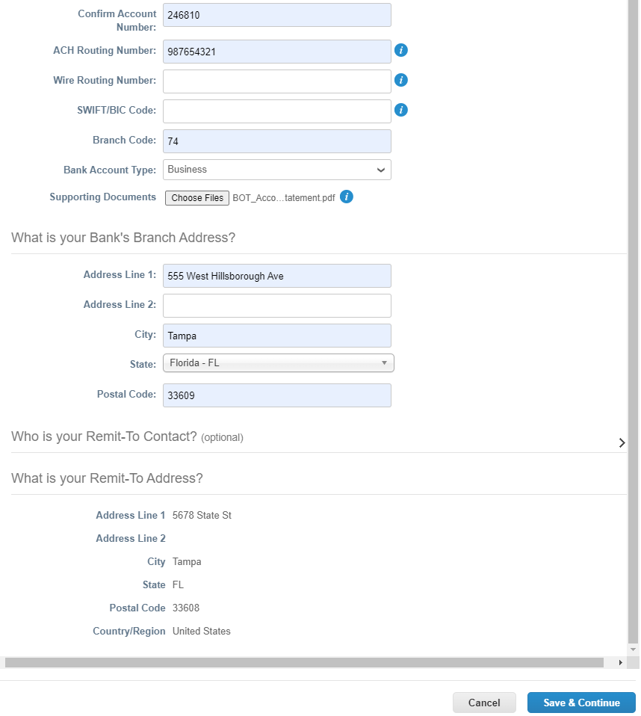

**19**

**18**

**20**

The **Where do you want to receive payment?** screen appears.

1. Click the **Next** button.

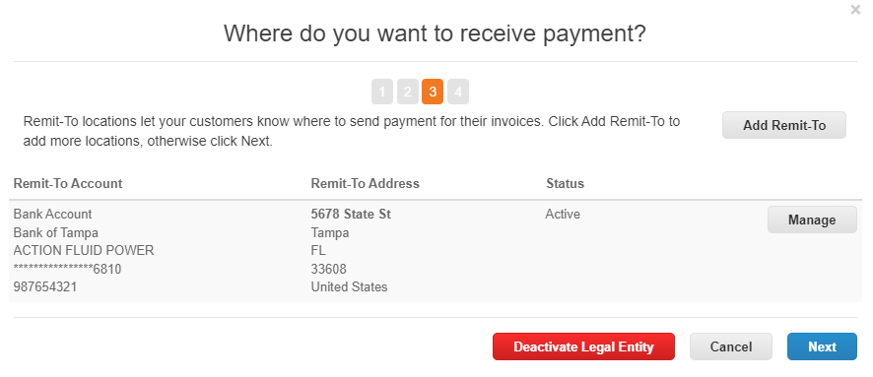

**21**

The **Where do you ship good from?** screen appears.

1. Click the **Add Ship From** button if you shipping detail are different from where your legal entity is registered.
2. Click the **Done** button.

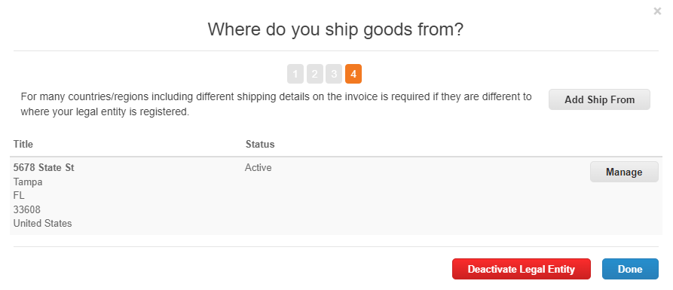

**22**

**23**

The **Setup Complete** screen appears.

1. Click the **Done** button.

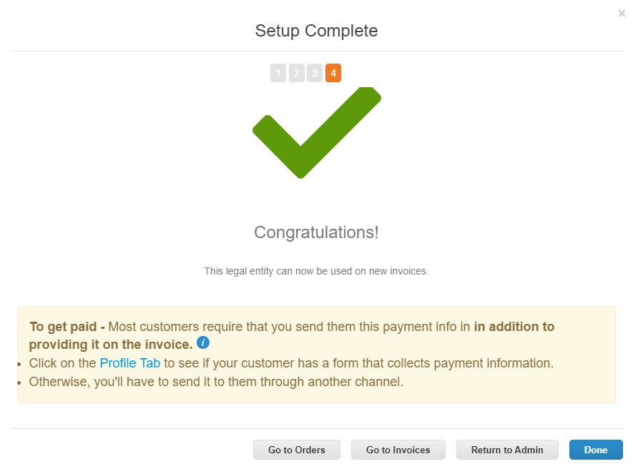

**24**

**Return to Table of Contents**

### How to Manage Legal Entity in the CSP

1. From your CSP Home screen, click the **Setup** tab.
2. Click the **Admin** subtab.

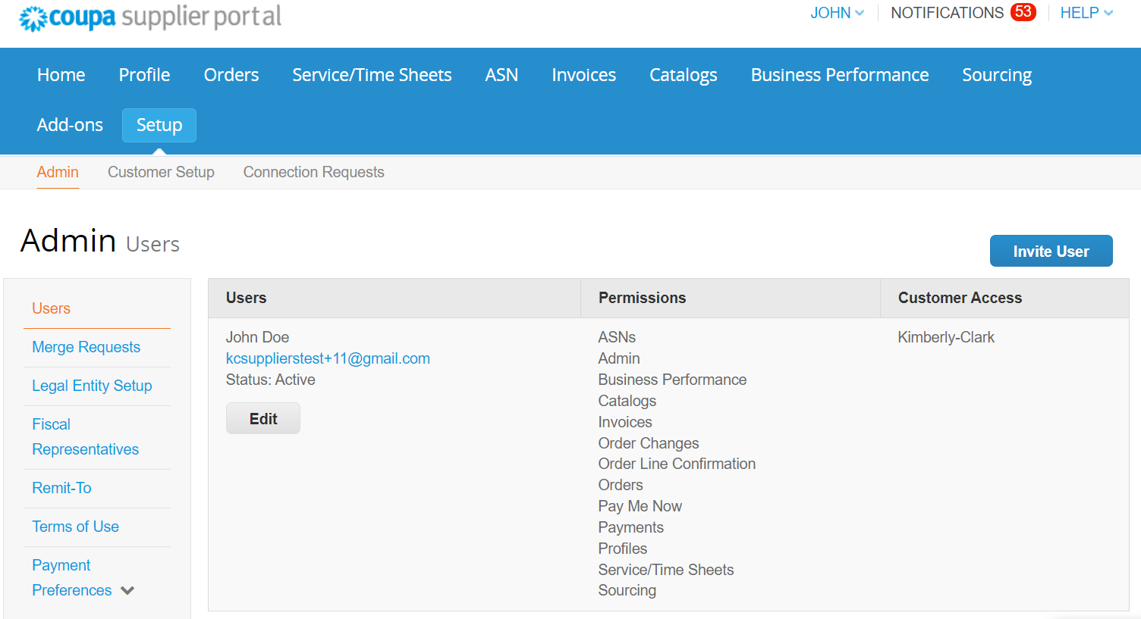

**1**

**2**

1. Select **Legal Entity Setup**.



**3**

|  |  |
| --- | --- |
|  | **Note:** The data you entered during registration will autofill these fields: Invoice From, Remit-To Accounts, Locations, Tax IDs, and Customers. |

1. Click the **Actions** button to manage the details of an existing Legal Entity.
2. Select **Manage Legal Entity** from the drop-down list.
   * Any updates needed to Manage Remit-to Accounts or to Deactivate Legal Entity can also be accessed from the **Actions** button.

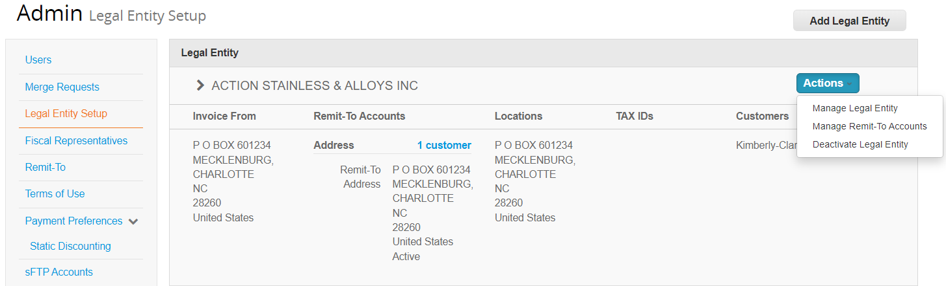

**4**

**5**

|  |  |
| --- | --- |
|  | **Note:** You cannot change the name or country/region associated to your legal entity in this process. If you need to amend the name or country/region of your legal entity you will need to deactivate the entity and set it up again. |

1. The **Miscellaneous Information** screen appears.
2. Click the **Deactivate Legal Entity** button if you need to deactivate your legal entity.
3. Click the **Save & Continue** button.

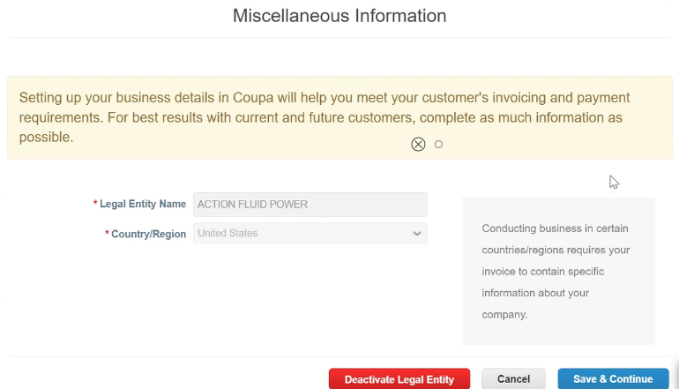

**8**

**7**

**6**

* 1. Click the **Save & Continue** button.

1. The **Tell your customers about your organization screen** appears.
2. If applicable, edit your selection in the **Which Customers do you want to see this** checkbox.
3. Click the **Continue** button.

|  |  |
| --- | --- |
|  | **Note:** You cannot change the address and tax ID information associated to your legal entity in this process. If you need to amend the name or country/region of your legal entity you will need to deactivate the entity and set it up again. |

**9**

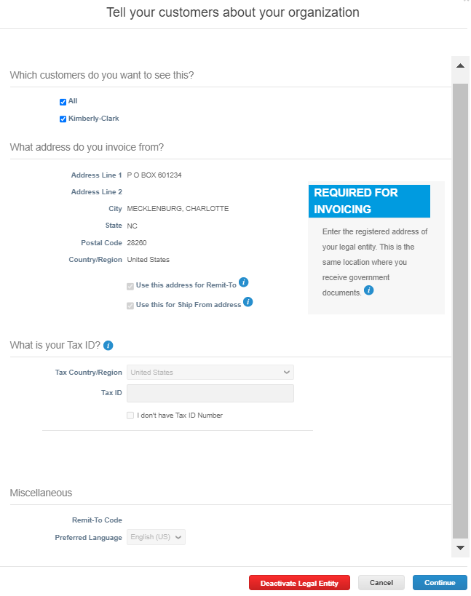

**10**

**11**

1. The **Where do you want to receive payment** screen appears.
2. Click the **Manage** button to edit your existing remit-to address.
3. Click the **Next** button.

**12b**

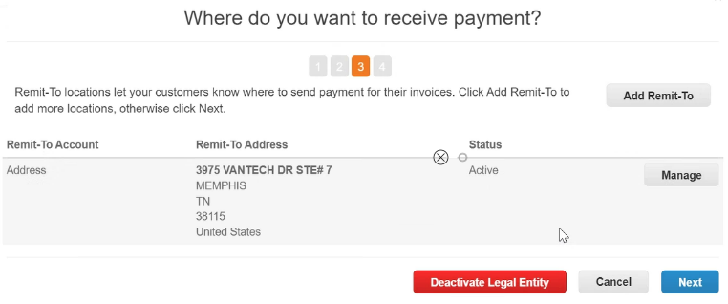

**13b**

**14b**

1. The **Where do you want to receive payment** screen appears.

|  |  |
| --- | --- |
|  | **Note:** You can maintain only one (1) Remit To address and payment data connected to your Payment Type. Although, you can set up multiple Remit To addresses, K-C will only send payment to one designated Remit To address.  *K-C only sends payment via electronic form. No payment will be sent in hard copy form. |

1. If applicable, edit the information in the following fields:
   1. **What is your Remit-To Integration Code?** (select the field to edit or add an existing code).
   2. **Contact Information** (select to edit existing contact information).
   3. **Which customers can use this account?** (select to update which customers you want to associate to this account).
2. Click the **Continue** button.

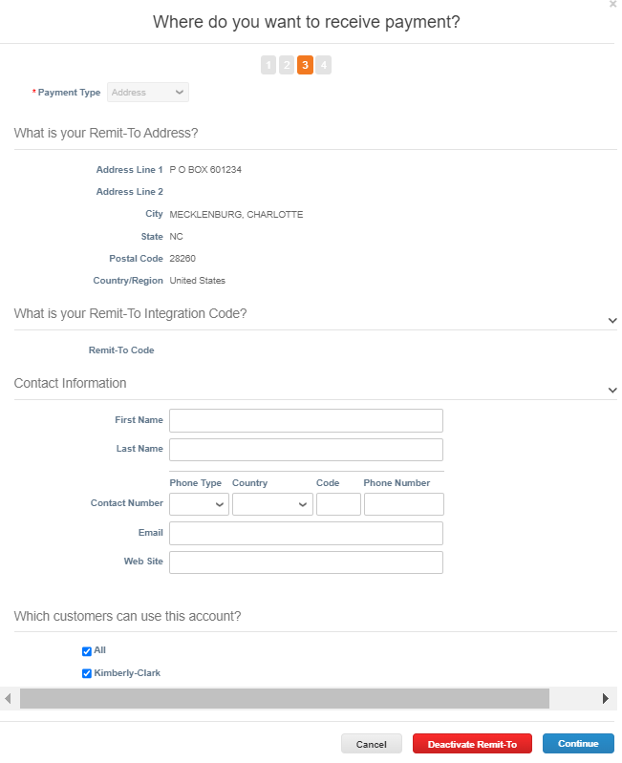

**15b**

**16a**

**16b**

**16c**

**17**

1. The **Where do you ship goods from?** screen appears.
2. If applicable, edit the information in the following fields:
   1. Click the **Add Ship From** to update your ship from address information.
   2. Click the **Manage** button to edit your existing ship from address information.
3. Click the **Done** button.

**18**

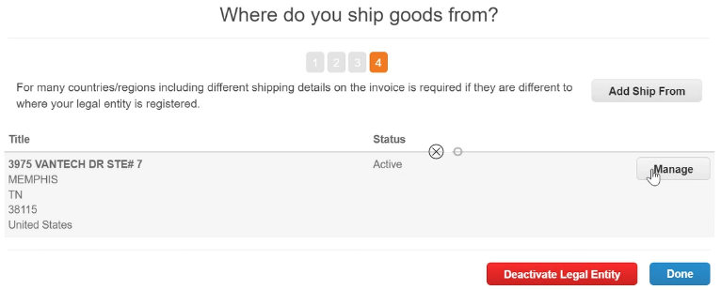

**19a**

**19b**

**20**

**Return to Table of Contents**

### How to Invite Users to the CSP

1. From your **CSP Home** screen, click the **Setup** tab.
2. Click the **Admin** tab.
3. Select **Users.**
4. Click the **Invite User** button.



**1**

**2**

**4**

**3**

|  |  |
| --- | --- |
|  | **Note:** You can review all users who are associated to your account on the **Users** screen. |

|  |  |
| --- | --- |
|  | **Note:** For auditing purposes, Coupa does not allow users to be deleted, so you cannot delete a user from your profile. Instead, you can deactivate a user when you no longer want that user to be able to access the account. |

1. The **Invite User** screen appears.
2. Enter the invitee’s contact information.
3. Define the **Permissions** (levels of access) for the invitee by selecting the following check boxes:
   * **All** (gives full access to all your CSP functions, except for user administration)
   * **Admin** (gives full access to all your CSP functions)
   * **Orders** (allows viewing and managing of Purchase Orders)
   * **Orders - Restricted Access** (allows accessing specific Purchase Orders)
   * **Orders - All** (allows viewing and managing of all Purchase Orders)
   * **Invoices** (allows creating and sending of invoices to customers)
   * **Catalogs** (allows creating and managing customer-specific electronic catalogs)
   * **Profiles** (allows modifying of customer-specific profiles)
   * **ASN** (allows creating and sending advanced ship notices (ASN) to customers
   * **Service/Time Sheets** (allows creating and submitting service/time sheets against Purchase Orders)
   * **Service/Time Sheets - Restricted Access to Service/Time Sheets** (allows accessing specific service/time sheets)
   * **Service/Time Sheets – All** (allows creating and submitting any service/time sheets against Purchase Orders)
   * **Payments** (allows viewing payments and downloading digital checks)
   * **Order Changes** (allows submitting PO change requests)
   * **Pay Me Now** (Available only if your customers use Coupa Pay and enabled the feature related to this permission)
   * **Business Performance** (allows viewing business performance information, e.g., order, invoice and delivery trends)
   * **Sourcing** (allows viewing public sourcing events)
   * **Order Line Confirmation** (allows viewing of Purchase Order lines within ASN)
4. Define which **Customers** are visible to the invitee by selecting the following check boxes:
   * **All** (allows viewing of all customers within your CSP)
   * **Kimberly-Clark** (allows viewing of only K-C within your CSP)

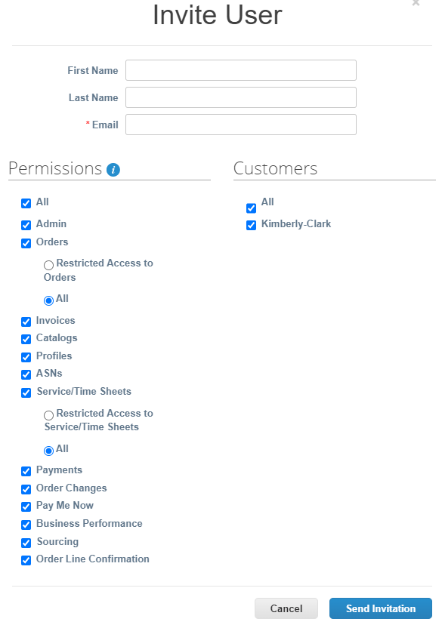

**5**

**6**

**8**

**7**

**9**

1. Click the **Send Invitation** button.

**Return to Table of Contents**

### How to Manage Notification Preferences in the CSP

Description: The CSP has added notification preference setting options

for canceled digital checks, virtual cards and created receipts.

1. From your **CSP Home** screen, mouse over **Your Name.**
2. Select **Notification Preferences**.

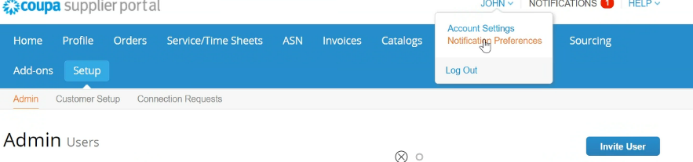

**1**

**2**

1. Choose your preferences how you would like to be notified (e.g., online, email or SMS) by selecting the check boxes from the corresponding notification areas (e.g., announcements, business performance, service/time sheets):
   * **Announcements** (information communicated from your customers)
   * **Business Performance** (summary of your orders and invoices, year-to-date order and invoice trends and lead time to shipping goods)
   * **Service/Time Sheets** (list of service/time sheets and related Purchase Order lines)

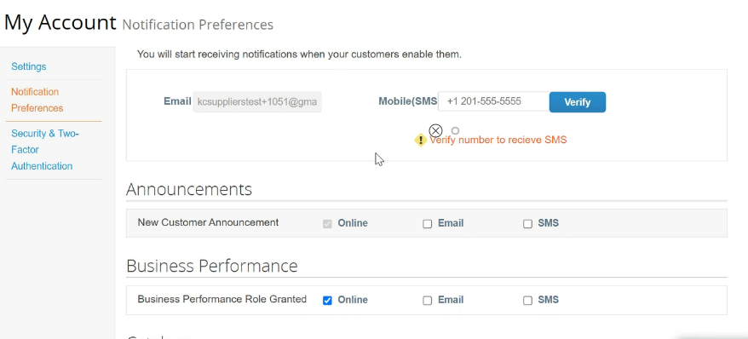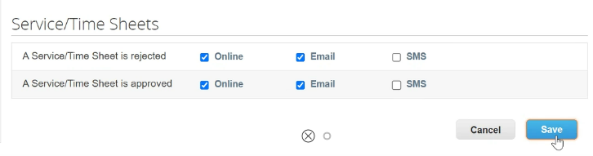

**3**

**4**

1. Click the **Save** button.

**Return to Table of Contents**

## Working within the CSP

### How to View and Search Purchase Orders in the CSP

1. From your **CSP Home** screen, select the **Orders** tab.

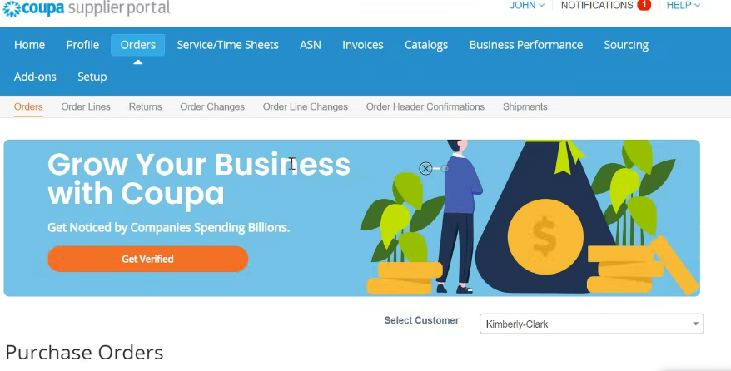

**1**

1. Select Kimberly-Clark from the **Select Customer** drop-down list.

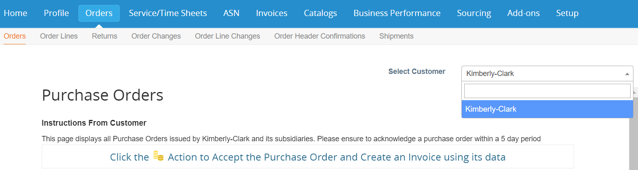

**2**

1. In the table beneath, search for Purchase Orders using the **PO Number** column and clicking the desired PO number.

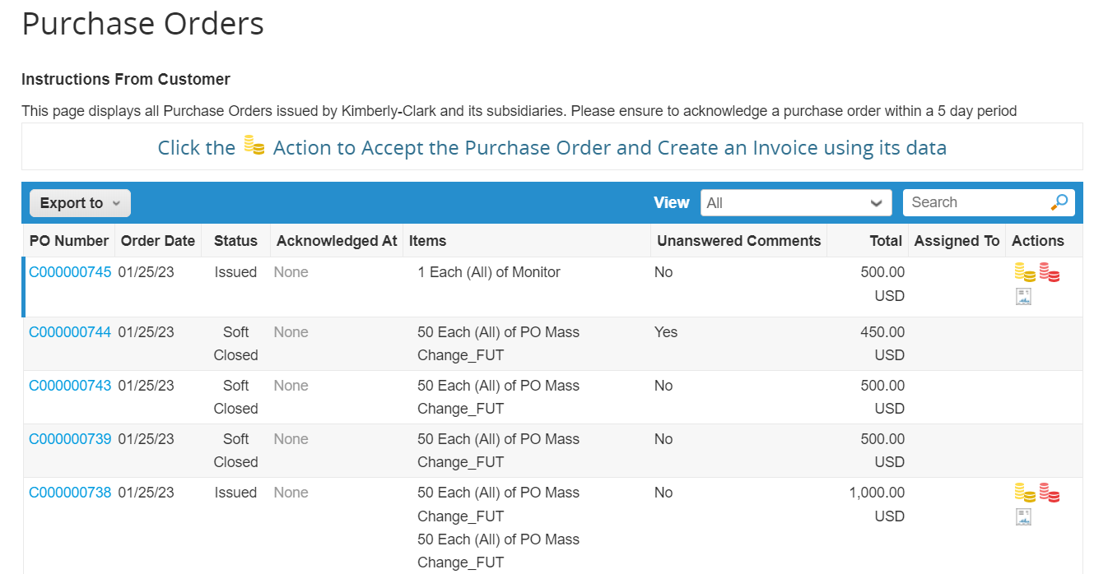

**3**

1. Click the **View** drop-down list to filter your search for Purchase Orders from the standard set of views available.
   * Select **Create View** to personalize your column display fields.

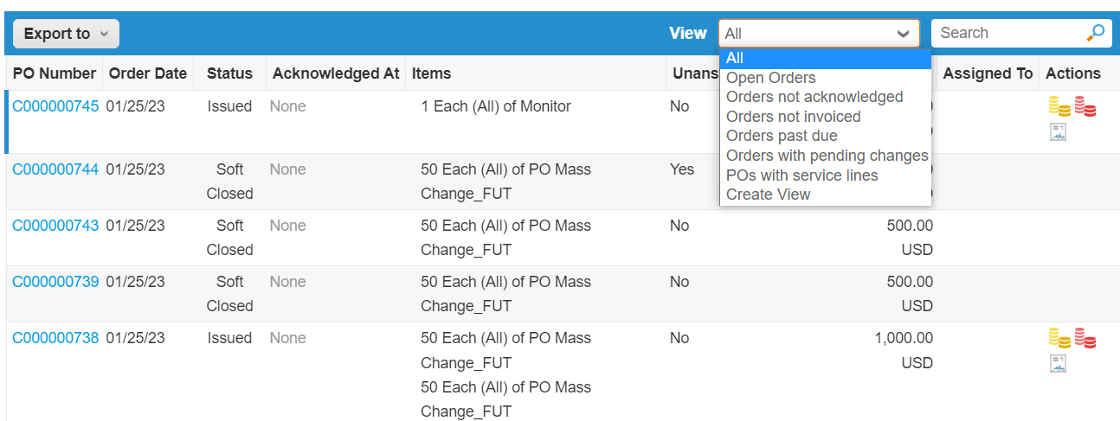

**4**

**4a**

1. The **Create New data table view** screen appears.
2. Enter a **Name** for your view.
3. Select the **Visibility** for your view. Choose from the following:
   * **Only me** (view is visible by only you)
   * **Everyone** (view is visible by all other users)
4. Select your **Start with view** field (use this option to load the settings from another view, and then modify those settings to fit your needs for this view). Available options are:
   * **All**
   * **Open Orders**
   * **Orders Not Acknowledged**
   * **Orders Not Invoiced**
   * **Orders Past Due**
   * **Orders with Pending Changes**
   * **POs Pending Rework**
   * **POs with Service Lines**
5. Click the **Match Conditions** drop-down list to apply conditions to your view based on data available in the CSP.

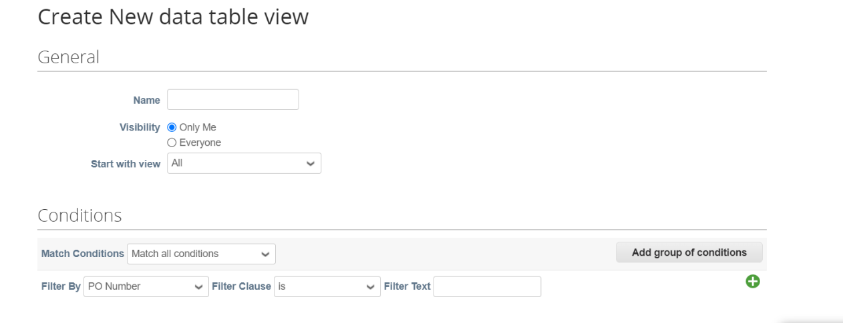

**5**

**6**

**7**

**8**

**9**

1. Click the **down arrow** to scroll to the next section, **Columns**.
2. Click-and-drag the data points from the **Available Columns** field for your **Selected Columns** to display.

* Click the **down arrow** to scroll to the next section, **Default Sort Order** (use this option to sort the result sets from your view in ascending or descending order).

1. Click the **Save** button.

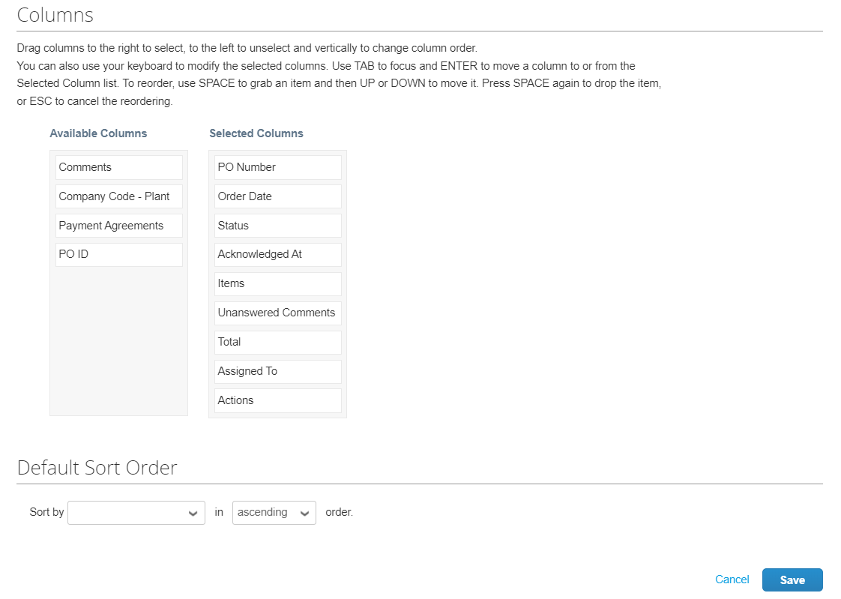

**11**

**12**

|  |  |
| --- | --- |
|  | **Note:** Creating Views is a fully personalized self-service option in the CSP. |

**Return to Table of Contents**

### How to View and Search Invoices in the CSP

1. From your **CSP Home** screen, select the **Invoices** tab.
2. Click the **View** drop-down list to populate all relevant invoices and Purchase Orders associated to their respective invoices.
3. Click the **Invoice Number** to view the details of the invoice.

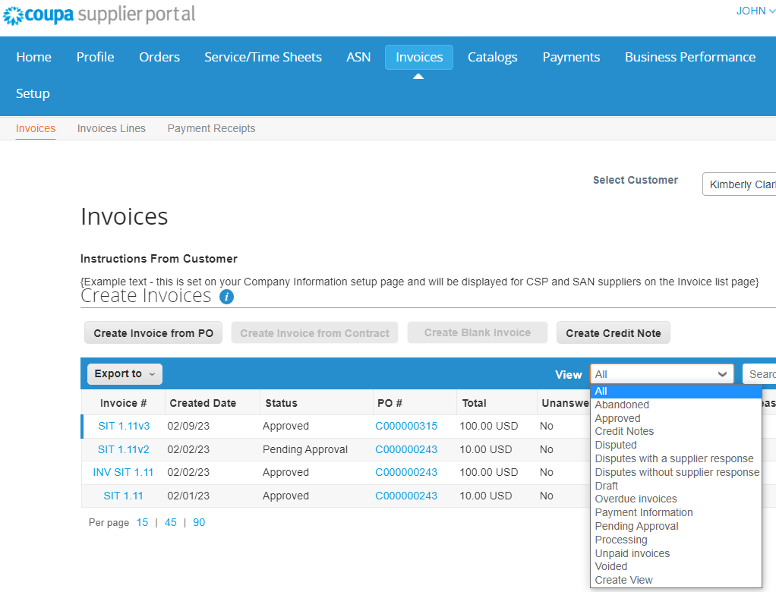

**1**

**2**

**3**

1. An **Invoice Overview** screen appears that provides you with the following:
   1. Invoice general information
   2. Bill to & Ship To information

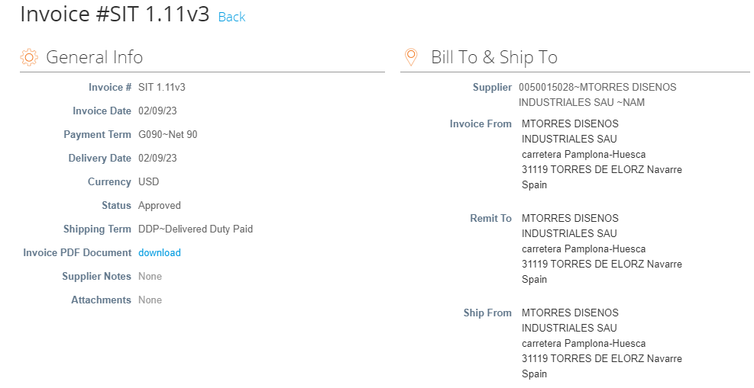

**4b**

**4a**

**4b**

**4a**

1. Additional invoice information includes the following:
   1. Supplier tax information
   2. 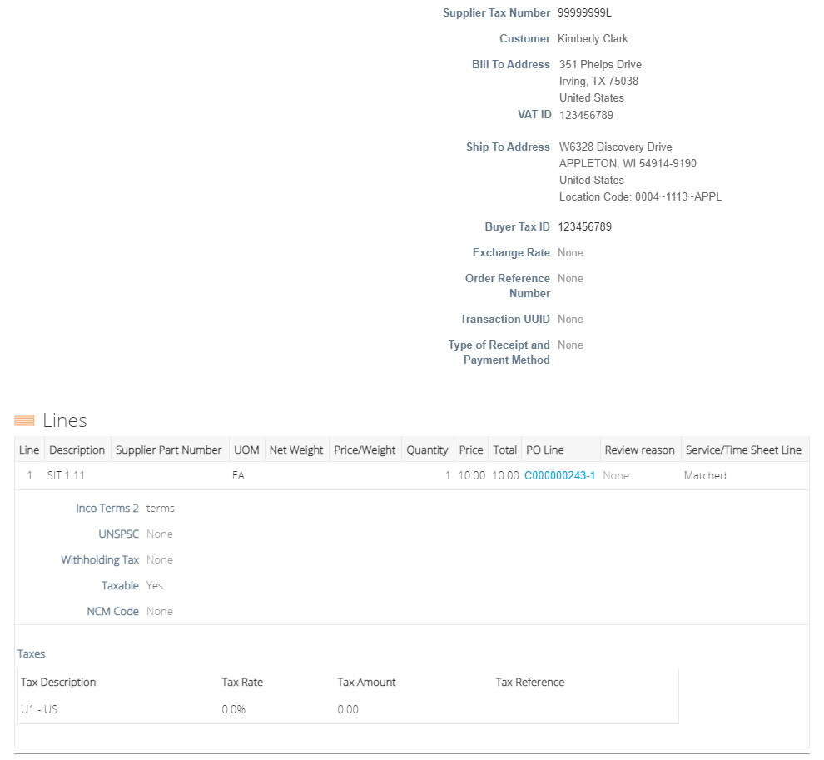PO line information

**5a**

**5b**

**Return to Table of Contents**

### How to Submit Vendor Acknowledgment of Purchase Orders in the CSP

|  |  |
| --- | --- |
|  | **Note:** You can choose to let your customer know that you received their PO by selecting  the **Acknowledged** checkbox on the PO. |

1. From your **CSP Home** screen, select the **Orders** tab.
2. Click the **Orders** subtab.
3. Click the corresponding **PO Number** to select the desired PO.

**1**

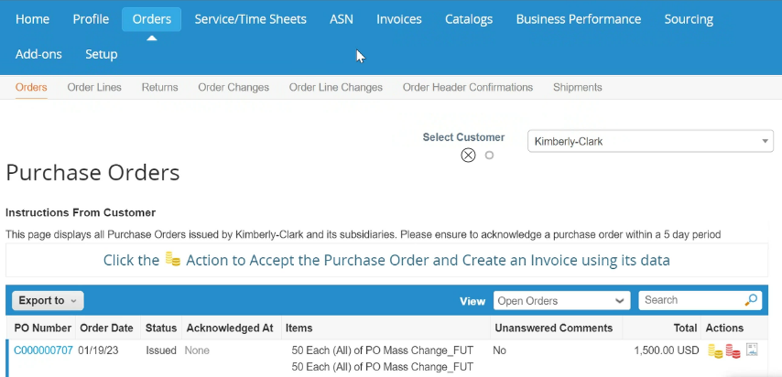

**2**

**3**

1. Review the following information on the PO:
   1. **Company Code Plant**
   2. **Ship-To Address**
2. Select the **Acknowledged** checkbox to acknowledge receiving the PO.

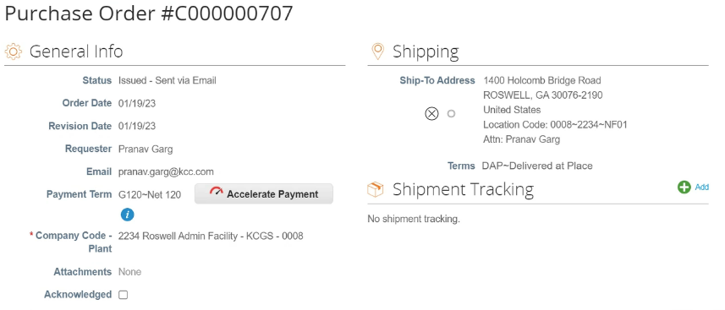

**4b**

**4a**

**5**



1. Scroll to the end of the **Lines** section and click the **Save** button.

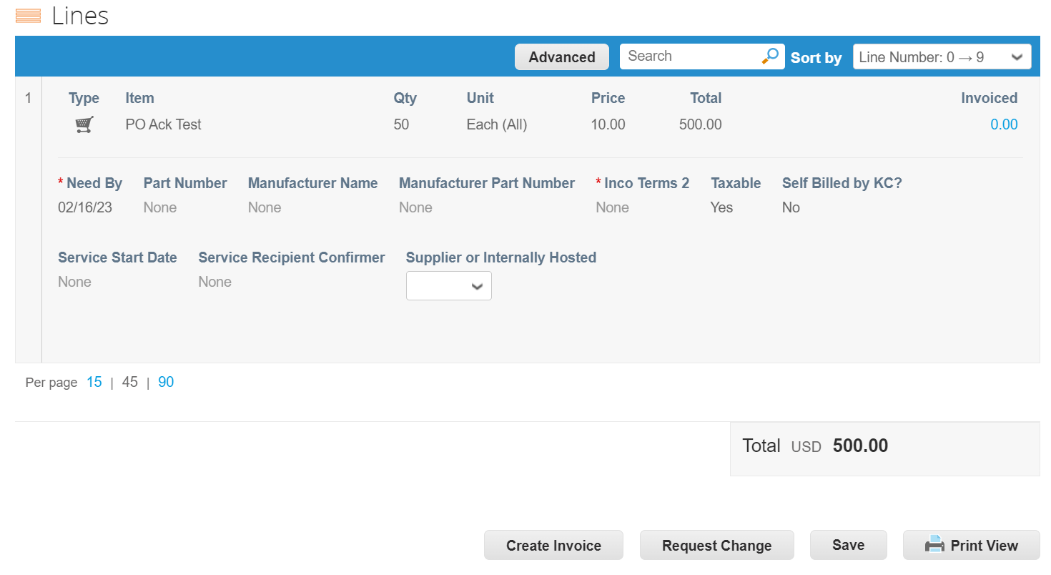

**6**

1. You will receive an **Order acknowledged** notification.

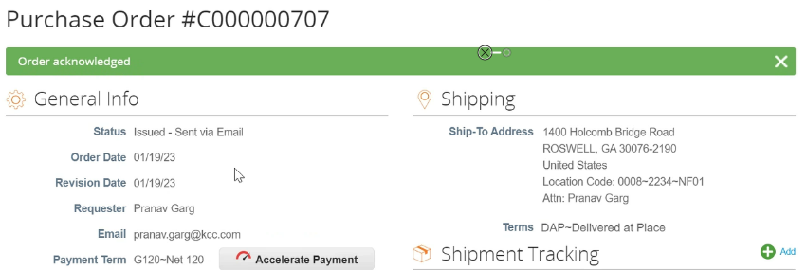

**7**

**Return to Table of Contents**

### x

1. From your **CSP Home** screen, select the **Orders** tab.
2. Click the **Orders** subtab.
3. Click the corresponding **PO Number** to select the desired PO.

**1**



**2**

1. Click the corresponding **PO Number** to select the desired PO.

**3**

1. The **Purchase Order** screen appears.
2. Scroll to the **Lines** section of the PO.
3. Click the **Request Change** button.

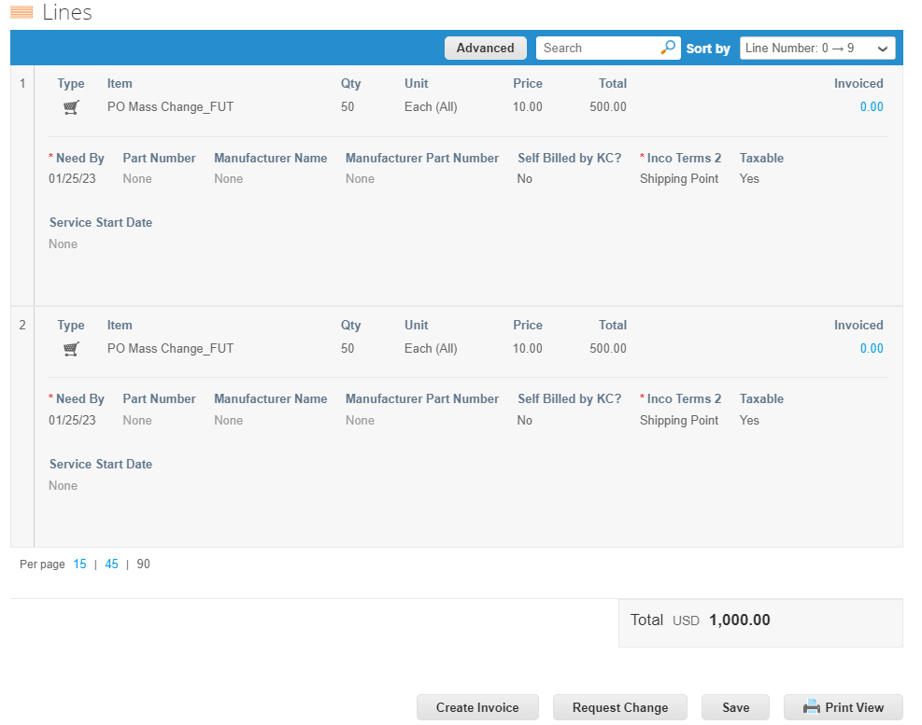

**5**

1. The **PO Lines section** becomes editable.
2. In the **PO Lines section**, make the desired edits to either of the following fields:
   1. **Need By**
   2. **Quantity**
   3. **Price**
   4. 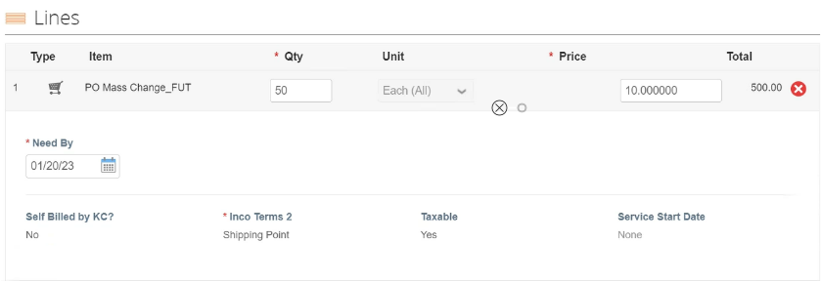**Line Delete** (click the red X to delete the entire line)

**6d**

**6c**

**6b**

**6a**

1. Select a reason for change from the **Reason for Change** drop-down list.
   1. Select **Other** to activate and type a reason.
2. Click the **Submit Change Request** to submit.
   * Click the **Save Change Request** button to save changes but not submit the request.
   * Click **Request PO Cancellation** to cancel the entire PO.

**7**

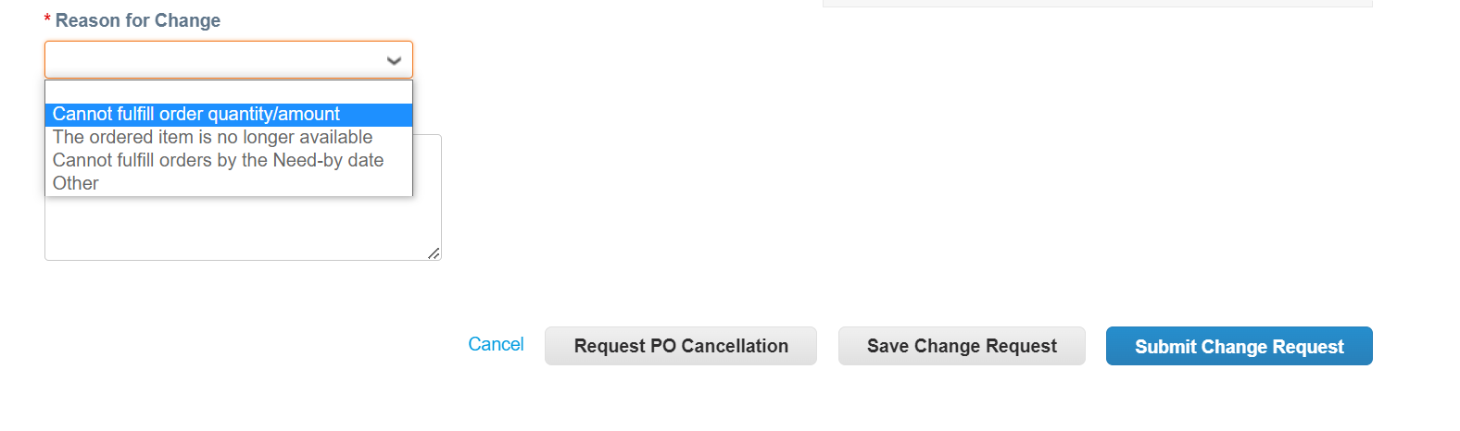

**8**

|  |  |
| --- | --- |
|  | **Note:** K-C will review the change request or cancellation request and send notification of acceptance or denial.You will receive an updated PO from K-C and you will still have the ability to submit other invoices. |

**Return to Table of Contents**

### How to Create an Advance Shipping Notice (ASN) in the CSP

Description: The CSP allows you to send advance notice to your customers about when you ship items.

|  |  |
| --- | --- |
|  | **Note**: ASNs are not an expected requirement for transacting within Coupa with Kimberly-Clark. |

1. 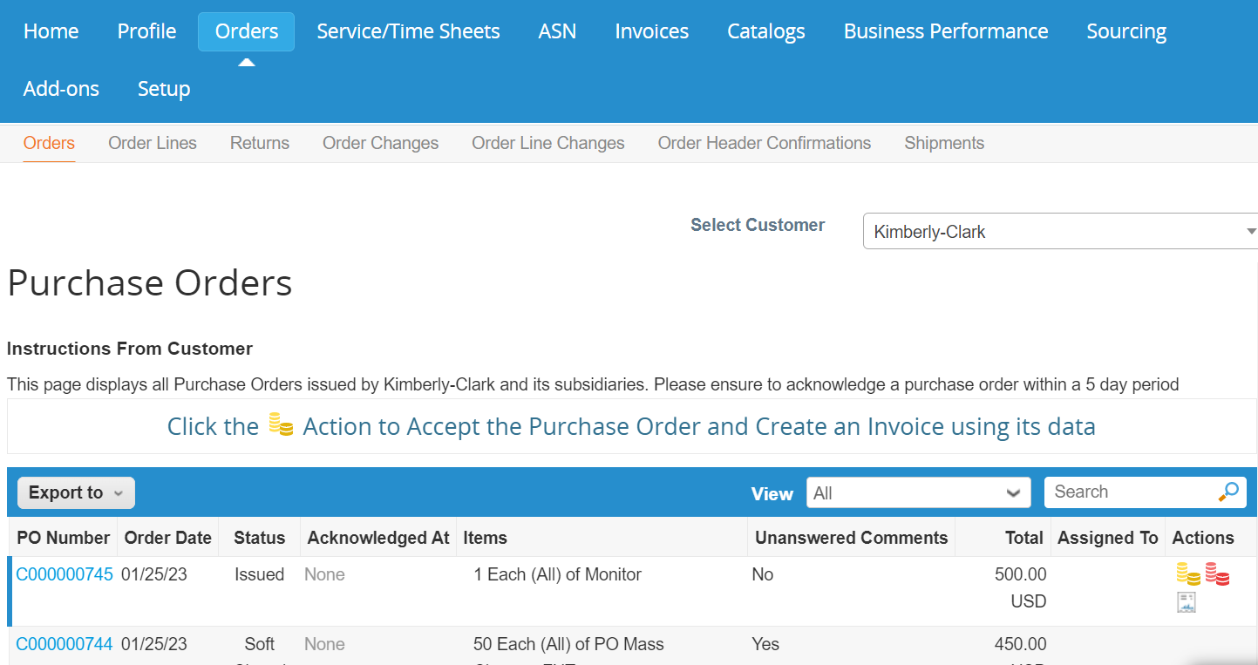From your **CSP Home** screen, select the **Orders** tab.

**1**

1. Identify the Purchase Order for which you would like to create an ASN.
2. Select the **Flip to ASN** icon.

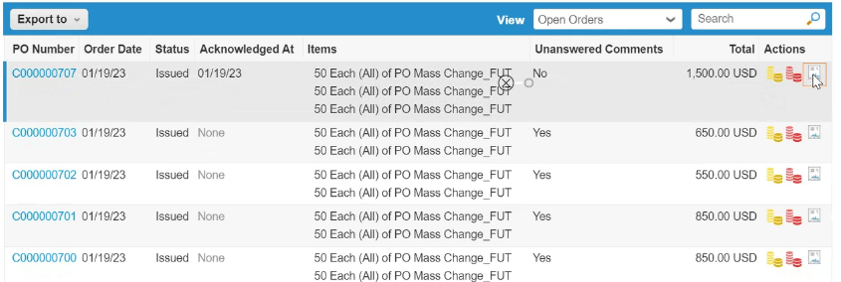

**2**

**3**

1. Enter the details for the ASN in the following sections:
   1. **ASN #**
   2. **Ship To** (this address will autofill from the PO)
   3. **Shipping Info**

|  |  |
| --- | --- |
|  | **Note**: You will need to provide K-C with your ASN numbers for related shipments or those ASNs that are provided to you from third-party logistics (3PL) companies. |

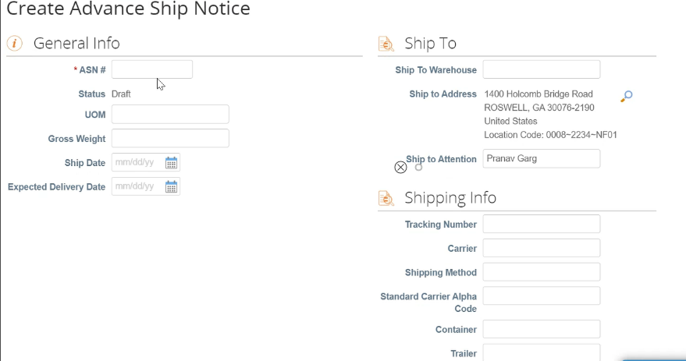

**4a**

**4c**

**4b**

1. Enter any **Comments** to K-C (if applicable).
2. 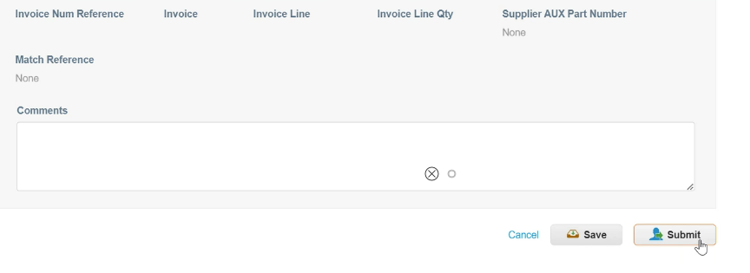Click the **Submit** button.

**5**

**6**

**Return to Table of Contents**

### How to Create Invoices in the CSP (Flipping a PO)

Description: The CSP allows you to quickly transfer a PO into an invoice (i.e., flip a PO) and send to your customers.

1. From your **CSP Home** screen, select the **Orders** tab.

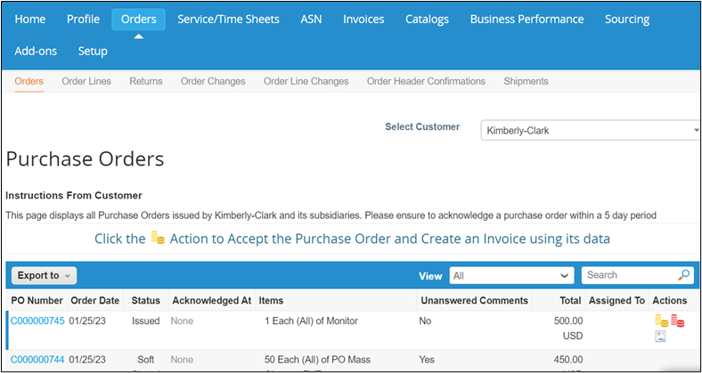

**1**

|  |  |
| --- | --- |
|  | **Note**: If this is your first-time invoicing Kimberly-Clark, you will need to accept the Coupa Supplier Portal’s updated Invoicing Terms of Use before continuing. |

* 1. Click the **I Accept** button (if applicable).

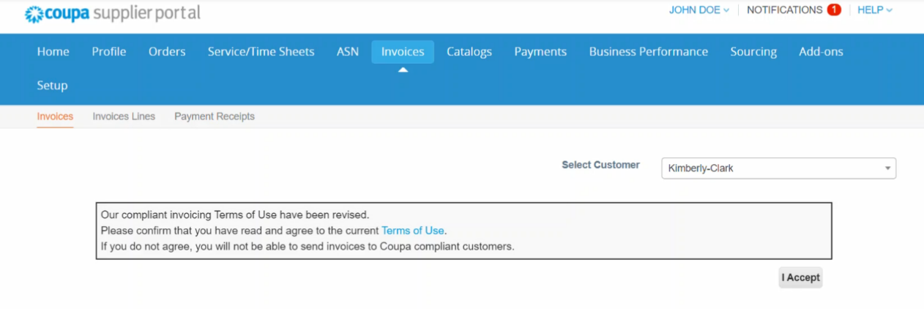

**1a**

1. In the **Actions** column, click the **Gold Coins** icon associated to PO for which you want to create an invoice.



**2**

1. The **Choose Invoicing Details** popup window appears.
2. Select the **Legal Entity** drop-down lists and choose your legal entity.
   * The information for the **Invoice From, Remit-To and Ship From Address** fields will autofill with the address details that are associated to your legal entity after it is selected.
3. Click the **Save** button.

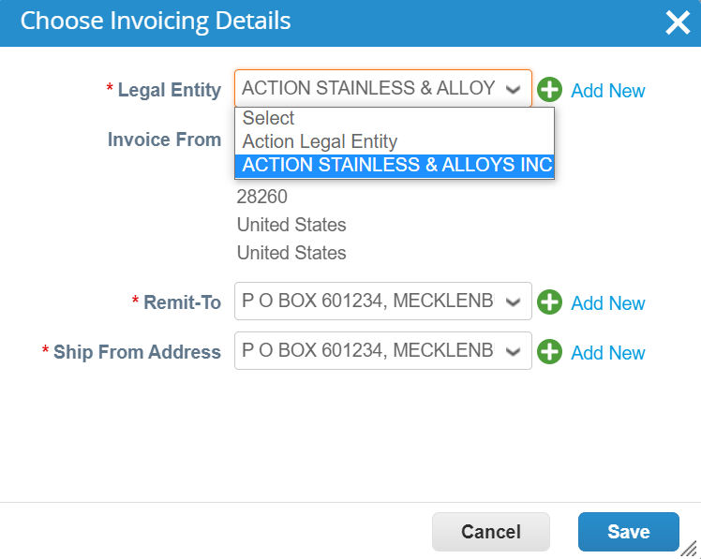

**3**

**4**

**5**

1. The **Create Invoice** screen appears.
2. Enter the invoice number in the **Invoice #** field.

The following fields autofill from the PO:

* + **Invoice Date** (the invoice must be dated within 7 calendar days of the current date)
  + **Payment Terms**
  + **Currency**
  + **Supplier**
  + **Invoice From Address**
  + **Remit-To Address**
  + **Ship From Address**

1. Click the **Add File** link.
2. Click the **Browse** button to attach an original copy of the invoice.

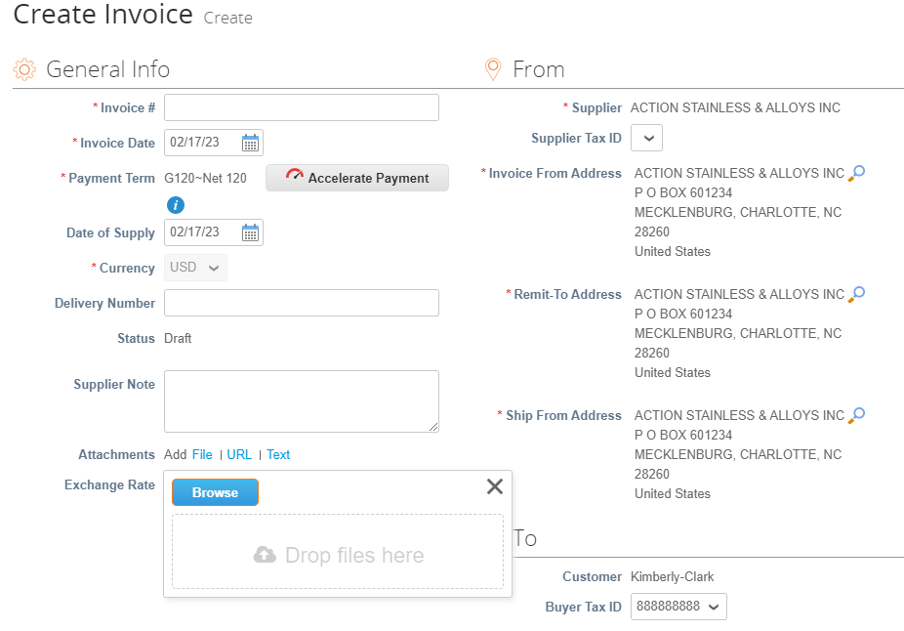

**6**

**7**

**8**

**9**

|  |  |
| --- | --- |
|  | **Note**: If the file size is more than 8MB, the invoice will be disputed. |

1. Click the **down arrow** to scroll to the **Lines** section on the **Create Invoice** screen.
2. Edit the details for the invoice lines in the following fields (if applicable):
   1. **Description**
   2. **Quantity (Qty)**
   3. **Supplier Part Number**
   4. **Withholding Tax**
   5. **NCM Code** (8-digit code that defines any goods that circulate in Mercosur countries)

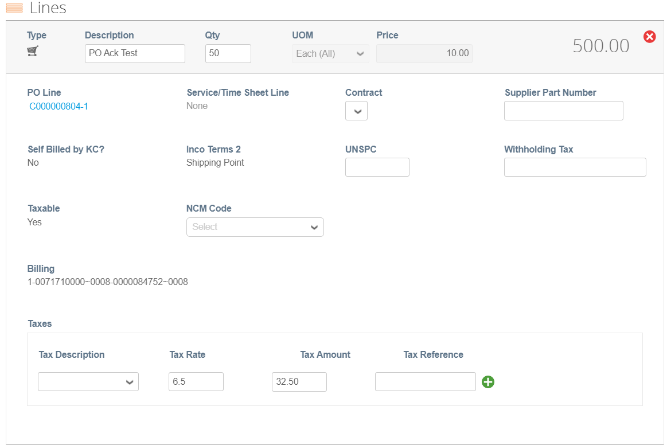

**10**

**11**

1. Click the **down arrow** to scroll to the **Totals & Taxes** section on the **Create Invoice** screen.
   1. In the **Totals & Taxes** section, apply any other header level costs associated to the PO (e.g., shipping and/or handling tax or any other miscellaneous charges) if applicable.
2. Click the **Calculate** button to verify the total amount of the invoice.
3. Click the **Submit** button.

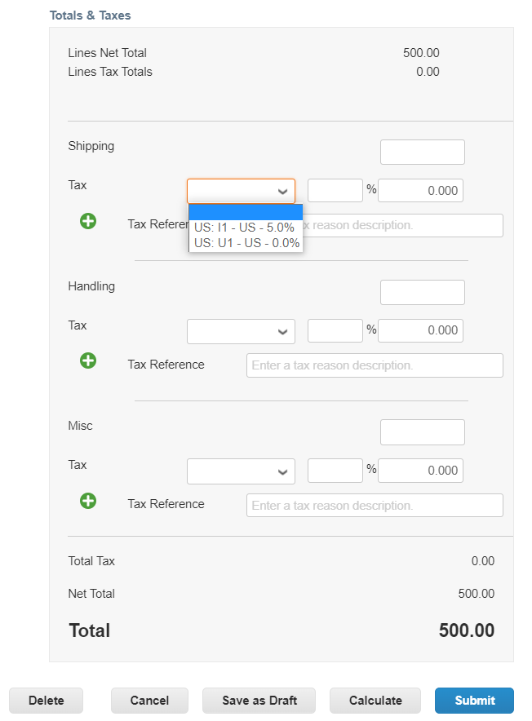

**12**

**13**

**14**

1. The **Are You Ready to Send?** popup window appears.
2. Click the **Send Invoice** button to issue the invoice.

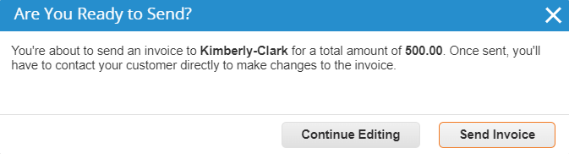

**15**

**16**

|  |  |
| --- | --- |
|  | **Note:** Per K-C processes, Service Invoices should only have one line. Service Invoices with more than one line will be disputed. |

If you receive this warning, please adjust your Service Invoice to only contain one line.

1. Click the **Continue Editing** button to make any necessary corrections.
2. Click the **Submit** button when done.

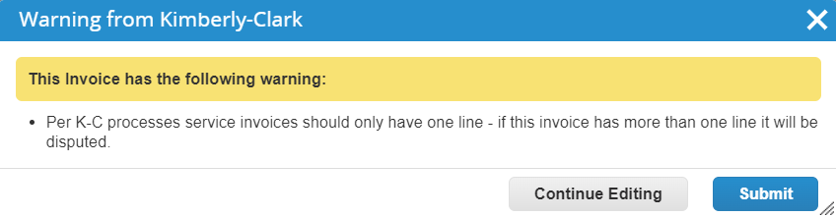

**17**

**18**

1. The **Invoices** screen appears where you are notified that your invoice is processing.

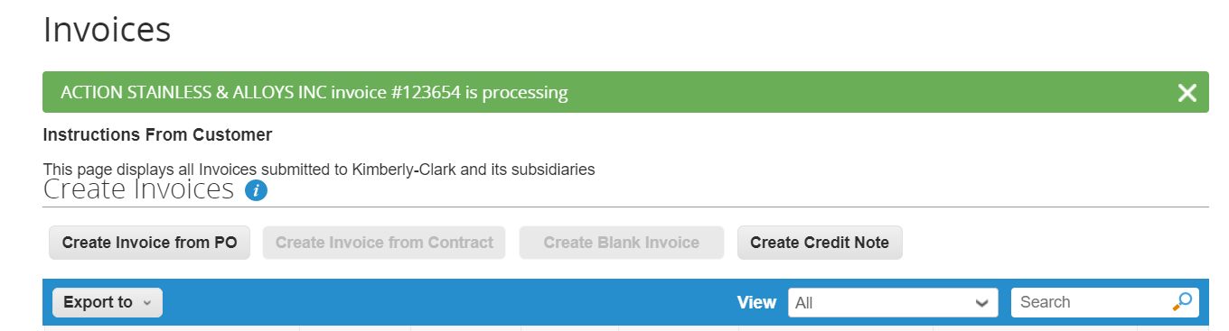

**19**

|  |  |
| --- | --- |
|  | **Note:** The invoice will move to a processing status. The invoice is now be linked and visible in K-C’s Coupa instance and in the CSP. |

|  |  |
| --- | --- |
|  | **Note:** Pending Approval status is contingent on validations processing within SAP. Once validated, the invoice status will change to Approved. |

**Return to Table of Contents**

### How to Track Invoices in the CSP

You can track the status of your invoices in the CSP once submitted.

1. From the **CSP home screen**, click the **Invoices** tab.
2. Verify the status of the invoice in the **Status** column. Statuses for the invoice are either:
   * **Approved** (invoices that are approved)

* **Disputed** (invoices that you or your customer have marked as disputed to indicate a discrepancy)
  + **Draft** (invoices that have been created, but not submitted to your customer)
  + **Pending Approval** (invoices that have not been approved by your customer yet)
* **Voided** (invoices that rejected or reversed by your customer)

1. Check the **Dispute Reason** column for comments from K-C as to the status of the invoice.
2. To Resolve the invoice, click the **Resolve** icon in the **Actions** column.

**1**

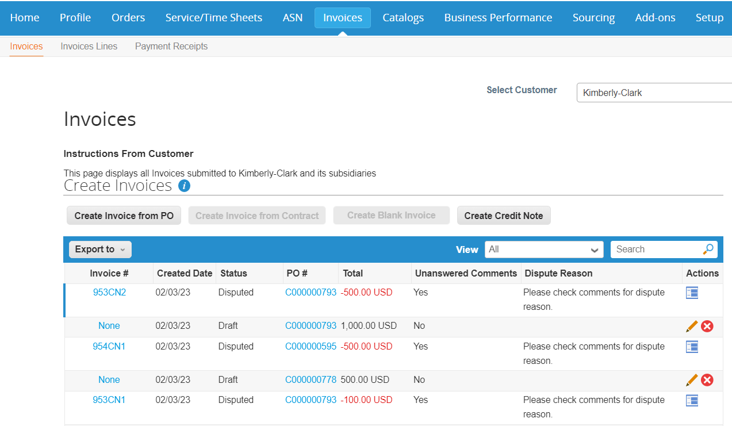

**4**

**3**

**2**

1. Click an associated **Invoice number** associated to **Disputed** status to check comments associated to a dispute reason.



**5**

1. Click the **Drop-down** **arrow** to view comments from K-C and determine a resolution for the noted dispute(s).

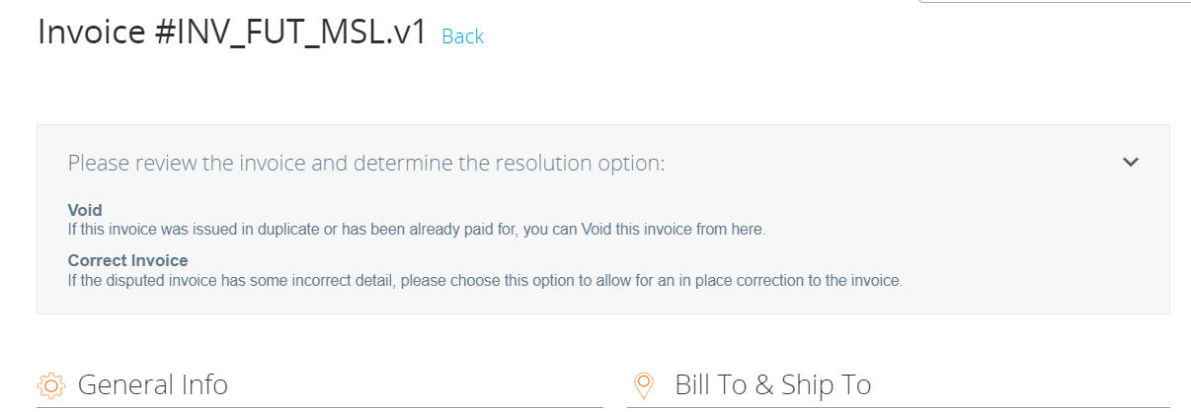

**6**

**Return to Table of Contents**

### How to Create a Credit Note in the CSP

1. From the **CSP home** screen, click the **Invoices** tab.
2. 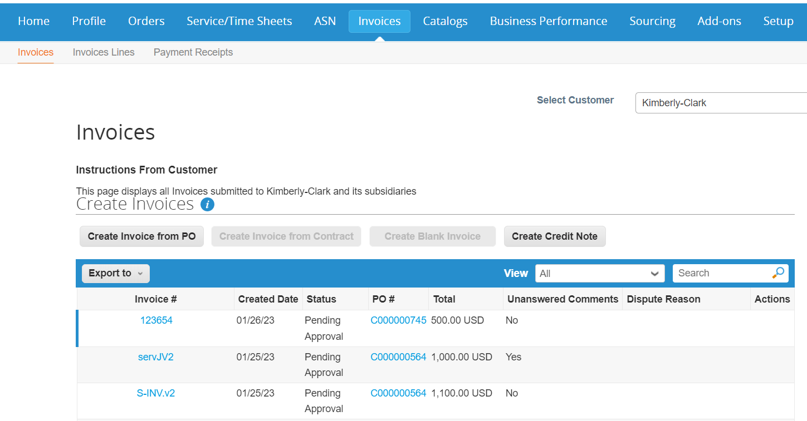Click the **Create Credit Note** button.

**1**

**2**

1. The **Credit Note** popup window appears.
2. Click the **Resolve issue for invoice number** radio button.
3. Select the appropriate invoice number from the dropdown list.
4. Click the **Continue** button.

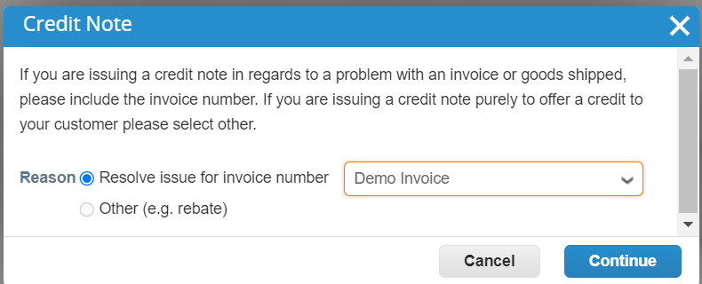

**3**

**4**

**5**

**6**

|  |  |
| --- | --- |
|  | **Note:** As a best practice, be sure to capture the invoice number as it will be entered later in this process. |

1. The **How do you want to correct invoice** popup window appears.
2. Select the appropriate choice from the following radio button options:
   * **Completely cancel the invoice with a credit note**
   * **Adjust invoice with a credit note**
3. Click the **Create** button.

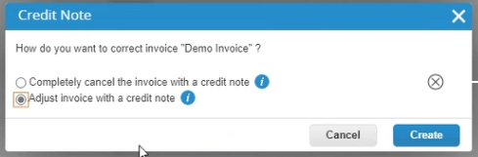

**7**

**8**

**9**

1. The **Create Credit** Note screen appears.
2. Enter the invoice number in the **Credit Note #** field.

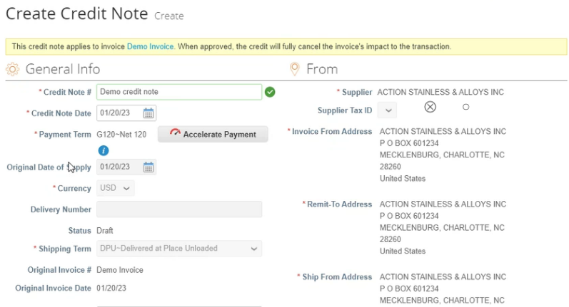

**10**

**11**

|  |  |
| --- | --- |
|  | **Note:** Many of the credit note fields have been prepopulated with the data from the purchase order. |

1. Click the down arrow to scroll to the **Totals & Taxes** section on the **Credit Note** screen.
   * In the **Totals & Taxes** section, apply any other header level costs associated to the PO (e.g., shipping and/or handling tax or any other miscellaneous charges).
2. Click the **Calculate** button to verify the total for the credit note.
3. Click the **Submit** button to submit the credit note.

**12**

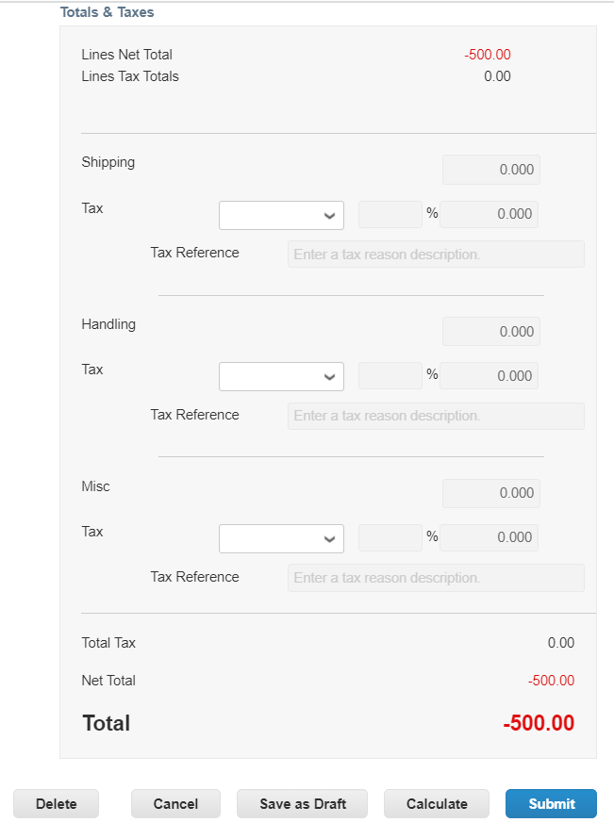

**13**

**14**

1. The **Are You Ready to Send?** popup window appears.
2. Click the **Send Credit Note** button.

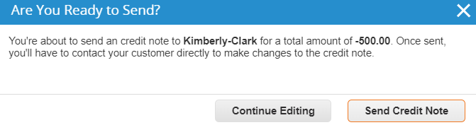

**15**

**16**

1. The **Credit Note** screen appears to inform you that the credit has not been applied and will fully cancel the invoice when approved.

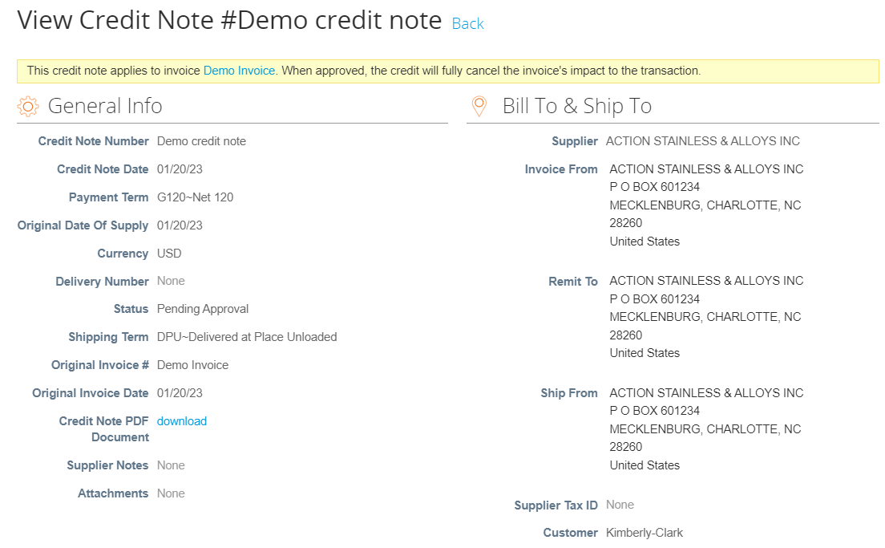

**17**

**Return to Table of Contents**

### How to View Payment Confirmation Details in the CSP

1. From the **CSP home** screen, click the **Invoices** tab.
2. Select **View** from the drop-down list to filter the search for the invoice from the views available.
   1. Payment confirmation views consist of the following:
      * **Overdue invoices**
      * **Paid invoices**
      * **Payment information**
      * **Unpaid invoices**

**1**

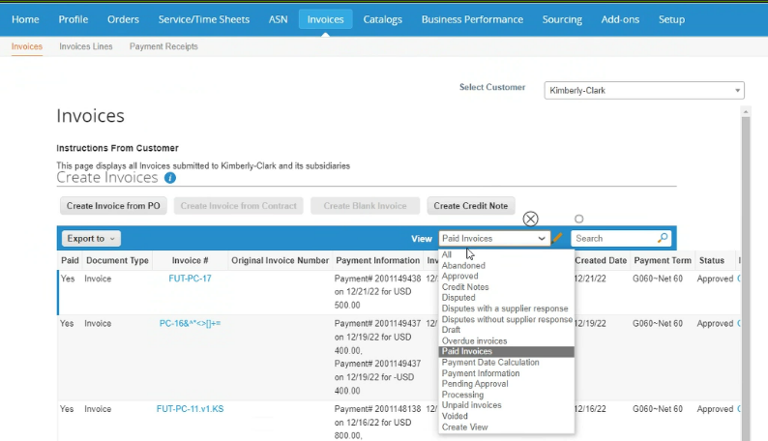

**2a**

1. Click the **Export to** button if you would like to export an Excel, CSV or .ZIP file for selected view.
2. Select the file type.

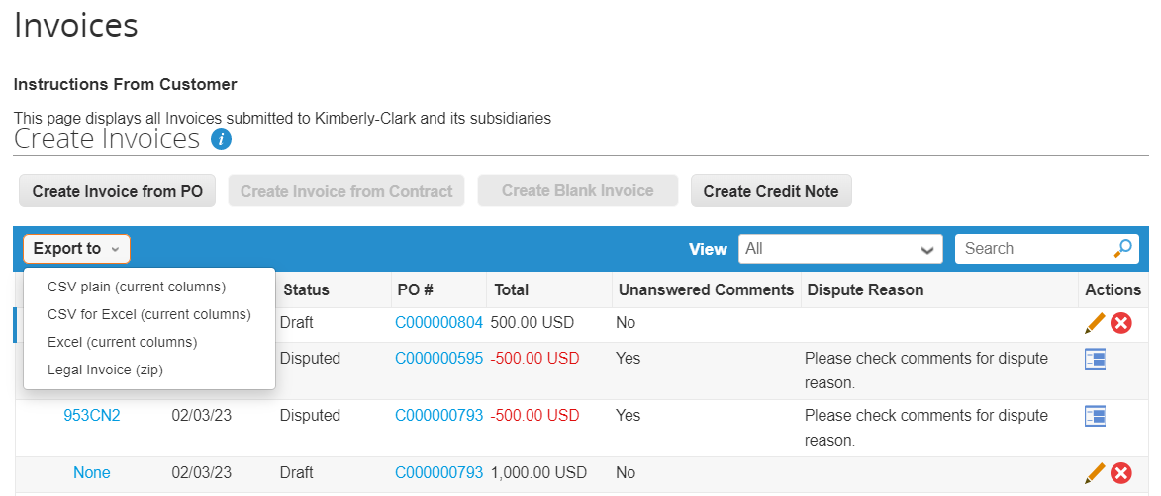

**3**

**4**

1. The notification appears that the **Data you requested will be emailed to you**.

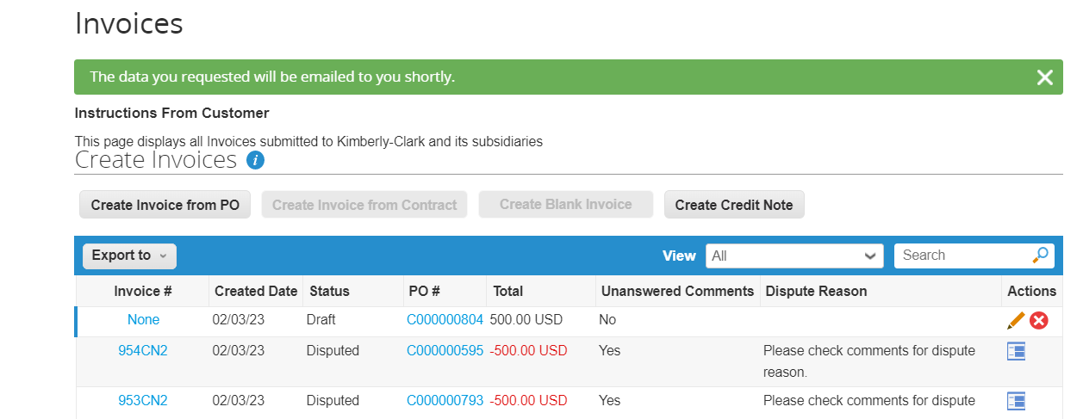

**5**

**Return to Table of Contents**

## Additional Resources

* + [How to Onboard as a New Supplier for Suppliers – Quick Reference Card](https://kimberlyclark.sharepoint.com/:w:/r/sites/i797/Learning%20Document%20Library/STP_QRC_How%20to%20Onboard%20as%20a%20New%20Supplier%20(for%20Suppliers)_Coupa_NA_EN%20.docx?d=w55c3a46d0f384683846448df0d046cb6&csf=1&web=1&e=IPevsI)
  + [How to Request Change Order in the CSP – Bite Size Learning](https://kimberlyclark.sharepoint.com/:v:/r/sites/i797/Learning%20Document%20Library/STP_BSL_%20How%20to%20Request%20Change%20Order%20in%20CSP_Coupa_NA_EN.mp4?csf=1&web=1&e=OTRgfQ)
  + [How to Setup a Legal Entity in the CSP – Bite Size Learning](https://kimberlyclark.sharepoint.com/:v:/r/sites/i797/Learning%20Document%20Library/STP_BSL_How%20to%20Setup%20a%20Legal%20Entity%20in%20CSP_Coupa_NA_EN.mp4?csf=1&web=1&e=BL6YLV)
  + [How to Create a Credit Note in the CSP – Bite Size Learning](https://kimberlyclark.sharepoint.com/:v:/r/sites/i797/Learning%20Document%20Library/STP_BSL_How%20to%20Create%20a%20Credit%20Note%20in%20CSP_Coupa_NA_EN.mp4?csf=1&web=1&e=6hQkLO)
  + [How to Create Invoices in the CSP – Bite Size Learning](https://kimberlyclark.sharepoint.com/:v:/r/sites/i797/Learning%20Document%20Library/STP_BSL_How%20to%20Create%20an%20Invoice%20in%20CSP_Coupa_NA_EN.mp4?csf=1&web=1&e=wnQIFD)
  + [How to Manage a Legal Entity in the CSP – Bite Size Learning](https://kimberlyclark.sharepoint.com/:v:/r/sites/i797/Learning%20Document%20Library/STP_BSL_How%20to%20Manage%20a%20Legal%20Entity%20in%20CSP_Coupa_NA_EN.mp4?csf=1&web=1&e=9XDq5N)
  + [How to Submit Vendor Acknowledgement in the CSP – Bite Size Learning](https://kimberlyclark.sharepoint.com/:v:/r/sites/i797/Learning%20Document%20Library/STP_BSL_How%20to%20Submit%20Vendor%20Acknowledgment%20of%20PO%20in%20CSP_Coupa_NA_EN.mp4?csf=1&web=1&e=m7g7rZ)
  + [How to View and Search Invoices in the CSP – Bite Size Learning](https://kimberlyclark.sharepoint.com/:v:/r/sites/i797/Learning%20Document%20Library/STP_BSL_How%20to%20View%20and%20Search%20Invoices%20in%20CSP_Coupa_NA_EN.mp4?csf=1&web=1&e=9kVfVi)
  + [How to View and Search Purchase Orders in the CSP – Bite Size Learning](https://kimberlyclark.sharepoint.com/:v:/r/sites/i797/Learning%20Document%20Library/STP_BSL_How%20to%20View%20and%20Search%20PO%20in%20CSP_NA_EN.mp4?csf=1&web=1&e=haLIjN)