

Powering K-C’s digital future



How to Manage Supplier Hosted Catalogs in the Coupa Supplier Portal (CSP)

*For the best learning experience, please click the* ***Editing*** *button and select* ***Open in Desktop*** *to view this document in your desktop application of Microsoft Word. Viewing this document in SharePoint or in-browser may distort the placement of images and text.*

Table of Contents

Table of Contents 1

Purpose 2

Key Terms 2

Prerequisite Information for Catalog Setup 3

Verify Catalog Setup 3

How to Manage Supplier Hosted Catalogs in the CSP 4

How to Create or Edit Catalog Items for Bulk Upload 7

Additional Resources 11

|  |  |
| --- | --- |
|  | **Your screen in Coupa may differ slightly from this training, but the steps to complete the activity will be the same.** |

|  |  |
| --- | --- |
| Warning outline | **Your screen in the Coupa Supplier Portal may differ slightly from this training, but the steps to complete the activity will be the same.** |

|  |  |
| --- | --- |
|  | **This icon indicates there are further policy or business process details relating to a step. Click on the provided link(s) placed throughout the QRC for more information.** |

## Purpose

This Quick Reference Card (QRC) explains the process for how to manage catalogs in the Coupa Supplier Portal (CSP).

* **Task 1:** How to Manage Supplier Hosted Catalogs in the CSP
* **Task 2:** How to Create/Edit Catalog Items for Bulk Upload in the CSP

## Key Terms

* + **n Items Changed (n Unchanged)** are the total number of items that changed and did not change in the catalog.
  + **Price Increase** is the total number of items in the catalog that increased in price. New items do not appear in this count.
  + **Price Decrease** is the total number of items in the catalog that decreased in price. New items do not appear in this count.
  + **Other Fields Updated** is the total number of items that were modified in a way other than a change in price.
  + **New Items** are the total number of new items included in the catalog since the last upload or creation of new items.
  + **Deactivated Items** are the total number of items that are no longer available in the catalog or search within Coupa.

## Prerequisite Information for Catalog Setup

All Supplier Hosted Catalogs with Kimberly-Clark (K-C) will be initially loaded by the K-C team to ensure K-C required fields are properly populated on the item record.

Additionally, this will ensure the accurate application of your contract specifications, including tiered or plant-based pricing (if applicable), any applicable SAP Material Numbers, catalog access control for content groups and other critical information for your catalog(s) item record within K-C Coupa. Once loaded and published by K-C you will be able to manage the catalogs in the Coupa Supplier Portal.

Additional details around K-C’s requirements are below:

* + K-C requires all catalogs to have a contract assigned to them.
  + K-C requires separate catalogs be maintained for plant-based and tiered-pricing to allow contract records to align to their specified pricing model.
  + K-C requires all items to have the corresponding K-C commodity assigned to them.

## Verify Catalog Setup

To verify that your catalog(s) have been loaded perform the following steps:

1. From your **CSP Home Page,** click the **Catalogs** tab in the menu bar.

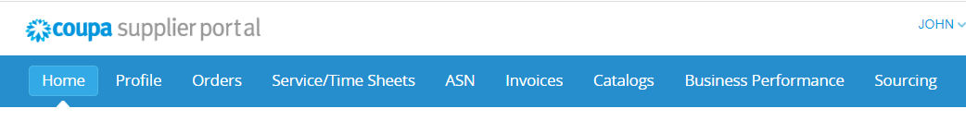

**1**

1. Click the **Select Customer** drop-down listand select **Kimberly-Clark**.
2. Click the **View** drop-down list and select **Accepted** (your list view will populate with all catalogs that have been accepted by K-C).

**2**

* 1. 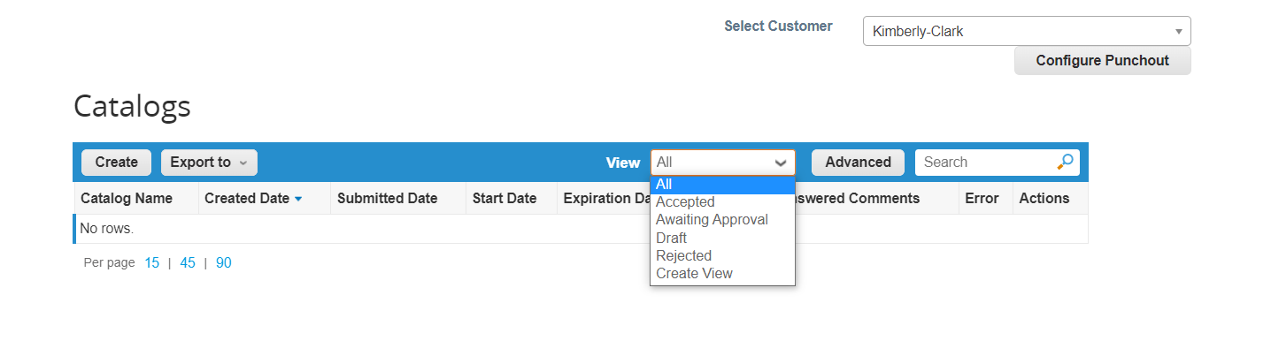

|  |  |
| --- | --- |
|  | **Note:** If you do not see any catalogs or a specific catalog that you are trying to identify, contact your K-C point-of-contact (POC) for information related to its setup. |

**3a**

**6**

## How to Manage Supplier Hosted Catalogs in the CSP

Please follow the steps outlined below to perform the task.

1. From your **CSP Home Page,** click the **Catalogs** tab in the menu bar.



**1**

1. Click the **Select Customer** drop-down listand select **Kimberly-Clark**.
2. Under the **Actions** column:

* Click the **Edit** icon (pencil) to edit an existing catalog.
* Click the **Red X** icon to delete an existing catalog from the **Catalogs** table.

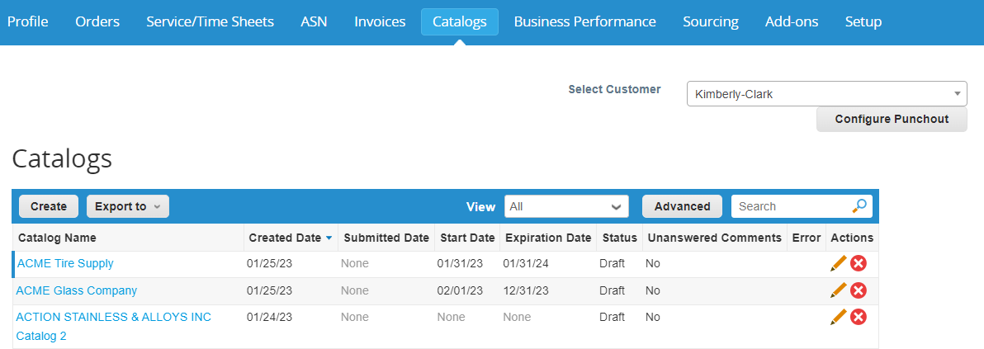

**2**

**3**

|  |  |
| --- | --- |
|  | **Note:** You will need to contact your K-C point-of-contact (POC) for information related to:   * Contract * Catalog Name(s) * Item Numbers * Item Name * Currency Type |

1. Edit the information in the following fields (if applicable):
   * **Catalog Name** (required * - follow the original catalog naming convention provided to you from K-C)
   * **Start Date** (if applicable, add date when your catalog pricing becomes effective)
   * **Expiration Date** (if applicable, add date when your catalog pricing expires)

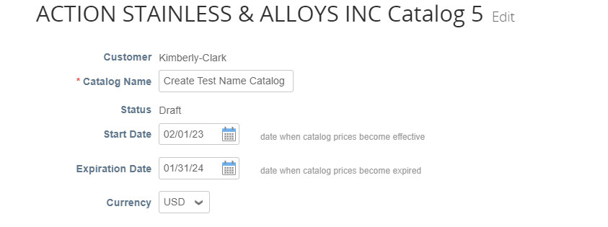

**4**

1. Click the **down arrow** to scroll to the next section, **Supplier Item Attributes**, on the **Catalog** page.
2. Edit the information in the following required fields:
   1. **Part Number** (you must contact K-C, this must be a unique number provided to you from K-C)
   2. **Contract** (required *, you must choose a contract in active status with K-C)
   3. **Price** (enter the net item price)
   4. **Currency** (select the currency type associated to your contract)
3. Click the **Save** button when you have completed all desired edits. 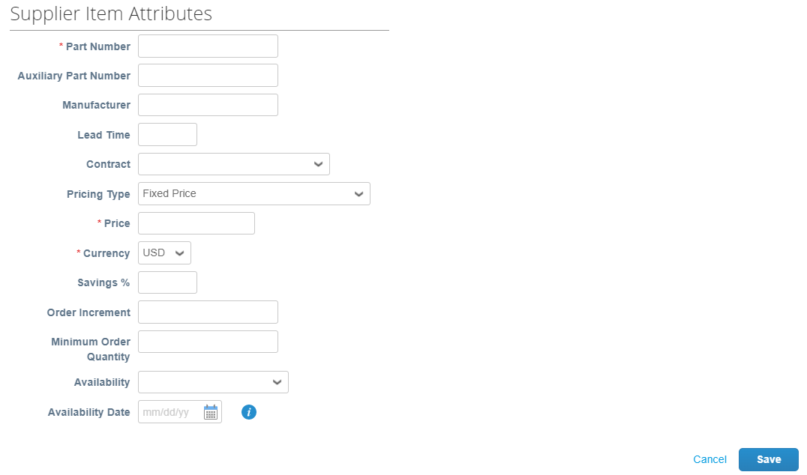

**5**

**6a**

**6b**

**6c**

**6d**

**7**

|  |  |
| --- | --- |
|  | **Note:** You will need to keep and maintain separate catalogs for items that are assigned to plant-based and/or tiered pricing structures. |

1. You will be redirected back to the **Catalog dashboard** screen (the dashboard will reflect any applicable changes made).
2. Click the **Save** button to save the changes.
3. Click the **Submit for Approval** button to submit your catalog edits for approval.

**8**

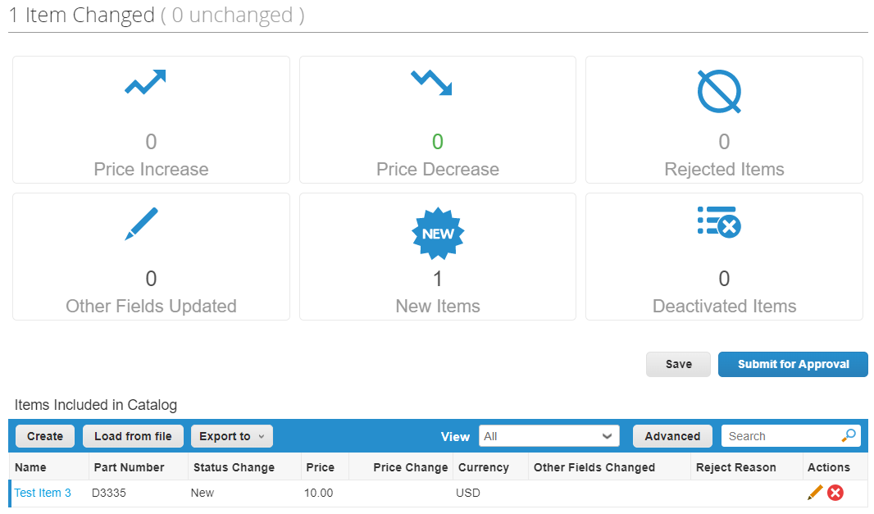

**9**

**10**

1. The **Catalog was successfully updated and awaiting approval** notification appears.

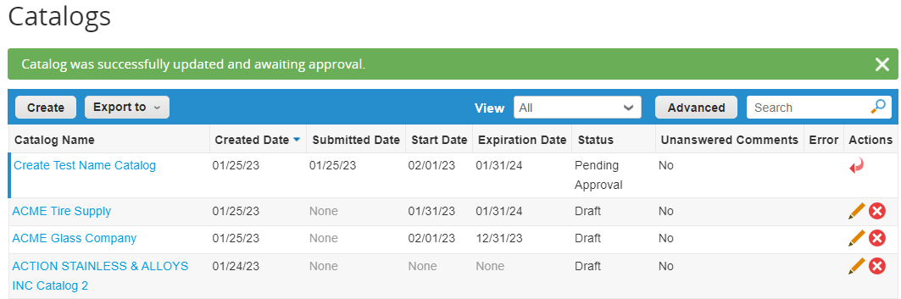

**11**

|  |  |
| --- | --- |
|  | **Note:** You will receive an email informing you of the approval status. Please contact your point-of-contact at K-C for tracking/status related information. |

## How to Create or Edit Catalog Items for Bulk Upload

Please follow the steps outlined below to perform the task.

1. From your **CSP Home Page,** click the **Catalogs** tab in the menu bar.



**1**

1. Click the **Select Customer** drop-down listand select **Kimberly-Clark**.
2. Under the **Actions** column, click the **Edit** icon (pencil) to edit an existing catalog from the catalog in the **Catalogs** table.
   * Click the **Red X** icon to delete an existing catalog from the **Catalogs** table.



**2**

**3**

1. Scroll below the **Item Changed/Unchanged (dashboard)** section.
2. Click **the Load from File** button.



**5**

**4**

1. Click the **Download button** and select your desired file type (CSV Plain or CSV for Excel).

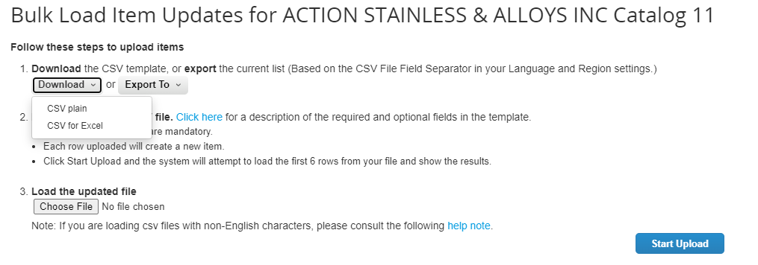

**6**

1. The template will download. Complete the following required column header fields:
   * **Supplier Part Number** (enter the part number from your system)
   * **Part Name** (item naming convention must match the Coupa Item master)
   * **Description** (item description must match the Coupa Item master)
   * **Price**
   * **Currency**
   * **Unit of Measure (UoM) code** (refer to item master)
   * **Active [yes or no] -** indicate if item is an active catalog item

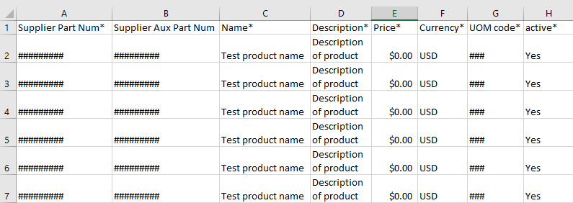

**7**

|  |  |
| --- | --- |
|  | **Note:** Do **not** change the column header names in the .CSV file. Please provide information in the other column headers as applicable. |

1. After making completing your edits, click the **Chose File** button start the upload process.
2. Click the **Start Upload** button when your file loads.

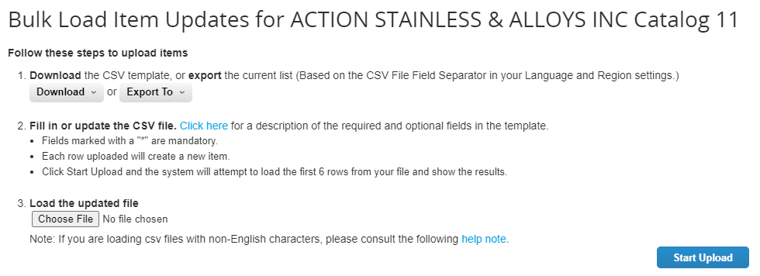

**8**

**9**

1. Verify the data from your file. Once complete click the **Finish Upload** button.
   * Click **Cance**l if you need to correct data in the .CSV file, and then upload it again.

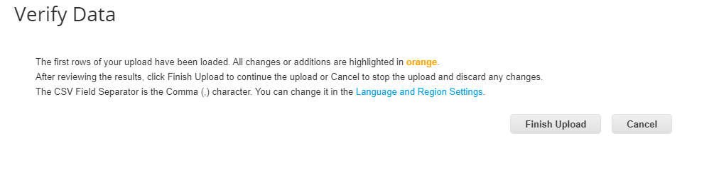

**10**

If there is an error with any of the data you have input, you will receive an **Error Generating Sample** notification.

1. CSP identifies the error number and error location on the file for all errors that need correction.
2. Click the **Back** button and re-upload the file.

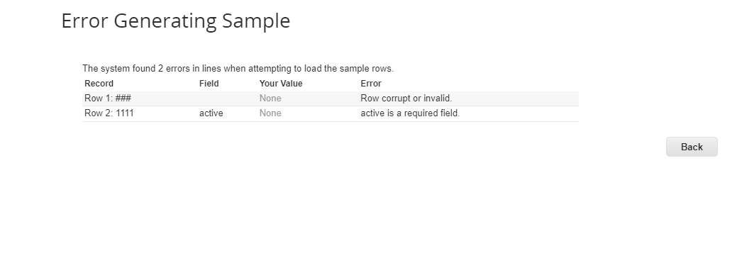

**11**

**12**

Re-upload the file until you receive a confirmation of successful upload.

1. The notification **Upload completed successfully** appears.
2. Click the **Done** button.

**13**



**14**

**8**

**6**

## Additional Resources

* [How to Navigate the Coupa Supplier Portal](https://kimberlyclark.sharepoint.com/:w:/r/sites/i797/Learning%20Document%20Library/STP_S4_QRC_How%20to%20Navigate%20and%20Use%20Coupa%20Supplier%20Portal_NA_EN.docx?d=w857c929c292a4c3dad98a2a233225bd8&csf=1&web=1&e=NXQO8K) – Quick Reference Card