

Powering K-C’s digital future



How to Complete a Periodic Recertification Request for Suppliers

*For the best learning experience, please click the Editing button and select Open in Desktop to view this document in your desktop application of Microsoft Word. Viewing this document in SharePoint or in-browser may distort the placement of images and text.*

Table of Contents

Purpose 2

Key Terms 2

Responding to and Completing a Periodic Recertification 3

Delegating Response to a Periodic Recertification 7

Submitting Response to a Periodic Recertification 9

Additional Resources 10

Change Version 10

|  |  |
| --- | --- |
| Warning outline | **Your screen in the Coupa Supply Portal may differ slightly from this training, but the steps to complete the activity will be the same.** |
| Warning outline | **Your screen in the Coupa Supply Portal may differ slightly from this training, but the steps to complete the activity will be the same.** |



|  |  |
| --- | --- |
|  | **This icon indicates there are further policy or business process details relating to a step. Click on the provided link(s) placed throughout the QRC for more information.** |

## Purpose

This Quick Reference Card (QRC) explains the process for responding to and completing a periodic recertification request.

* **Task 1:** Responding to and Completing a Periodic Recertification Questionnaire
* **Task 2:** Delegating a Response to a Periodic Recertification Questionnaire
* **Task 3:** Submitting Responses to a Periodic Recertification Questionnaire

## Key Terms

* + **Coupa Risk Assess (CRA)** is asystem that connects all parties involved in risk management to collaborate on reducing the cost of compliance, minimizing risk and maximizing the value of their relationships.
  + **Coupa Supplier Portal (CSP)** is a web portal designed to assist suppliers in managing their business transactions with Kimberly-Clark
  + **Due Diligence Questionnaires (DDQ)** are forms used both internally and externally to assist in evaluating retained information on a potential supplier’s data security, legal, financial, and other aspects of their organization to help identify and mitigate risk.
  + **Recertification** is the process of periodically reassessing the level of risk for suppliers via due diligence questionnaires.
  + **Risk Domains** are identified areas used to frame the types of controls that should be evaluated during supplier risk assessment to help guide risk management.

## Responding to and Completing a Periodic Recertification

Kimberly-Clark has varying Due Diligence Questionnaires to support its risk programs. Periodically, information gathering for recertification for in-scope areas of risk will be required. The completion of recertification questionnaires is an automated process that adheres to the predetermined recertification criteria from Kimberly-Clark.

Please follow the steps below to respond to and submit a periodic recertification questionnaire.

The individual designated as the CSP primary contact will receive an email notification from Kimberly-Clark with instructions.

1. Click the **R. Portal** linkto access the questionnaire.
   1. Suppliers can also access the Chatbot Link to communicate with Kimberly-Clark if further assistance is needed.
   2. Suppliers can also access additional training resources from Kimberly-Clark if further assistance is needed.

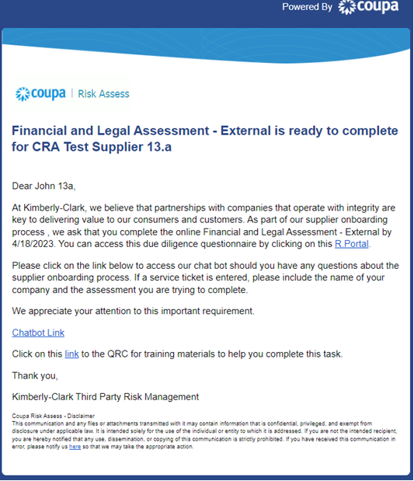

**1**

**1a**

**1b**

The **Coupa home screen** appears.

1. Click the **Suppliers** tab.

**2**

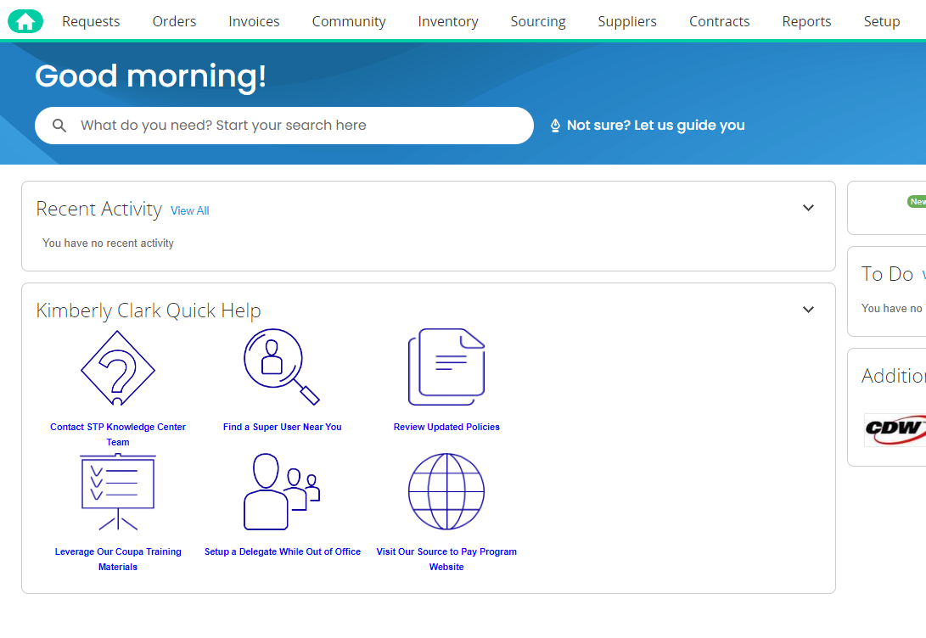

1. Click the **Risk Assess** subtab.

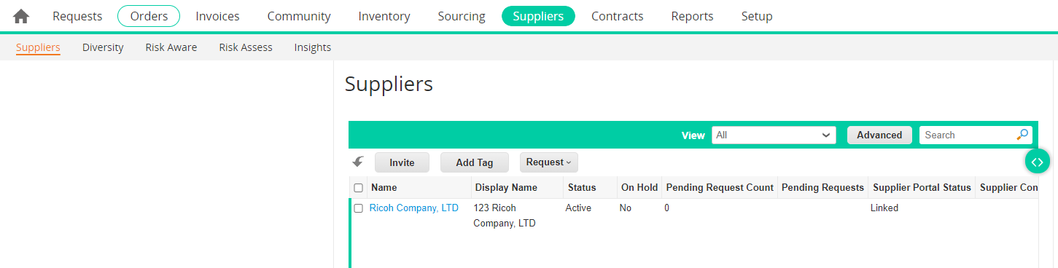

**3**

The **Coupa Risk Assess Dashboard** appears.

1. Locate the **Evaluations** tile and click the **Show Me All** link.
   * Review the list for open evaluations.
2. Click the **View** button to open the appropriate (pending) questionnaire.

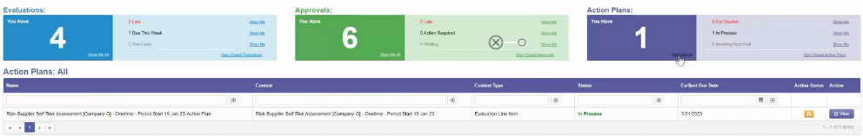

**4**

**5**

The Recertification form will load with prepopulated data that was provided at the initial form completion.

1. Click the **Instructions** link (if available) to expand the questionnaire’s instructions.

|  |  |
| --- | --- |
|  | **Note:** Suppliers will only edit information on the form that needs to be updated and/or upload any supporting documentation.  Please provide those requested documents via upload where applicable. |

1. Click the **Upload** button to attach supporting documents (if applicable).

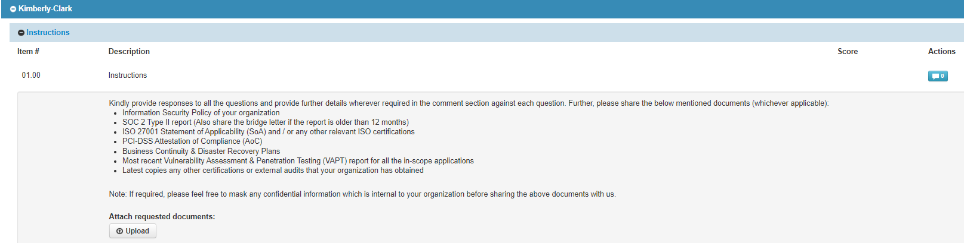

**6**

**7**

**3a**

Questions are organized by section title. Be sure to expand each section to review responses. A section may contain either one (1) or a grouping of several questions.

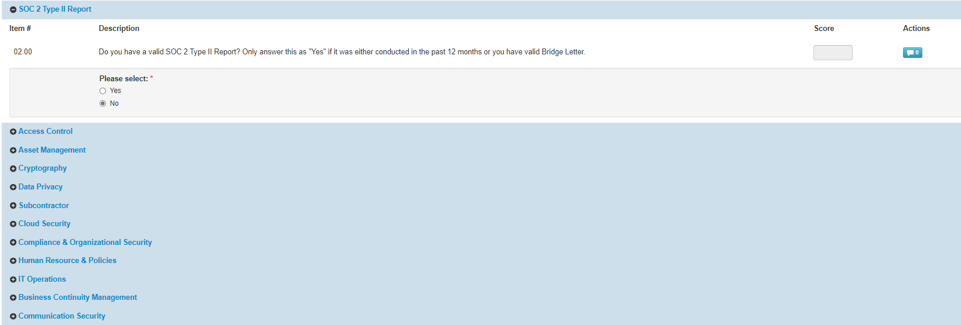

1. Click the **(+)** icon to expand the question sections’ details.

**7a**

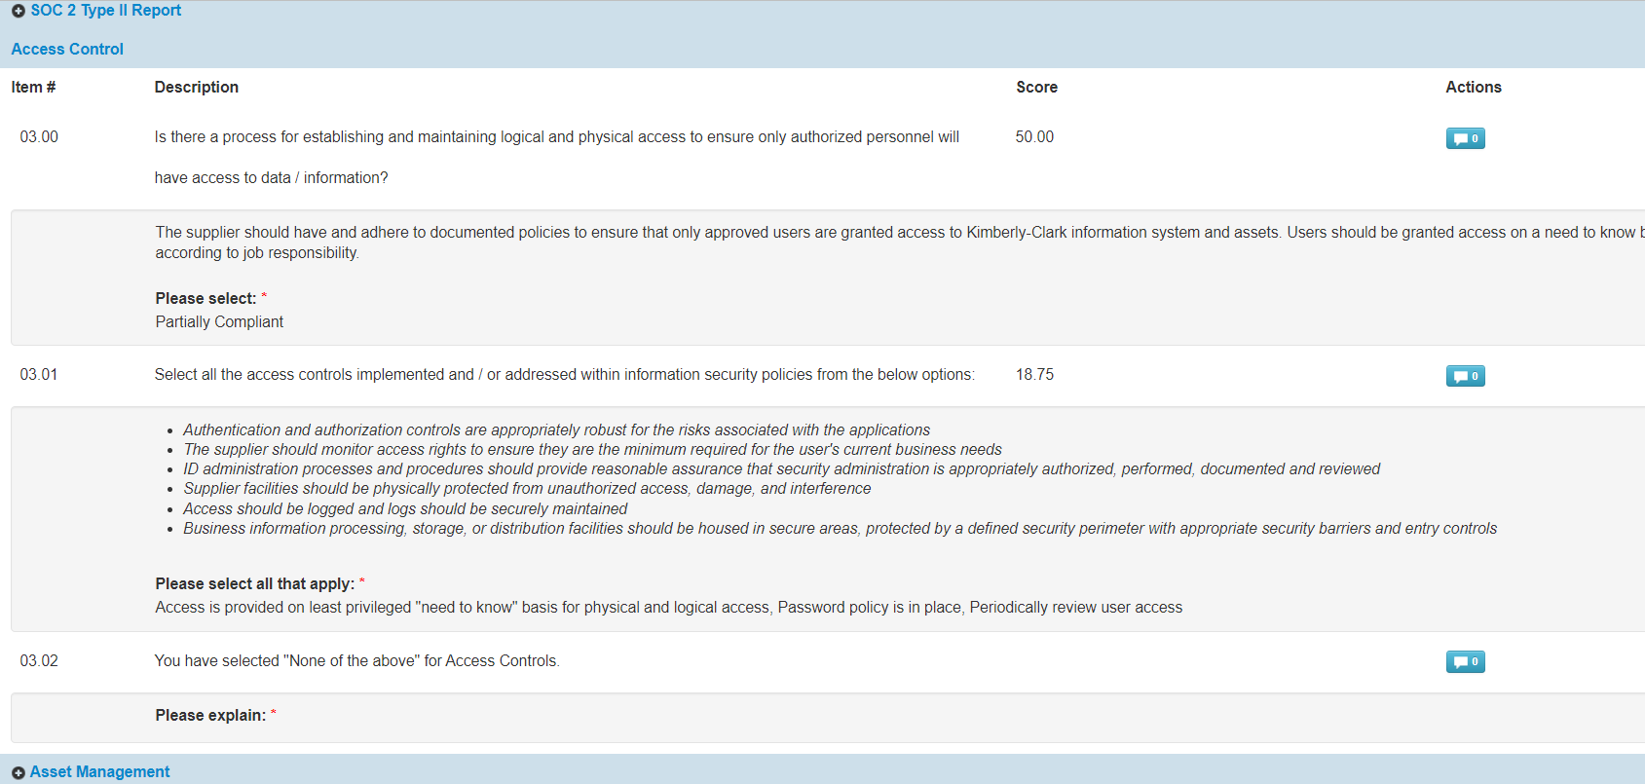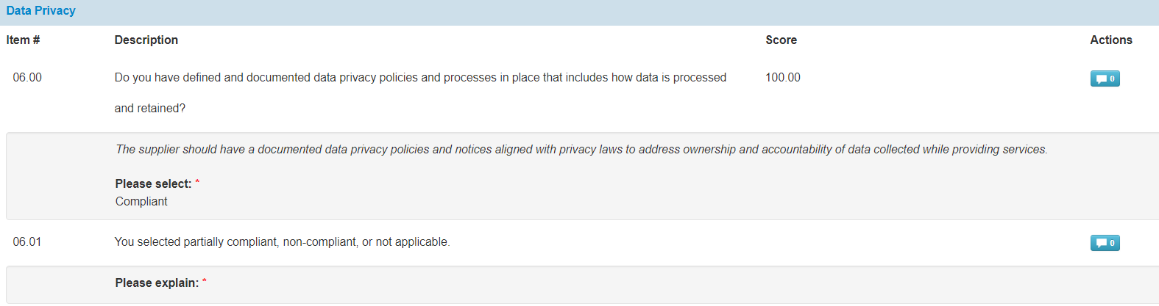

For those question sections that do not feature an upload button, comments and documentation can still be provided by clicking the **Actions** button.

1. Click the **Actions** button to add any comments to the questionnaire for Kimberly-Clark to receive.



**8**

1. Enter a comment in the **Comments** field to add additional information regarding attached information, ask questions, or to provide more detail about responses to action item(s) indicated in the plan.
2. Click the **Attachments** tab to add supporting attachments (if applicable).
3. Click the **Save & Close** button when complete.

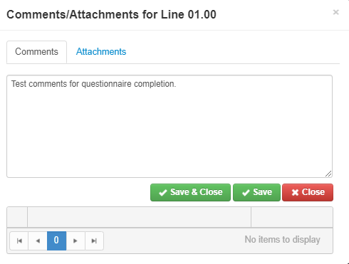

**a**

**9**

**b**

## Delegating Response to a Periodic Recertification

If a Periodic Recertification questionnaire needs to be reassigned, follow these steps.

1. Click the **Delegate** button to assign the completion of the questionnaire to a designee.

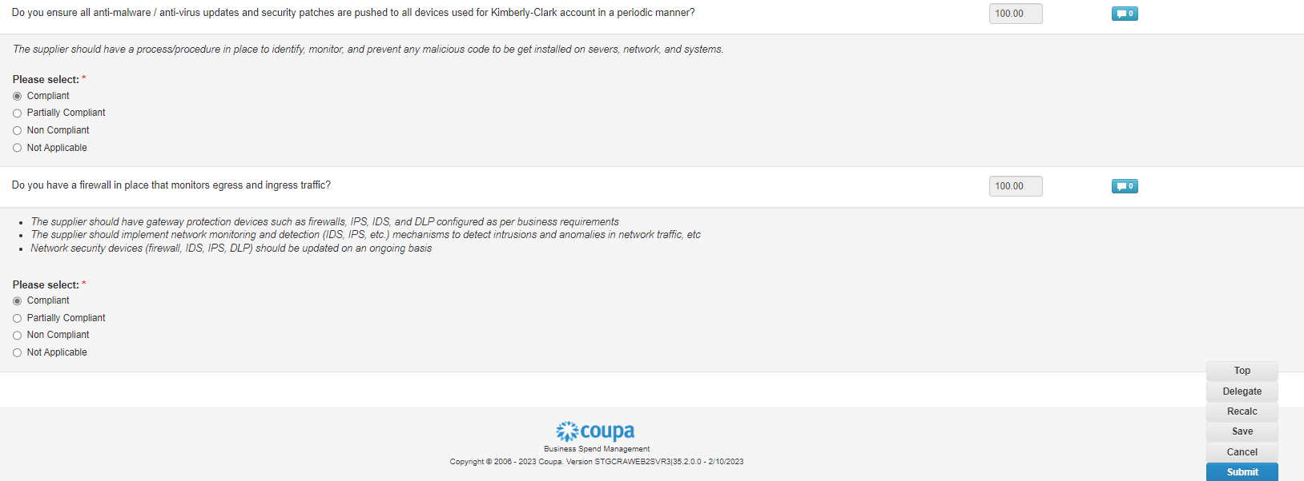

**1**

The **Confirm Action** popup window appears.

1. Click the **Confirm** button.

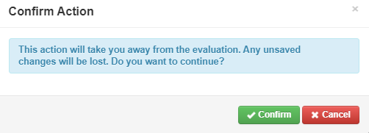

**2**

|  |  |
| --- | --- |
|  | **Note:** Confirming this action continues the process of reassigning your ability to submit responses to the questionnaire. |

1. In the **Delegate to User/Group** section select from either of the following radio button options:
   * **Delegate User** (assigns and delegates approval authority of this action to an individual)
2. Enter the **Name of the individual** in the field.
   1. If the individual’s name does not populate, click the green **(+)** icon to add the individual as user.

**3**

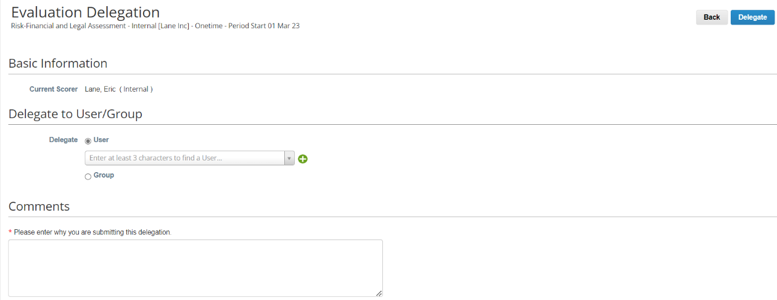

**4**

**a**

* 1. Complete the following fields to add a user:
     + **Email Address**
     + **First Name**
     + **Last Name**

1. Click the **Create User** button when complete.

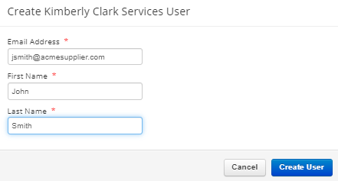

**b**

**c**

1. Enter an **Explanation** for submitting the delegation in the comments field (*required).
2. Click the **Delegate** button when complete.

**6**



**5**

|  |  |
| --- | --- |
|  | **Note:** The delegated individual receives an email notification of their newly assigned action. |

## Submitting Response to a Periodic Recertification

If delegation is not needed, and after reviewing and/or providing updated responses and attachments (if applicable) to the questionnaire:

1. Click the **Save** button to save all submitted responses.
2. Click the **Submit** button to submit the responses.

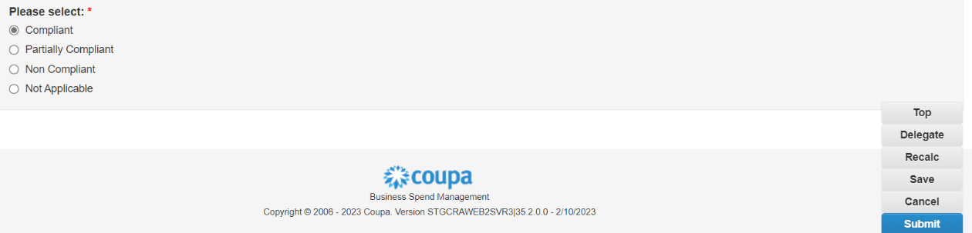

**1**

**2**

The **Submit Evaluation** popup window appears

1. Click the **Submit** button to validate and submit the responses to Kimberly-Clark.

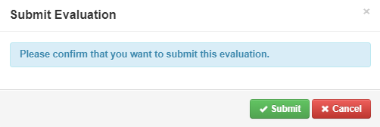

**3**

|  |  |
| --- | --- |
|  | **Note:** Submitted questionnaires route via CRA for review and approval processes within Kimberly-Clark. The designated individual submitting the form will be notified via email of the evaluation outcome. |

**8**

**6**

## Additional Resources

* N/A